

|  |  |  |  |  |
| --- | --- | --- | --- | --- |
| 72 Central Campus Dr Salt Lake City, UT 84112 |  |  |  | fluorender@sci.utah.edu  www.fluorender.com |

FluoRender User’s Guide

Version 2.26.2/February 2021

|  |  |
| --- | --- |
|  | **Please make sure that you have the latest graphics driver installed on your computer before start using FluoRender. Your graphics card needs to at least support:**  **OpenGL 4.0**  **OpenCL 1.2**  **Look up your graphics card’s capability on Wikipedia.org**  **For AMD graphics processing units:**  [**https://en.wikipedia.org/wiki/List\_of\_AMD\_graphics\_processing\_units**](https://en.wikipedia.org/wiki/List_of_AMD_graphics_processing_units)  **For Intel graphics processing units:**  [**https://en.wikipedia.org/wiki/List\_of\_Intel\_graphics\_processing\_units**](https://en.wikipedia.org/wiki/List_of_Intel_graphics_processing_units)  **For Nvidia graphics processing units:**  [**https://en.wikipedia.org/wiki/List\_of\_Nvidia\_graphics\_processing\_units**](https://en.wikipedia.org/wiki/List_of_Nvidia_graphics_processing_units) |

|  |  |
| --- | --- |
|  | **You can find FluoRender tutorial videos on YouTube.** |

Table of Contents

[List of Figures 6](#_Toc63176725)

[Chapter 1 What’s New in Version 2.26.2 8](#_Toc63176726)

[Chapter 2 Installation 11](#_Toc63176727)

[Install FluoRender on Microsoft Windows](#_Toc63176728)

[Install FluoRender on Mac OS X/macOS](#_Toc63176729)

[Install FluoRender on Linux Systems](#_Toc63176730)

[Chapter 3 FluoRender User Interface 18](#_Toc63176731)

[FluoRender on Windows](#_Toc63176732)

[FluoRender on macOS](#_Toc63176733)

[Reorganizing FluoRender’s User Interface](#_Toc63176734)

[Chapter 4 Loading Data 21](#_Toc63176735)

[Volume Data](#_Toc63176736)

[ImageJ & Bioformats Plugin](#_Toc63176737)

[Mesh Data](#_Toc63176738)

[Chapter 5 Managing Data Sets 26](#_Toc63176739)

[Chapter 6 Managing Workspace 29](#_Toc63176740)

[Toolbar Icons](#_Toc63176741)

[Context Menu Commands](#_Toc63176742)

[Chapter 7 Basic Render View Operations 32](#_Toc63176743)

[Multi-view Management](#_Toc63176744)

[Interactions](#_Toc63176745)

[Channel Intermixing Methods](#_Toc63176746)

[Render View Settings](#_Toc63176747)

[Capturing Render View](#_Toc63176748)

[Full Screen Mode (Microsoft Windows Only)](#_Toc63176749)

[Standard Orthographic Views](#_Toc63176750)

[Chapter 8 Adjusting Volume Properties 40](#_Toc63176751)

[Transfer Function Settings](#_Toc63176752)

[Effect Settings](#_Toc63176753)

[MIP Render Mode](#_Toc63176754)

[High Transparency Render Mode](#_Toc63176755)

[Quality Settings](#_Toc63176756)

[Other Settings](#_Toc63176757)

[Synchronize Settings](#_Toc63176758)

[Mode Combinations](#_Toc63176759)

[Chapter 9 Output Adjustment 49](#_Toc63176760)

[Chapter 10 Clipping Volumes 51](#_Toc63176761)

[Clipping Plane Display Controls](#_Toc63176762)

[Clipping Plane Translations](#_Toc63176763)

[Clipping Plane Rotations](#_Toc63176764)

[Chapter 11 Adjusting Mesh Properties 53](#_Toc63176765)

[Basic Mesh Properties](#_Toc63176766)

[Mesh Manipulations](#_Toc63176767)

[Chapter 12 Movie Playback and Export 55](#_Toc63176768)

[Basic Movie Operations](#_Toc63176769)

[Advanced Key Frame Movies](#_Toc63176770)

[Automatic Key Generation](#_Toc63176771)

[Frame Cropping](#_Toc63176772)

[Chapter 13 Batch Processing with 4D Scripts 63](#_Toc63176773)

[4D Script Settings](#_Toc63176774)

[4D Script Files](#_Toc63176775)

[4D Script Tasks](#_Toc63176776)

[Chapter 14 Managing Projects 77](#_Toc63176777)

[Chapter 15 Paint Selection 79](#_Toc63176778)

[Brush Types](#_Toc63176779)

[Brush History](#_Toc63176780)

[Selection Settings](#_Toc63176781)

[Brush Properties](#_Toc63176782)

[Wacom Tablet and Display Tablet Support](#_Toc63176783)

[Creating New Channels from Selection](#_Toc63176784)

[Mask Copy and Paste](#_Toc63176785)

[Output](#_Toc63176786)

[Align Render View to Selection Mask](#_Toc63176787)

[Chapter 16 Measurement 86](#_Toc63176788)

[Measurement Tool Types](#_Toc63176789)

[Averaging](#_Toc63176790)

[Profiling](#_Toc63176791)

[Distance](#_Toc63176792)

[Project](#_Toc63176793)

[Making Changes to Measurement Tools](#_Toc63176794)

[Align Render View to Rulers](#_Toc63176795)

[Chapter 17 Component Analysis 93](#_Toc63176796)

[Settings for Component Generation](#_Toc63176797)

[Clustering](#_Toc63176798)

[Component Analysis](#_Toc63176799)

[Chapter 18 Processing and Analyzing Volumes 104](#_Toc63176800)

[Volume Size](#_Toc63176801)

[Noise Reduction](#_Toc63176802)

[Volume Channel Calculations](#_Toc63176803)

[Colocalization Analysis](#_Toc63176804)

[Chapter 19 Tracking 110](#_Toc63176805)

[Track Map Generation and Management](#_Toc63176806)

[Semi-Automatic Tracking](#_Toc63176807)

[Component Selection Settings](#_Toc63176808)

[Visualizing Tracking Results](#_Toc63176809)

[Assign/Modify IDs](#_Toc63176810)

[Manually Linking Components](#_Toc63176811)

[Making Analysis](#_Toc63176812)

[Chapter 20 Volume-Mesh Conversion 119](#_Toc63176813)

[Chapter 21 Data Processing with OpenCL Filters 121](#_Toc63176814)

[Chapter 22 Settings 123](#_Toc63176815)

[Project Settings](#_Toc63176816)

[Rendering Settings](#_Toc63176817)

[Performance Settings](#_Toc63176818)

[File Format Settings](#_Toc63176819)

[ImageJ Link Settings](#_Toc63176820)

[Settings through the “fluorender.set” File](#_Toc63176821)

[Chapter 23 Contributing to FluoRender 134](#_Toc63176822)

[Developing and Contributing with Source Code via GitHub](#_Toc63176823)

[Appendices 135](#_Toc63176824)

[A. Functions of FluoRender](#_Toc63176825)

[B. File Formats](#_Toc63176826)

[C. Keyboard Shortcuts](#_Toc63176827)

[D. Command Line Options](#_Toc63176828)

[E. Frequently Asked Questions](#_Toc63176829)

[Index 152](#_Toc63176830)

# List of Figures

[Figure 2‑1. Installation language. 11](#_Toc63176831)

[Figure 2‑3. License agreement. 12](#_Toc63176832)

[Figure 2‑4. Destination location. 12](#_Toc63176833)

[Figure 2‑5. Main user interface of FluoRender on Windows. 13](#_Toc63176834)

[Figure 2‑6. Additional tasks. 13](#_Toc63176835)

[Figure 2‑7. Ready to install. 14](#_Toc63176836)

[Figure 2‑8. FluoRender installation on Mac OS X. 15](#_Toc63176837)

[Figure 2‑9. FluoRender software license. 15](#_Toc63176838)

[Figure 2‑9. FluoRender software license. 16](#_Toc63176839)

[Figure 2‑9. FluoRender install information. 16](#_Toc63176840)

[Figure 2‑9. FluoRender installation successful. 17](#_Toc63176841)

[Figure 3‑1. Main user interface of FluoRender on Windows. 18](#_Toc63176842)

[Figure 3‑2. Main user interface of FluoRender on macOS. 19](#_Toc63176843)

[Figure 4‑1. Load a Z-stack sequence. 22](#_Toc63176844)

[Figure 4‑2. Load a time sequence. 23](#_Toc63176845)

[Figure 4‑2. Load a series from LIF. 24](#_Toc63176846)

[Figure 5‑1. Dataset panel. 26](#_Toc63176847)

[Figure 5‑2. Save volume dialog. 27](#_Toc63176848)

[Figure 6‑1. Workspace panel. 29](#_Toc63176849)

[Figure 7‑1. Multiple render views in FluoRender. 32](#_Toc63176850)

[Figure 7‑2. Channel intermixing modes. 36](#_Toc63176851)

[Figure 7‑3. Save captured image dialog. 38](#_Toc63176852)

[Figure 8‑1. Volume properties. 40](#_Toc63176853)

[Figure 9‑1. Output adjustment panel. 49](https://d.docs.live.net/6a73dd1f17cfc8cb/FluoRender/FluoRender_Manual.docx#_Toc63176854)

[Figure 10‑1. Clipping plane panel. 51](https://d.docs.live.net/6a73dd1f17cfc8cb/FluoRender/FluoRender_Manual.docx#_Toc63176855)

[Figure 11‑1. Mesh properties. 53](#_Toc63176856)

[Figure 11‑2. Mesh manipulations. 54](#_Toc63176857)

[Figure 12‑1. Main movie playback controls. 55](#_Toc63176858)

[Figure 12‑2. Save or export a movie or time sequence. 56](#_Toc63176859)

[Figure 12‑3. Basic movie playback controls. 58](#_Toc63176860)

[Figure 12‑4. Advanced movie playback controls. 59](#_Toc63176861)

[Figure 12‑5. Auto key options. 61](#_Toc63176862)

[Figure 12‑6. Frame cropping controls. 62](#_Toc63176863)

[Figure 13‑1. 4D script settings. 63](#_Toc63176864)

[Figure 14‑1. Save project dialog. 77](#_Toc63176865)

[Figure 15‑1. The Paint Brush dialog. 79](#_Toc63176866)

[Figure 16‑1. Launch Measurement window from main toolbar. 86](#_Toc63176867)

[Figure 16‑2. Measurement window. 86](#_Toc63176868)

[Figure 17‑1. The basic settings in the component analyzer dialog. 93](#_Toc63176869)

[Figure 17‑2. Clustering tools. 96](#_Toc63176870)

[Figure 17‑3. Component analysis tools. 98](#_Toc63176871)

[Figure 17‑4. Select components from the output table or in the render view. 102](#_Toc63176872)

[Figure 18‑1. Access the additional processing and analyzing functions from the drop-down menu of the main tool bar 104](#_Toc63176873)

[Figure 18‑2. Volume size dialog. 104](#_Toc63176874)

[Figure 18‑3. Noise reduction dialog. 105](#_Toc63176875)

[Figure 18‑4. Calculation functions in the Analyze window. 106](#_Toc63176876)

[Figure 18‑5. Colocalization analysis dialog. 108](#_Toc63176877)

[Figure 19‑1. Components and Tracking window. 110](#_Toc63176878)

[Figure 19‑2. The Selection tab of the Component and Tracking window. 112](#_Toc63176879)

[Figure 19‑3. Tracks of a tracked cell. 114](#_Toc63176880)

[Figure 19‑5. The Modify tab of the Component and Tracking Window. 115](#_Toc63176881)

[Figure 19‑4. The Linkage tab of the Component and Tracking window. 116](#_Toc63176882)

[Figure 19‑6. The Analysis tab of the Component and Tracking window. 117](#_Toc63176883)

[Figure 20‑1. Convert dialog. 119](#_Toc63176884)

[Figure 21‑1. OpenCL kernel editor. 121](#_Toc63176885)

[Figure 22‑1. Settings, project panel. 123](#_Toc63176886)

[Figure 22‑2. Settings, rendering panel. 125](#_Toc63176887)

[Figure 22‑3. Settings, performance panel. 126](#_Toc63176888)

[Figure 22‑4. Settings, file format panel. 128](#_Toc63176889)

[Figure 22‑5. Settings, ImageJ Link panel. 129](#_Toc63176890)

# What’s New in Version 2.26.2

Thank you for using FluoRender and spending some time on the operation manual. You may also want to read another document containing several tutorials, which can be downloaded from FluoRender’s website.

FluoRender Version 2.26.2 strengthened data analysis in the large data streaming mode, which divides a large data set into multiple data bricks. Changes made to the paint brush and component analyzer allowed data skipping of unselected bricks to improve computing speed when only local features of a large data set are being analyzed.

|  |  |
| --- | --- |
|  | **Multichannel support in component distance calculation** |

A unified adjacency matrix is computed for an arbitrary number of channels. Each channel needs to be segmented and analyzed using the component analyzer. Then the mutual distances of the components are computed as the elements of the adjacency matrix. See Chapter 17 for more details.

|  |  |
| --- | --- |
|  | **Upscaling movie export** |

An exported movie, in QuickTime or Tiff format, can be upscaled to higher resolutions. See Chapter 12 for more details.

|  |  |
| --- | --- |
|  | **Ruler group** |

Rulers created in the Measurement window can be assigned with a group number. See Chapter 16 for more details.

|  |  |
| --- | --- |
|  | **Component length** |

The length of each component is calculated in the component analysis. The length is computed as the length of the longest axis using the Principal Component Analysis. See Chapter 17 for more details.

|  |  |
| --- | --- |
|  | **Brick skipping in component analysis** |

When the large data streaming is enabled and use selection mask is checked, the component analysis functions ignore data bricks that are not selected by a mask. Therefore, the computing time for a local structure within a large data set is significantly reduced. See Chapter 17 for more details.

|  |  |
| --- | --- |
|  | **Brick skipping in brush painting** |

When the large data streaming is enabled, bricks not covered by a brush stroke are not included in the computations. Therefore, the computing time for selecting a local structure within a large data set is significantly reduced. See Chapter 15 for more details.

FluoRender Version 2.26.2 fixed these issues:

* Removed a limitation to Tiff file name length.
* The intensity values of 8-bit Leica files were not scaled correctly.
* The color lookup tables in Leica files were not applied correctly.
* Zoom level display mode was not read correctly from a project file.
* A file sequence was not loaded correctly on Mac OS.
* An ellipse ruler was not computed correctly when its ruler points were moved.
* Component size was not computed correctly for a single image section in the streaming mode.
* A single component spanning multiple bricks may not be combined correctly.
* Component colors were not displayed correctly when Alpha is turned off in the volume settings.
* A single component spanning multiple bricks may not be assigned with a matching color for all its parts.
* Components were not selected correctly in the streaming mode.

Previously, FluoRender Version 2.26 added support of reading several microscopy formats natively as well as other features:

|  |  |
| --- | --- |
|  | **Zeiss ZISRAW CZI file support** |

The implementation of the CZI file reader in FluoRender version 2.26 is based on the ZISRAW file format design specification V 1.2.2, published in July 2016. See Chapter 4 for more details.

|  |  |
| --- | --- |
|  | **Nikon ND2 file support** |

The implementation of the ND2 reader in FluoRender version 2.26 is based on the ND2 SDK version 1.1.0.0. The SDK only provides support on Windows and Linux. Therefore, the ND2 file support is not available on macOS. See Chapter 4 for more details.

|  |  |
| --- | --- |
|  | **Leica LIF file support** |

The implementation of the LIF file reader in FluoRender version 2.26 is based on the Leica Image File Formats Version 3.2, published in September 2016. A LIF file may contain multiple images from different experiments. Use the new series selection function to select one image at loading. See Chapter 4 for more details.

|  |  |
| --- | --- |
|  | **Leica LOF file support** |

The implementation of the LOF file reader in FluoRender version 2.26 is based on the Leica Image File Formats Version 3.2, published in September 2016. A LOF file can only contain one image. See Chapter 4 for more details.

|  |  |
| --- | --- |
|  | **Ruler prune tool** |

Ruler prune tool deletes very short branches on an automatically generated ruler using the grow ruler tool. See Chapter 16 for more details.

|  |  |
| --- | --- |
|  | **New zoom ratio display modes** |

There are now three zoom ratio display modes: view-based, pixel-based, and data-based. The data-based mode maps the physical size of a volume channel to screen pixels. A scale bar of the same length across several sample files can be guaranteed in the data-based mode. See Chapter 7 for more details.

|  |  |
| --- | --- |
|  | **Updated batch reading** |

The batch reading mode is separated from 4D sequence reading. For example, a LIF file contains multiple images, each being a 4D sequence. Check the batch mode to switch between images. Check the 4D sequence mode to enable 4D play back for the current image. See Chapter 12 for more details.

|  |  |
| --- | --- |
|  | **OpenCL device selection** |

Use the OpenCL device selector to determine the GPU for OpenCL processing. See Chapter 22 for more details.

FluoRender Version 2.26 also fixed these issues:

* Components cannot be updated correctly after an existing result.
* Grow selection and grow ruler may not work properly for small-size data.
* Crash when deleting rulers.
* Interaction speed decreased significantly at high magnification ratio on a high-resolution display.

# Installation

## Install FluoRender on Microsoft Windows

|  |  |
| --- | --- |
|  | We have discontinued the support of 32-bit Windows since Version 2.14. Please make sure that your hardware is 64-bit compatible and a 64-bit Windows is installed. If you have any questions about Windows version, please contact us. Continued support will only be available for the latest Release of FluoRender. |

1. Download *FluoRender\_2.26.2\_win64.exe* from our website (https://github.com/SCIInstitute/fluorender/releases).
2. Double-click the installer icon to initiate the installation.

|  |  |
| --- | --- |
|  | You may be asked by “User Account Control” to provide permission to allow the installer from an unknown publisher to make changes to your computer. Click “Yes” to allow FluoRender to install. |

1. The first dialog you will see will ask you to select your language for installation. Click OK.



Figure 2‑1. Installation language.

1. At this point, the installer checks to see if you have FluoRender already on your machine. If FluoRender is not yet on your machine, continue to step 5. If the version you are installing already exists, setup will terminate.

|  |  |
| --- | --- |
|  | If you wish to re-install the same version of FluoRender, first uninstall using Add/Remove programs in the Control Panel. |

If you are trying to install an older version of FluoRender, you will be asked to confirm an installation overwrite of the newer version. If your existing FluoRender is older than what is being installed, you will be asked if you wish to upgrade to the installer’s version.

1. License Agreement. FluoRender is under the MIT license agreement. Please read and accept the license. Click Next to continue.

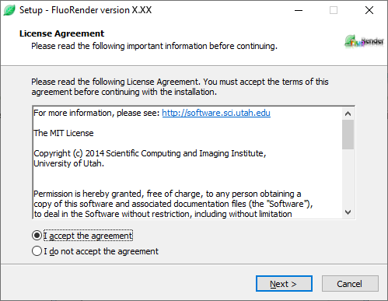

Figure 2‑3. License agreement.

1. Choose your installation path. Default is recommended. Click Next to continue.

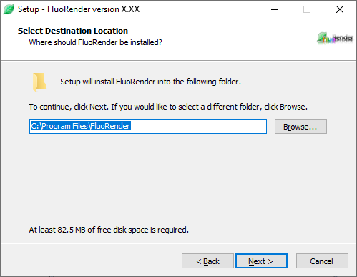

Figure 2‑4. Destination location.

1. Select shortcut options. Click Next to continue.

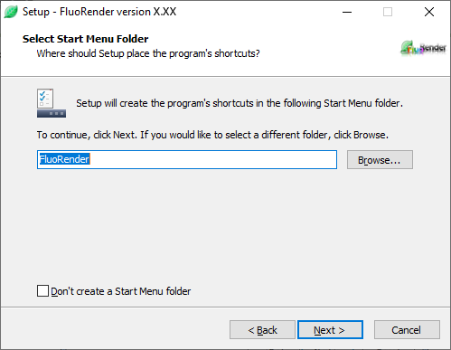

Figure 2‑5. Main user interface of FluoRender on Windows.

1. Select Additional Tasks. Check the box if you wish to have a desktop shortcut to FluoRender. Click Next to continue.

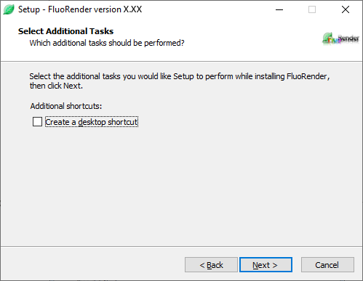

Figure 2‑6. Additional tasks.

1. Ready to Install. Here is a review of what will be installed on your machine. Click Install to continue.

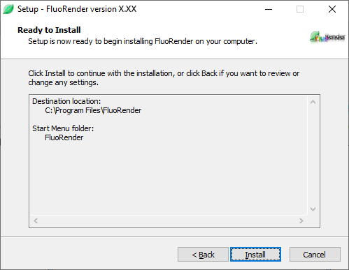

Figure 2‑7. Ready to install.

|  |  |
| --- | --- |
|  | You may also be asked to install “Microsoft Visual Studio 2017 Runtime Redistributable for x64”. You will need an internet connection for the installer to download and install this requirement for FluoRender. |

1. After clicking “Install”, setup will copy files onto your computer. When completed, setup will tell you that install is complete and to click “OK” to run FluoRender.

## Install FluoRender on Mac OS X/macOS

|  |  |
| --- | --- |
|  | We have discontinued the support of old Mac OS X versions. Currently supported versions include: 10.9 (Mavericks). Please make sure your hardware is compatible with this version of Mac OS X. If you are unable to use OS X 10.9, you will need to use FluoRender 2.14 (also on FluoRender’s download website). FluoRender 2.14 is compatible with OS X 10.6 and above. There are many new features and bug fixes that are not included in 2.14. Continued support will only be available for the latest Release of FluoRender. |

1. Download *FluoRender\_2.26.2\_mac64.pkg* from our website (https://github.com/SCIInstitute/fluorender/releases).
2. Double-click the package file icon to start the installation process.



Figure 2‑8. FluoRender installation on Mac OS X.

1. Click the button “Continue” to view the license.



Figure 2‑9. FluoRender software license.

1. Click the button “Continue”.



Figure 2‑9. FluoRender software license.

1. Click the button “Agree” to accept the license.



Figure 2‑9. FluoRender install information.

6. Click the button “Install” to install FluoRender on your computer. You need to type the root password in order to continue installation.



Figure 2‑9. FluoRender installation successful.

7. If the installation finishes, click the button “Close” to quit the installation program. You can run FluoRender from the “Application” directory.

## Install FluoRender on Linux Systems

Download FluoRender’s source code and build the executables. You will also need Cmake, wxWidgets, and Boost.

# FluoRender User Interface

|  |  |
| --- | --- |
|  | Not every function of FluoRender is available for Mac OS X. Refer to appendix for the difference of FluoRender on the two operating systems. The rest of this guide is based on the Windows version of FluoRender. |

## FluoRender on Windows

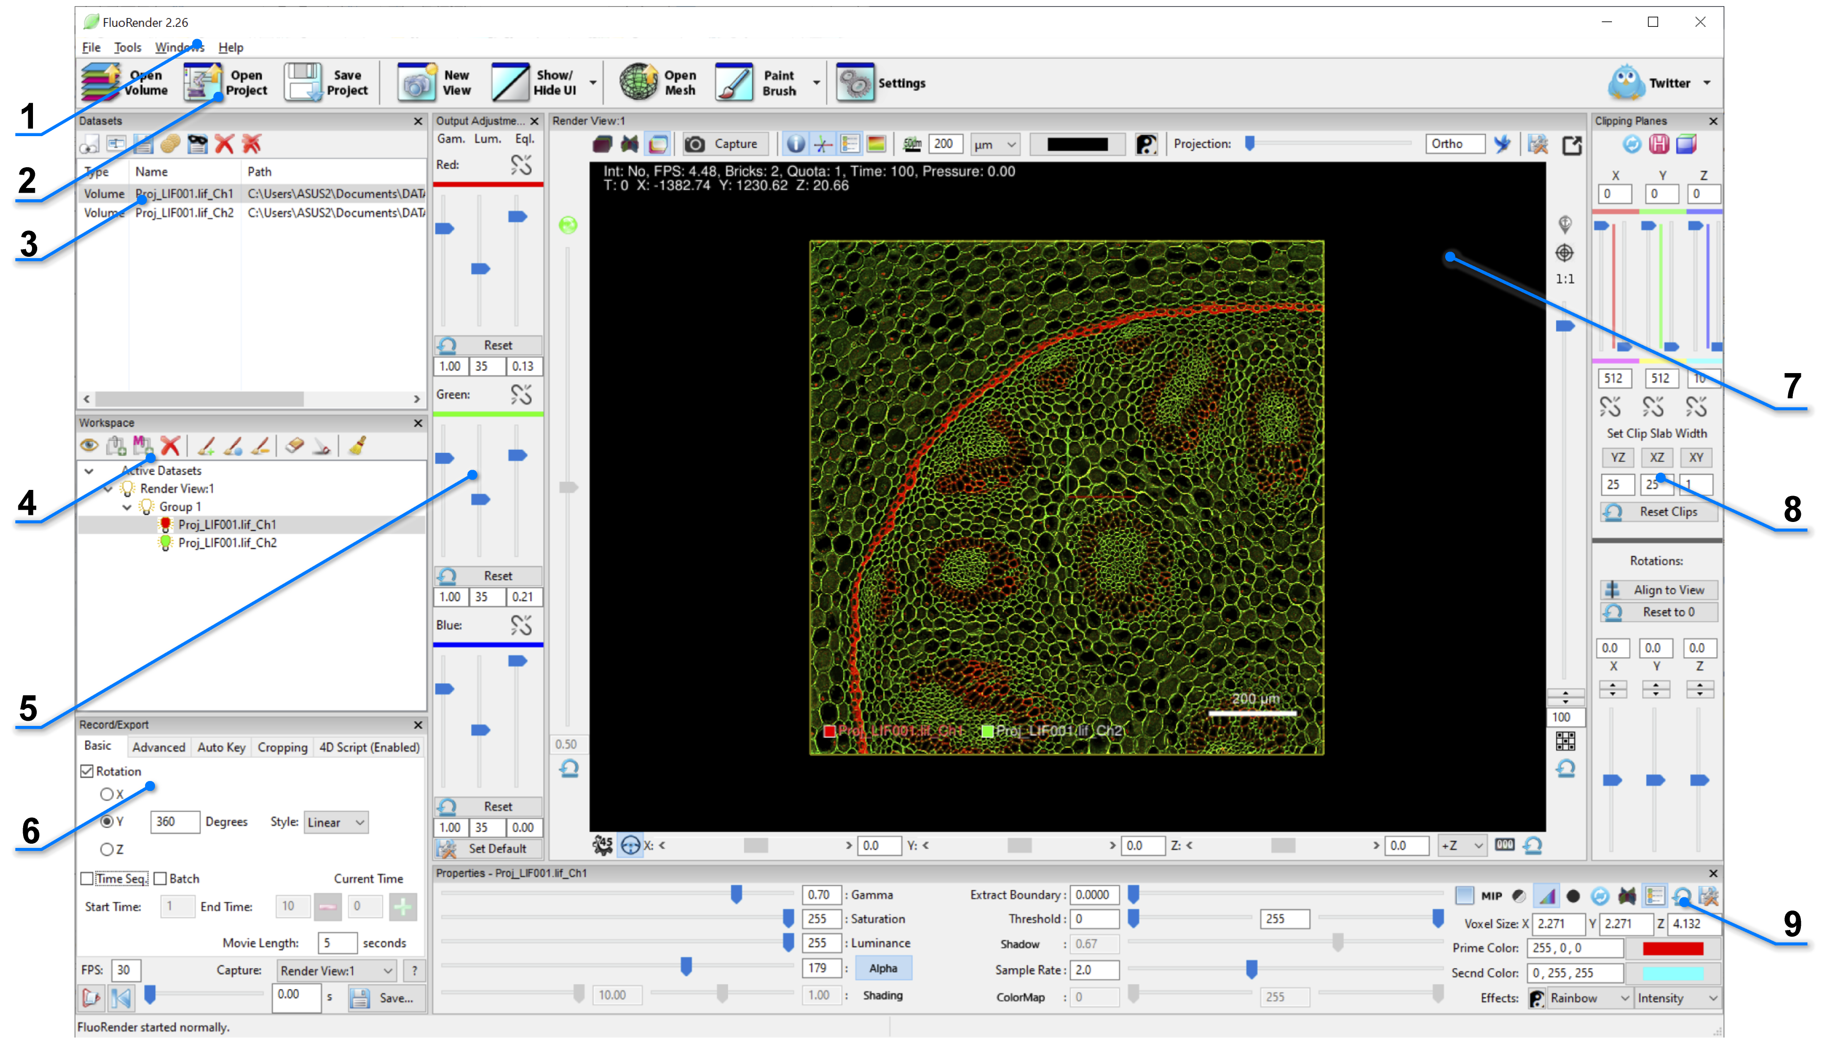

Figure 3‑1. Main user interface of FluoRender on Windows.

1. **Main menu.** Functions in main menu can be accessed from the main toolbar as well.
2. **Main tools.** The most commonly used functions are listed on the left side of the main toolbar, including loading volumes and projects. Analysis tools of FluoRender are stacked under one button on the main tool bar. You can use the drop-down menu to choose a tool that is not currently shown. The most recently used tool is shown for quick access.
3. **Dataset panel.** Currently loaded data sets are listed in the dataset panel. They can be added to a render view. Multiple instances of the same data set can be added to render views as well.
4. **Workspace panel.** Currently visualized data sets are listed in the workspace panel. For volume data, each item is called a “channel”. There is no limit to the number of channels can be visualized. When a channel is selected in the workspace panel, most subsequent operations are applied to the selection.
5. **Output adjustment panel.** Use this panel to adjust the visual settings of render view output, as individual RGB color channels. When a volume is selected in the workspace, its adjustments are for the entire group that the selection belongs; when a render view is selected, its adjustments are for the entire render view.
6. **Record/Export panel.** Record and export a rotation movie, a time sequence, or a key frame animation using this panel. The selected view port can also be cropped for export.
7. **Render view panel.** The main panel for visualization and analysis. Multiple render view panels are supported.
8. **Clipping plane panel.** Use clipping planes to isolate a portion of selected volume. Clipping planes belonging to different channels can also be synchronized.
9. **Property panel.** All adjustable visual settings of current selection. Adjustments are applied in real-time.

|  |  |
| --- | --- |
|  | Try the example project, which can be found in the “Data” folder in the FluoRender installation directory. |

## FluoRender on macOS

|  |  |
| --- | --- |
|  | Although the macOS interface is nearly identical to Windows (minus unsupported functions), the appearance is slightly different due to intrinsic Operating System differences. The “look and feel” more represents that of a Mac. |

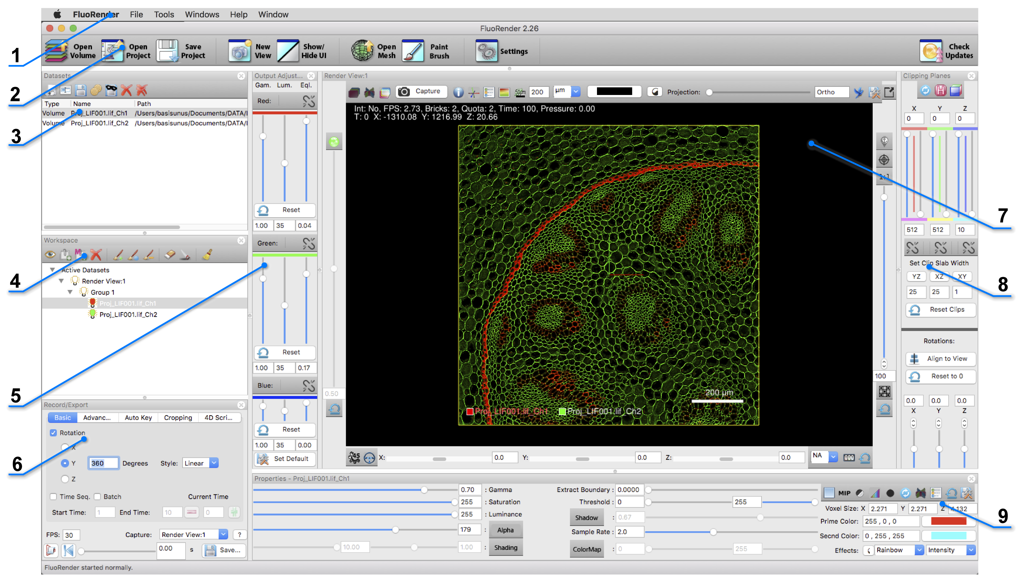

Figure 3‑2. Main user interface of FluoRender on macOS.

1. **Main menu.** Functions in main menu can be accessed from the main toolbar as well.
2. **Main tools.** The most commonly used functions are listed on the left side of the main toolbar, including loading volumes and projects. You will notice a difference here on a Mac, as the drop-down menu is not available to the Analyze button. You can access those features through the main menu, under Tools. The most recently used analysis tool is shown on the main tool bar.
3. **Dataset panel.** Currently loaded data sets are listed in the dataset panel. They can be added to a render view. Multiple instances of the same data set can be added to render views as well.
4. **Workspace panel.** Currently visualized data sets are listed in the workspace panel. For volume data, each item is called a “channel”. There is no limit to the number of channels can be visualized. When a channel is selected in the workspace panel, most subsequent operations are applied to the selection.
5. **Output adjustment panel.** Use this panel to adjust the visual settings of render view output, as individual RGB color channels. When a volume is selected in the workspace, its adjustments are for the entire group that the selection belongs; when a render view is selected, its adjustments are for the entire render view.
6. **Record/Export panel.** Record and export a rotation movie, a time sequence, or a key frame animation using this panel. The selected view port can also be cropped for export.
7. **Render view panel.** The main panel for visualization and analysis. Multiple render view panels are supported.
8. **Clipping plane panel.** Use clipping planes to isolate a portion of selected volume. Clipping planes belonging to different channels can also be synchronized.
9. **Property panel.** All adjustable visual settings of current selection. Adjustments are applied in real-time.

## Reorganizing FluoRender’s User Interface

Most panels, dialogs, and windows of FluoRender can be closed by clicking the close button on the top right corner. To reopen a panel, use the Windows menu. You can also hide or show all panels except render views using the “Show/Hide UI” button in the main toolbar. Most panels can be repositioned by dragging its top bar. Additionally, panels can be resized by dragging the dividers between two panels.

# Loading Data

Volume and mesh objects are the two major data types to be visualized and analyzed in FluoRender. A volume is a 3D image comprised of sample points on a regular 3D grid, each sample point called a voxel. A volume can be saved on disk as a single file, or as a series of 2D images. A time sequence of volumes is generated from continuously scanning a living sample. A time sequence can be saved as individual time points, or as a single file with a supported format. See Appendices for more details on file formats.

## Volume Data

### Single channel

To open a single channel volume, click “Open Volume”  in the main toolbar. In the file browser dialog, choose a supported volume data file. Then, click “Open”. The selected file is loaded into FluoRender and visualized in the render view with default settings.

### Multiple channels

To open more than one channel of volumes, click “Open Volume”  in the main toolbar. In the file browser dialog, select multiple files within the same file folder. Then, click “Open”. The selected files are loaded into FluoRender and visualized in the render view with default settings. The first three channels loaded are assigned with red, green, and blue colors respectively. Then, a subsequently loaded channel is assigned with a randomly generated color.

|  |  |
| --- | --- |
|  | Alternatively, the “Open Volume” command can be found in the main menu. Users can also drag and drop file(s) to the FluoRender main user interface to open them. If FluoRender is not currently running, Users can drag and drop file(s) to the desktop icon of FluoRender. FluoRender also supports file names as command inputs. For example, to launch FluoRender with opened files, type the following command in the console window: FluoRender.exe “file1” “file2”. |
|  | If excitation wavelength information is read from meta data, colors can be automatically assigned. See Chapter 22 and the appendix on file format for more details. |

### Z-stack sequence

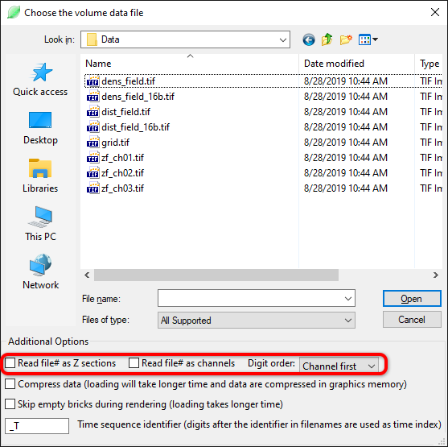

Figure 4‑1. Load a Z-stack sequence.

A volume channel stored in the form of a series of 2D images (Z-stacks) can be loaded with FluoRender, on condition that the stack files are named properly with numbers to index the sequence. A multichannel data set can store RGB channels in one Z slice. Or the channels may be stored as individual files. When channels are stored as separate files, a number representing the channel index needs to be in the names as well. To open a Z-stack sequence, click “Open Volume”  in the main toolbar. In the file browser dialog, check the options to match the naming style (Figure 4‑1). Then, select **just one** file from the sequence and open it. FluoRender will match the file names within the folder to the selected file and load the entire sequence as a volume channel. Use the table below as a guideline for setting the options.

|  |  |  |
| --- | --- | --- |
| Z-stack type | Option setting | Example |
| Multiple Z sections, single channel | 🗹Read file# as Z sections | Name\_Z###.tif |
| Single Z section, multiple channels | 🗹Read file# as channels | Name\_C###.tif |
| Multiple Z sections, multiple channels;  Channel number goes first | 🗹Read file# as Z sections;  🗹Read file# as channels;  Channel first | Name\_C###\_Z###.tif |
| Multiple Z sections, multiple channels;  Z section number goes first | 🗹Read file# as Z sections;  🗹Read file# as channels;  Z section first | Name\_Z###\_C###.tif |

### Time sequence



Figure 4‑2. Load a time sequence.

FluoRender can also load a time sequence. Similar to a Z-stack sequence, a time sequence has to be named correctly for loading. However, there is a configurable identifier for a time sequence. To open a time sequence, click “Open Volume”  in the main toolbar. In the file browser dialog, make sure the “Time sequence identifier” matches that within the sequence. Then, select **just one** file in the sequence to open it. The selected file is visualized. To view the time sequence, use the playback functions in the “Record/Export” panel (Chapter 12).

|  |  |
| --- | --- |
|  | Make sure the time sequence identifier only appears once in the file name. For example, when using identifier “\_T”, a file name pattern like “My\_Time\_Sequence\_T\*\*.tif” can confuse FluoRender, because “\_T” appears twice. In this case, you can simply change the identifier in the file browser dialog to “e\_T”, which appears only once in the file name. |

### Loading data with masks

Mask files to a channel are saved along with the original data files. They are automatically loaded into FluoRender when the data files are loaded. It is possible to generate masks on reduced resolution data and apply them to original resolution data. Simply copy the mask files into the same directory and make sure the file names are the same (except the suffixes). FluoRender automatically resamples the mask files if their resolution does not match with the original files.

### Load mask and label directly

You can also load mask and label files directly into FluoRender. Their file extensions are .msk and .lbl respectively.

### ImageJ Hyperstack

ImageJ can save a 5D (XYCZT) data set as a hyperstack in a single TIFF file. Information about the hyperstack is saved in the image description of the TIFF file. You can open a hyperstack TIFF using the same method as a normal TIFF file. FluoRender will read the image description and separate channels and time points accordingly. FluoRender supports ImageJ Hyperstack files larger than 4 GB. Convert a large time sequence data set into the Hyperstack to open in FluoRender.

### Large Data Streaming

If a data set is large in terms of spatial resolution or channel number, rendering can become less interactive, or even impossible. Enable large data streaming when data size exceeds graphics memory size. Details of large data streaming can be found in Chapter 22. When data are being loaded, the progress dialog displays current large data streaming settings.

|  |  |
| --- | --- |
|  | Since FluoRender version 2.22, large data streaming is turned on by default. However, the large data size setting determines if a data set is actually divided into bricks. |
|  | Skip empty bricks during rendering can be enabled when volumes are loaded for large data streaming. When enabled, each brick is checked, and empty bricks are ignored during rendering to allow faster speed. |

### File Formats

To achieve great performance, we code our own readers for different formats, instead of using third-party format converters. See Appendices for supported file formats.

### Series Selection

Some raw formats may save multiple series of images in a single file, such as Leica LIF. Use the series selector to choose a series. Notice that the series index starts from 0.

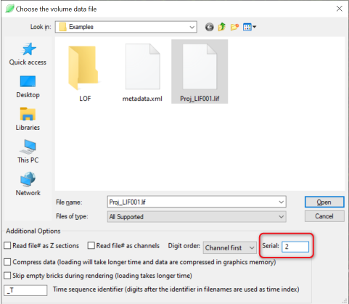

Figure 4‑2. Load a series from LIF.

### Automatic Channel Separation

When loading Prairie/Bruker XML format, if the data set contains tiles scanned at different stage locations, FluoRender will check if the tiles overlap with each other. If no overlapping tiles are found, FluoRender separates each tile into a channel. This is useful when an experiment scans several samples mounted on the same stage. Make sure you set the stage to leave some space between any two samples.

### Multiresolution Data

FluoRender supports the VVD format, which contains a series of resolution levels. A resolution level is selected for display based on the zoom ratio. An extremely large data set can therefore be visualized.

## ImageJ & Bioformats Plugin

You can use ImageJ and Bioformats to load a format originally unsupported by FluoRender. You need to have ImageJ and Bioformats installed and configured correctly. See Chapter 22 for the settings to link FluoRender with ImageJ. When ImageJ and Bioformats are correctly configured, click “ImageJ Import”  in the main toolbar. In the file browser dialog, choose one or multiple files and let ImageJ load them into FluoRender.

|  |  |
| --- | --- |
|  | You can also link FluoRender with Fiji, which includes Bioformats. Therefore, no additional plugins and configurations are needed. |

## Mesh Data

To load mesh data, click “Open Mesh”  in the main toolbar. In the file browser dialog, choose one or multiple mesh files to load them.

|  |  |
| --- | --- |
|  | Only Wavefront OBJ format is currently supported. A mesh object can have associated materials and textures. |

# Managing Data Sets

Loaded data sets are listed in the “Datasets” panel (Figure 5‑1).



Figure 5‑1. Dataset panel.

Each loaded data set has a type identifier (volume, mesh, etc.), a name (initialized to its file name), and a path. For a data set created within FluoRender, the path entry is empty initially. When a created data set is saved, the path entry is updated. Only one data set can be selected from the list at one time. The following operations are applied to the selected data set.

 **Add.** It adds selected data set to the render view. If multiple render views are opened, the data set is added to the first render view in the “Workspace” panel.

|  |  |
| --- | --- |
|  | Alternatively, user can right-click a data set. In the context menu, under “Add”, there is a list of currently opened render views. A different render view than the first one can be selected through the context menu. The same data set can be added to a render view for multiple times. Each instance of the data set has its own volume settings. However, if the intensity values of any one of the instances are changed, all will be updated. |

** Rename.** It allows renaming selected data set. Names are used to uniquely identify data sets within FluoRender. They are initialized to their file names after loading, which can be changed for easy data organization. FluoRender will automatically resolve name conflicts, for example, when data sets are duplicated.

** Save.** It saves selected data set to hard drive. FluoRender will always ask for a directory and file name for saving a data set. Make sure that important original data sets are not over-written.

|  |  |
| --- | --- |
|  | The file formats that a selected volume can be saved are less than that can be read. For example, for volumes, TIFF is the preferred format. |

When saving a volume channel, these additional options are available:

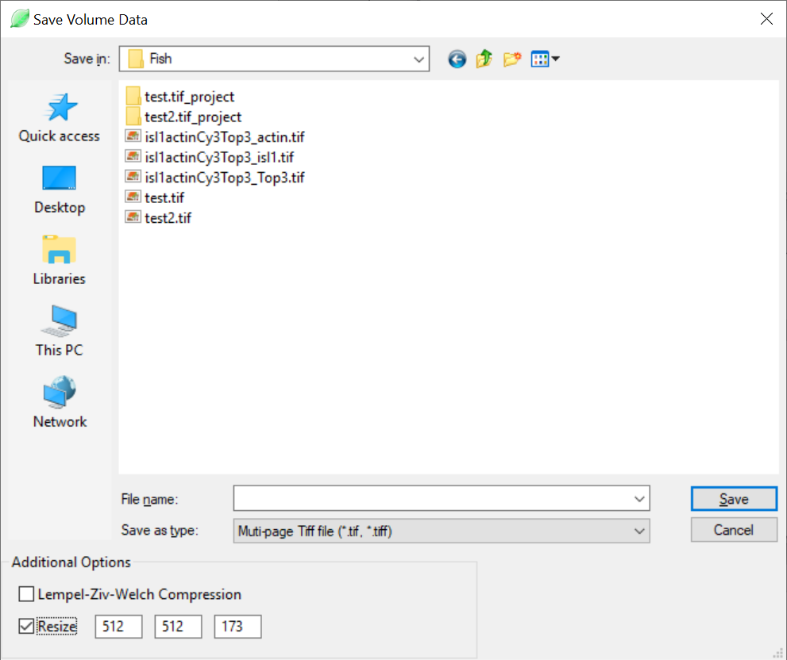

Figure 5‑2. Save volume dialog.

**Lempel-Ziv-Welch compression.** It saves the image content in the TIFF file using the compression method.

**Resize.** Once checked, the original resolution of the volume channel is displayed. New resolution values can be entered. FluoRender will resample the data to the new resolutions.

** Bake.** It saves selected volume data set with its properties applied. For example, you can set a threshold value for a volume data set to cut off noise signals. When you “bake” the volume data set, you save it with the threshold applied, therefore removing the noise signals. Volume properties that are saved with the baking function include:

* Gamma
* Saturation
* Alpha
* Extract boundary
* Threshold (Soft threshold, see Chapter 22)
* Clipping planes

The same settings for saving a volume channel (Figure 5‑2) are used for baking.

|  |  |
| --- | --- |
|  | Data values outside of the clipping planes are set to 0 when baked. You may use this feature to create a sub volume from the original data. However, the actual data size is unchanged. Clipped space is padded with zero values. |

 **Save Masks**. It saves the selection mask and label mask of a selected volume channel. The name of the mask files is automatically chosen based on the file name of the selected volume channel. Therefore, make sure the volume channel is saved before saving its masks.

** Delete.** It deletes selected data set from FluoRender. It does not delete data from hard drive.

In addition, the “delete all” **** command is used to delete all data sets in the list.

# Managing Workspace

Only data sets in the “Workspace” panel can be visualized and analyzed (Figure 6‑1). Most operations in FluoRender are applied on currently selected item in the “Workspace” panel. Only one item can be selected at one time. If a volume or mesh is selected, its properties are loaded into the “Property” panel. Items are organized into a “Render View”-“Group”-“Data Set” hierarchy. Items can be reorganized through dragging and dropping them on the list.

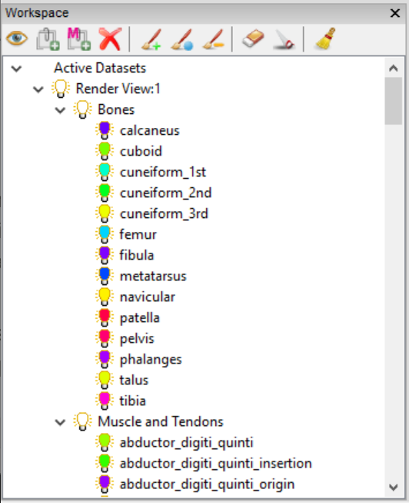

Figure 6‑1. Workspace panel.

## Toolbar Icons

 **Toggle visibility.** Click to enable and disable the visibility of a selected data set. The same effect can be achieved by double-clicking the icon of a data set. Visibility of a group or a render view can be toggled similarly. When the visibility of a group is disabled, every item within the group becomes invisible.

 **Add a volume group.** Volume data sets are organized under groups. Some operations are applied on groups, instead of individual volume channels, including output adjustments, and synchronized operations.

|  |  |
| --- | --- |
|  | Alternatively, a volume data set can be dragged to the bottom empty space within the “Workspace” list. A new volume group is automatically created. |

** Add a mesh group.** Mesh groups are for organizing mesh data sets.

** Delete selection.** It removes a selected data set from the workspace. Removed data sets are not deleted from FluoRender and can still be accessed from the “Dataset” panel.

The rest of the workspace toolbar icons are for paint selection. Please refer to Chapter 15 for details.

## Context Menu Commands

|  |  |
| --- | --- |
|  | Context menu commands can vary when different items are selected. |

### Common context menu commands

**Toggle Visibility.** It changes the visibility of a selected item.

**Randomize Colors.** It randomly chooses a color for current selection.

**Add Volume Group.** It adds a volume group to current render view.

**Add Mesh Group.** It adds a mesh group to current render view.

**Delete.** It deletes current selection from workspace. “Close” is shown instead for a render view.

|  |  |
| --- | --- |
|  | Alternatively, you can hold down the “Ctrl” key and double-click the icon of an item to randomize its color. |

### Context menu commands for render views

**Collapse/Expand.** It collapses or expands a list of child items.

### Context menu commands for groups

**Isolate.** It disables the visibility of all other data sets except those in the group.

**Show All.** It enables the visibility of all data sets.

### Context menu commands for volumes

**Isolate.** It disables the visibility of all other data sets except current selection.

**Show All.** It enables the visibility of all data sets.

**Copy Mask.** It copies the mask of the selected channel to be pasted into another channel.

**Paste Mask.** It pastes the copied mask into the selected channel.

**Merge Mask.** It merges a copied mask into the selected channel with its existing mask.

**Exclude Mask.** It pastes a copied mask into the selected channel and subtract it from the existing mask.

**Intersect Mask.** It pastes a copied mask into the selected channel and computes the intersection between the two masks.

**Paint Brush.** It shows the “Paint Brush” window (see Chapter 15).

**Measurement.** It shows the “Measurement” window (see Chapter 16).

**Component Analyzer.** It shows the “Component Analyzer” window (see Chapter 17).

**Tracking.** It shows the “Tracking” window (see Chapter 19).

**Noise Reduction.** It shows the “Noise Reduction” window (see Chapter 17).

**Volume Size.** It shows the “Volume Size” window (see Chapter 17).

**Colocalization.** It shows the “Colocalization” window (see Chapter 17).

**Convert.** It shows the “Convert” window (see Chapter 20).

**OpenCL Kernel Editor.** It shows the “OpenCL Kernel Editor” (see Chapter 22).

|  |  |
| --- | --- |
|  | Details on volume processing and analysis functions are discussed in the respective chapters. |

### Context menu commands for mesh objects

**Manipulate.** It shows mesh transformation controls in the “Property” panel. Selected mesh object can be rotated, translated, and scaled (see Chapter 11).

# Basic Render View Operations

Render views are the most important panel/window in FluoRender. Data are visualized and analyzed within render views. Multiple render views can be created and managed. Figure 7‑1 shows FluoRender’s capability to mimic a classical “four-view” configuration. However, each render view provides powerful visualization functions, so it is adequate to use single render view for most visualization and analysis requirements.

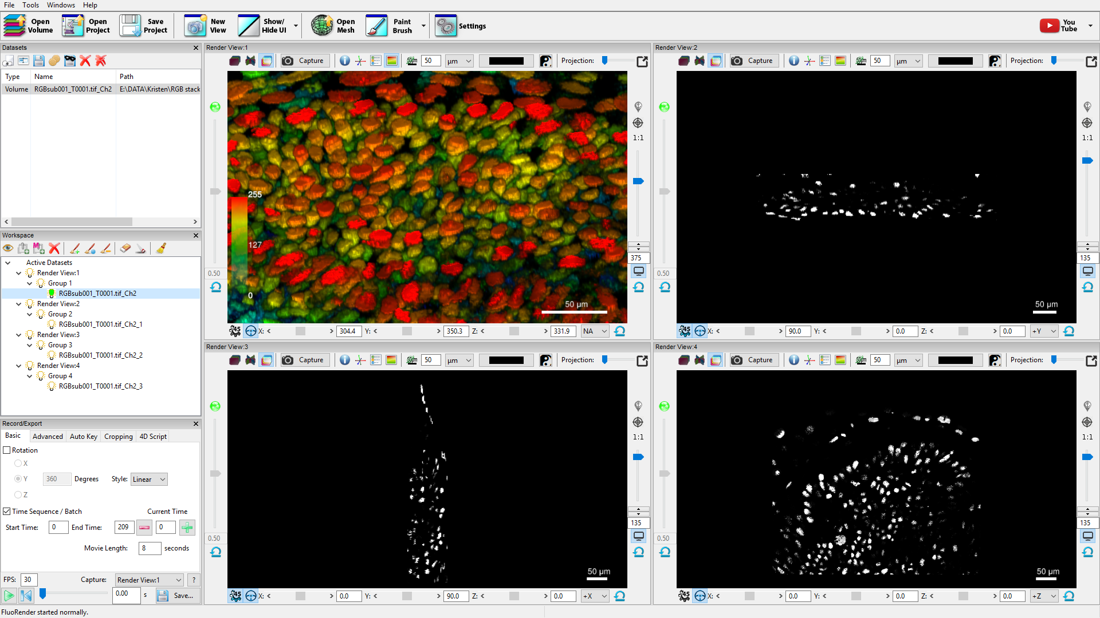

Figure 7‑1. Multiple render views in FluoRender.

## Multi-view Management

Render views are sequentially numbered in a session. FluoRender requires at least one render view available at the center of the main user interface. To create a new render view panel, click “New View”  in the main toolbar. The newly created render view is placed side-by-side with the initially created one. To adjust the sizes of render views, drag the divider between two render views. Like most panels in FluoRender, additional render views can be detached from the main user interface and become a standalone window. This can be useful when multiple monitors are available. Additional render views can be closed from the “Workspace” panel. However, the initial render view cannot be closed or detached from the main user interface. To close an additional render view, right-click its icon in the “Workspace” panel. In the context menu, choose “Close”.

Opened data sets are automatically added to the initial render view. To add a data set to an additional render view, right-click the data set in the “Dataset” panel. In the context menu, choose “Add to”, and then choose the desired render view. Data sets are duplicated by instance, which means that they share original data values, but can receive different settings. For example, there are four instances of the opened data set in Figure 7‑1. The instance in the top-left render view is color-mapped, while the rest are not.

## Interactions

Basic render view interactions can be achieved using a mouse or compatible pointing device. In addition, standard control widgets can be found surrounding a render view panel.

|  |  |
| --- | --- |
|  | Free-fly  mode should be disabled for trackball-like interactions. When free-fly mode is enabled, the following interactions use a different model. See free-fly mode for more details. |

### Rotations

To rotate the view, click and hold down the left mouse button (or primary button), and drag mouse to the intended direction. Additional controls for rotation are located at the bottom of the render view panel. Use the sliders to restrict rotations around a single axis. Or, you can input the exact rotation values.

There are three buttons for rotation control.

 **Geared rotation.** When enabled, all rotation angles are restricted to multipliers of 45. This allows users to quickly rotate to axis-aligned angles. For example, the axis-aligned views in Figure 7‑1 use this function to visualize image sections.

 **Rotation slider style.** There are two styles for rotation sliders. The first mode is the “steering wheel” mode. In its resting state, the slider control is at the center. A rotation angle around an axis starts to change when user drags the handle to one direction. The change rate depends on the offset of the handle to its center. The view keeps rotating at the specified speed as long as the handle is held at an offset position. This allows users to continuously rotate the view without resorting to the movie export functions. The second mode is the direct mode. The control of slider sets the angle directly.

 **Zero rotation.** After rotating the render view to an arbitrary orientation. Click the zero rotation button to set current orientation as the zero rotation. Use this function for a tilted or flipped scan. To reset the zero rotation, reset the rotation angles first. Then, click the zero rotation button again. Also use the alignment functions to compute the leveled rotation for a scan (see Chapter 15, Chapter 16, and Chapter 17).

 **Reset rotation.** It sets all rotation angles of X, Y, Z axes to 0.

|  |  |
| --- | --- |
|  | Rotations of different render views can be synchronized by enabling “Link all render views’ rotations” in the “Rendering” panel of the setting dialog. |

On a computer equipped with a multitouch display, use one finger to rotate the view.

 When an Xbox controller is connected, use the right thumb stick to rotate the view.

### Zooming

To zoom the view, click and hold down the right mouse button (or secondary button), and drag mouse in straight up-down or left-right directions.

**Zooming in:** Up or right.

**Zooming out:** Down or left.

Additional controls for zooming are located on the right border of the render view. Use the slider to change the zoom level. Or, input an exact zoom level value. Value input also allows zoom levels greater than the slider’s range.

These buttons are for zooming control.

1:1 **1:1 ratio.** It sets a zoom level so that one sample point (pixel or voxel) of the original data occupies exactly one screen pixel.

**Zoom level display mode.** There are two modes for zoom level display:

 **View-based mode.** The zoom level is a percentage value representing how much a data set occupies the entire render view area. When you change the render view size, this value remains unchanged and the rendering changes its size based on this number. Use this mode when you want to generate renderings of the same size for data sets of different physical sizes. For example, you have two scans of 512x512 and 1024x1024 respectively. Render them in two projects and set the zoom level to the same value in the view-based mode. It generates two images of the same size for the two scans, although they have different data sizes. Scale bars represent the same value have different lengths in the two images.

 **Pixel-based mode.** The zoom level is a percentage value representing how much a data set is enlarged or shrunk relative to its size when the 1:1 ratio button is pressed. It displays 100 when the 1:1 ratio button is pressed. When you change the render view size, this value changes since the rendering changes its size along with the render view. Press the 1:1 ratio button again to set its value to 100. Use this mode when you want to generate renderings of exact pixel sizes. For example, you have two scans of 512x512 and 1024x1024 respectively. Render them in two projects and set the zoom level to the same value in the pixel-based mode. It generates two images of different sizes which are proportional to the original data sizes.

 **Data-based mode.** Use this mode if you want to share a single scale bar across samples or compare their physical sizes. At 100 zoom ratio, one physical unit (usually µm) is mapped to one screen pixel.

|  |  |
| --- | --- |
|  | Depending on the zoom level display mode, 100 zoom level does not necessarily mean 1:1 ratio, and vice versa. In the view-based mode, we use the relative size of the entire data boundary (rotations considered) versus render view size to determine the zoom level. When visualizing a square data set in a square render view, the data set occupies the entire render view when the zoom level = $\sqrt{2}×100≅141$. 100 zoom level usually means that the entire data set can be seen with generous margins. In the pixel-based mode, 100 zoom level means 1:1 ratio. The data-based mode also considers the voxel size in a physical unit. |

 **Reset zooming.** Resets the zoom level to default. The default zoom level is saved when render view settings are saved.

 On a computer equipped with a multitouch display, use two fingers and move them closer or apart to zoom.

 When an Xbox controller is connected, use the left thumb stick to zoom the view. Push the left thumb stick upward to zoom in; push the left thumb stick downward to zoom out.

### Panning

To pan the view, click and hold down the middle mouse button (or wheel), and drag mouse to the intended direction. If middle button is not available, hold down the “Ctrl” key (or “Command” key on a Mac) and use the left mouse button instead.

Panning can be reset using a button  (Center data) on the right border of the render view.

|  |  |
| --- | --- |
|  | Use the center axis as an indicator for the center of the render view. You can turn on the center axis with the button C:\Users\HP2\SkyDrive\FluoRender\center_axis.png on the top border of render view. |

 **Rotation center anchor.** Enable rotation center anchor to let FluoRender determine the depth of current rotation center based on underlying data, so that a prominent feature can keep at the view center after rotation. This is usually used for large data sets, when panning is necessary to examine the details. If slow interaction speed is experienced, enable this mode once to set the rotation center and then turn it off. Otherwise, rotation center is continuously updated while panning. Rotation center anchor is turned on automatically at a high zoom ratio, which is useful for very large data sets, and especially multiresolution data sets. The zoom ratio threshold can be configured in the settings. See Chapter 22 for more details.

 On a computer equipped with a multitouch display, use two fingers and move them together to pan.

 When an Xbox controller is connected, use the directional pad to pan the view. Notice that the direction of the control is the same as the moving direction of the viewer, like in a video game.

### Projection (Perspective Angle)

Projection determines how 3D structures are projected. Strong foreshortening effect is achieved with large angle values. Use the slider on the top border of render view to set a perspective angle. When the slider handle is placed to the left end, orthographic projection is used. When the mouse cursor is moved into the slider region, a bounding box of currently selected volume channel is displayed.

|  |  |
| --- | --- |
|  | When the “free-fly”  mode is enabled, the projection is forced to perspective. |

### Selecting

Both volume and mesh data sets can be selected directly from the render view. Click on the visualization of a data set with the left mouse button, and the selected data set is highlighted in the “Workspace” panel.

## Channel Intermixing Methods

For multi-channel data, FluoRender provides three intermixing modes (Figure 7‑2). Use different intermixing modes to best visualize features from different channels.



Figure 7‑2. Channel intermixing modes.

 **Layered.** Channels are rendered individually and then layered one on top of another. Top channels in the workspace are also rendered on top. Changing the order of channels in the workspace will affect the visualization result. Layered mode is good for visualizing un-occluded features from top channels.

 **Depth.** Channels are intermixed with correct spatial occlusion. Depth mode is good for inspecting spatial relationships between channels.

 **Composite.** Channels are rendered individually and then their colors are summed up. Composite mode is good for occluded features between colocalized structures.

|  |  |
| --- | --- |
|  | A different render mode can be set for a group. Refer to Chapter 8 for more details. |
|  | Use output adjustments of a render view to reduce brightness if outputs of composite mode become oversaturated. See Chapter 9 for more details. |

## Render View Settings

The following render view settings are available through control widgets surrounding render view.

** Center view axis.** It toggles the display of center view axis. The center of render view is indicated by a widget of color-coded lines, perpendicular to each other. It rotates with current rotations settings.

 **Information.** It toggles information display. Information includes render speed (in frames per second), and current cursor location in 3D.

 **Legend.** It displays a legend, or list of names of currently visualized data. You can turn on or off the display of each channel of volume data by checking the legend button in the volume properties.

 **Color map legend.** It displays a swatch for the currently selected volume channel if a color map is applied.

** Scale bar.** It displays a scale bar at the bottom margin of render view. The length that the scale bar measures can be set using the numeric input next to the scale bar button. This button can be clicked twice to enable the scale bar text. A unit can be chosen from the dropdown list next to the numeric input. Click thrice to disable the scale bar.

|  |  |
| --- | --- |
|  | If correct metadata are read from data, the unit of the scale bar is chosen automatically. If no metadata can be obtained, the unit defaults to µm. |

 **Free-fly.** When free-fly mode is enabled, it allows user to rotate the view around the viewing point, instead of the center of render view, which is the default interaction mode of render view that uses a trackball/turn-table model. Projection mode is set to perspective. Zooming operations become moving camera forward/backward.

**Background color.** It changes background color of render view. To view data of low intensities, a background with a bright color can be helpful.

 Reverse background color. It reverses the background color. For example, you can click the reverse background color button to set a white background from black quickly.

|  |  |
| --- | --- |
|  | A gradient background can be enabled in the FluoRender settings. When a gradient background is enabled, a faded color of the chosen background color is used at the “horizon” of render view. |

**Depth attenuation.** It attenuates the renderings of data into a dark color based on their distance to the viewer. The strength of depth attenuation can be adjusted using the slider on the left border of render view.



|  |  |
| --- | --- |
|  | The range of depth attenuation can be controlled by the rotation center. |

** Save settings.** It saves all render view settings into a file. The settings are restored to the saved values next time when FluoRender is launched.

## Capturing Render View

Click the “Capture” button to save the render view as an image file.

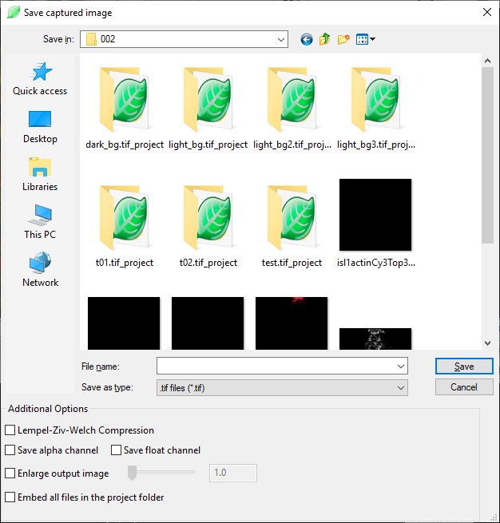

Figure 7‑3. Save captured image dialog.

In the pop-up dialog (Figure 7‑3), input the desired file name for the captured image. There are three additional options that you can check before saving the image.

**Lempel-Ziv-Welch Compression.** The captured image is saved in a TIFF file with the LZW compression. LZW is a lossless compression method, so that the file size is reduced depending on the useful information in the file.

**Save alpha channel.** An alpha channel is saved in addition to the RGB channels. The alpha channel allows overlaying the rendered data on a different background.

**Save float channel.** When this option is checked, each channel (RGBA) of the output image will be stored with 32-bit floating point numbers. FluoRender renders everything using floating point frame buffers. Therefore, saving a captured image using the floating-point numbers maximize the precision. You can use an image editing tool, such as Adobe Photoshop to make further adjustments to the captured image without losing the dynamic range. Saving floating-point number images when the HDR (high dynamic range) mode is one way to present the results on non-HDR displays. See Chapter 22 for more information on the HDR mode.

**Enlarge output image.** Check this option and the enlargement factor becomes available. The render view will be rendered at the enlarged size and saved. Both the width and height of the render view are enlarged by the factor.

|  |  |
| --- | --- |
|  | For example, when you set the enlargement factor to 4, it renders the data as if it were connected to a display 4x4=16 times larger. Make sure your graphics card can support an output image this large. If the program stops responding, set a small number and capture again. |

**Embed all files in the project folder.** If you choose to save a project along with the captured image, check this option so that all original data files are resaved in the project.

## Full Screen Mode (Microsoft Windows Only)

You can enter a full screen mode so that the user interface of FluoRender occupies the entire display area. Use the menu Windows ->Full screen to enter or leave the full screen mode.

 **Full Screen.** Enter full screen mode. Window title and borders are hidden.

 **Full Screen.** Leave full screen mode.

You can also let the rendering area of a render view to occupy an entire display area. Use the button at the top right corner of a render view panel to enter render view full screen mode. Use the Esc key on a keyboard to leave the render view full screen mode.

## Standard Orthographic Views

Six standard orthographic views can be selected from the drop-down list for each render view: +X, -X, +Y, -Y, +Z, and -Z. Each view sets the viewing angle of data from an orthographic axis. When an orthographic view is selected, the 45 degree rotation lock is also enabled, so that the rotation of the view snaps to 45 increments. To quit a standard orthographic view, select “NA” from the list, or disable the 45 degree rotation lock and then rotate the view. When the view is rotated from one of the standard orthographic views, the orthographic view selection list is updated if a new standard orthographic view is achieved.

# Adjusting Volume Properties

When a visible volume channel is selected in the “Workspace” panel, its properties are shown in the “Property” panel (Figure 8‑1).

|  |  |
| --- | --- |
|  | When the visibility of a volume channel is disabled, its properties will not be loaded into the “Property” panel even if it is selected. |

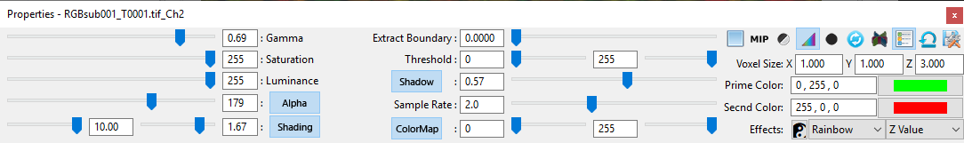

Figure 8‑1. Volume properties.

## Transfer Function Settings

A transfer function determines how intensity values from the original volume are mapped (or transferred) to colors that can be viewed on screen with the help of rendering techniques.

**Gamma.** It adjusts a nonlinear intensity and transparency mapping of the channel values, using a “Gamma curve”: $V_{out}=V_{in}^{γ}$. Increasing Gamma value maps originally intensity values to brighter colors; decreasing Gamma darkens them. Notice that transparency mapping is also influenced by the Gamma value. Therefore, setting a high Gamma value also makes rendering noisier. Or, it accentuates the low intensity values from the original volume, which usually makes the rendering (an integration calculation) darker. Considering such characteristics of Gamma, the direction of the slider is reversed by design.

**Saturation.** It sets a threshold value that maps to the maximum output, or “saturated” output. All intensity values greater than the setting are mapped to the brightest color. You can decrease this value to enhance low intensity signals, or, when the original scan is dark.

**Luminance.** It changes the luminance of the primary color assigned to the volume. This setting is linked to the primary color setting. An HSV color model is used for luminance calculation.

**Alpha**

**Alpha.** A multiplier to transparency mapping. Decreasing this value makes rendering more transparent. Alpha setting can be disabled. When disabled, volume transparency mapping is disabled. All voxels become opaque. It is useful when a thin layer of volume is visualized. For example, the image sections in Figure 7‑1 have Alpha disabled.

**Extract boundary.** It is a threshold value for gradient magnitude. First, the gradient magnitude for each voxel is calculated. Then, voxels with lower gradient magnitude values than the setting are excluded from rendering. Increasing this value extracts salient boundary structures.

**Threshold.** It sets two threshold values (low and high). Voxels of intensity values within the range of setting are rendered. Use this setting to exclude noisy signals.

|  |  |
| --- | --- |
|  | You can set a soft threshold in the settings. Soft thresholds can make edges soft. See Chapter 22 for more details. |

**Prime Color.** It is the base color of the selected volume channel. Color can be set by typing RGB numbers in the text input box, or from the color chooser. Shortcuts to most commonly used colors are also available. Double-click the text input box to first select all text. Then, type the following letter code for different predefined colors.

r – Red; g – Green; b – Blue; c – Cyan; m – Magenta; y – Yellow; w – White, k – Black.

|  |  |
| --- | --- |
|  | A dark color, such as black, can be used for bright background. |
|  | Alternatively, a random color can be assigned from the “Workspace” panel. See Chapter 6 for more details. |
|  | If excitation wavelength information is read from meta data, colors can be automatically assigned. See Chapter 22 and Appendices for more details. |

**Second Color.** It is the color to highlight selected structures within a volume. By default, the highlight color is calculated as the inverse of the primary color and changes with it. Once you choose a secondary color, it is fixed to your choice.

**ColorMap**

**Color map.** When enabled, it maps original intensity values to a color map. The range of the color map can be adjusted using the low and high values. Additionally, you can choose a color map type and mapping mode.

**Reverse color map.** Reverse the direction of the color map. For example, the rainbow color map is blue to red; the reversed rainbow color map is red to blue.



|  |  |  |
| --- | --- | --- |
| **Color Map Type** | | **Mapping Mode** |
| Rainbow |  | Intensity |
| Hot |  | Y value |
| Cool | E:\OneDrive\FluoRender\cm04_cool.png | X value |
| Diverging | E:\OneDrive\FluoRender\cm05_div.png | Gradient |
| Monochrome |  | Differential |
| High-key | (Uses prime color) |  |
| Low-key | (Uses prime color) |  |

 **Invert.** It inverts original intensity values so that high becomes low, and vice versa.

|  |  |
| --- | --- |
|  | Use inversion when a thick sample is mostly occupied with high intensity signals. Threshold setting can be used in conjunction with inversion to visualize deep structures. |

## Effect Settings

**Shading.** When enabled, it applies shading effect on local features. Higher local contrast can be achieved by lowering this value.

**Shading**

|  |  |
| --- | --- |
|  | Rendering can become too bright when this setting is enabled. In such a case, use “output adjustment” to lower the brightness. See Chapter 9 for more details. |

**Light.** It changes the ratio between highlight and shade.

**Shadow.** When enabled, it applies a shadow effect on rendering. The value setting controls the strength of the shadow effect.

**Shadow**

## MIP Render Mode

The maximum intensity projection mode can be enabled to visualize concentrations of high intensity values.

|  |  |
| --- | --- |
|  | When MIP is enabled, certain transfer function settings become unavailable, including luminance, Alpha, extract boundary, and threshold. In addition, MIP cannot be enabled in the Depth channel intermixing mode. Effect settings are available in MIP mode for shape and detail enhancement. |

## High Transparency Render Mode

 The high transparency mode is an alternative to MIP that allows you see high intensity structures inside of a volume channel more clearly. When the high transparency mode is on, low intensity signals are assigned with a higher degree of transparencies to reveal the underlying structures.

|  |  |
| --- | --- |
|  | The high transparency color map is recommended to be used together with the high transparency mode. Otherwise, 3D structures may look flat. Additionally, shading and shadow effects help bring out the details. |

## Quality Settings

**Sample rate.** It determines the density of slices for rendering one voxel. A higher setting improves rendering quality but slows down interaction speed.

|  |  |
| --- | --- |
|  | Slices are recalculated when viewing direction is changed. It makes sure that slices are always facing the view for little artifact. Therefore, user may experience varying rendering speed for an anisotropic volume. A “Variable sample rate” setting can be enabled to automatically adjust sample rate for both high quality and interactive speed. See Chapter 22 for more details. |
|  | A value higher than the slider’s range can be set using the numeric input. |

 **Interpolation.** When enabled, it uses trilinear interpolation for smooth rendering result. Otherwise, nearest neighbor interpolation is used.

|  |  |
| --- | --- |
|  | It is usually desirable to disable interpolation when a single image section is visualized, and exact intensity values are examined. See Chapter 10 for more details on rendering image sections. |

 **Smoothing.** When enabled, a low-pass filter is applied to rendered images to suppress high frequency noise.

|  |  |
| --- | --- |
|  | The filter window size changes with zoom level. The effect of low pass filtering is most obvious at high zoom levels. Therefore, smoothing is usually applied to reduce artifacts when zoomed in, for example, to remove artifact from trilinear interpolation. |

## Other Settings

**Voxel size.** It sets the spacing between two sample point in original data, or voxel size, in X, Y, Z directions. It uses the unit in scale bar settings. If metadata are correctly read from a scan, this setting is automatically determined. Otherwise, default values are used.

 **Synchronize group.** Once enabled, settings of current selection are propagated to other channels within the same group. Subsequent setting changes of any channel in the group are also automatically applied to other channels. Group channels of similar scans into one group and set up an initial setting with this function. Disable synchronization for finer adjustment of each channel.

** Depth mode in group.** It forces depth channel intermixing mode within a group, disregarding render view’s settings. Usually, a group in depth mode is layered on top of other channels and visualized without occlusion.

 **Show legend.** When enabled, it includes current selection into the render view legend. Legend of render view has to be enabled in order to see it. Exclude channels of low importance from legend to save render view space.

 **Save settings.** It saves all volume property settings into a file. The settings are restored to the saved values when FluoRender is launched.

|  |  |
| --- | --- |
|  | Settings such as color and luminance are determined when a volume is added to render view. Spacing settings can be read from a scan’s metadata. If correct spacing settings are read from metadata, the saved values are not used. |

## Synchronize Settings

You may use the synchronize group button  to synchronize all settings within a group, or you can synchronize settings with a slider adjustment individually. Double-click a setting’s name to just synchronize one setting. For a setting whose name is a push button (i.e., alpha, color map, shading, and shadow), double-click with the right mouse button.

|  |  |
| --- | --- |
|  | Use group synchronization for quick overall adjustment. Use individual synchronization for fine tuning. |

## Mode Combinations

This table lists different setting combinations for a volume. (0 = Mode OFF, 1 = Mode ON)

| High Transp | Alpha | MIP | Color Map | XYZ Mapping | Shading | Depth Attn | Availability | Note |
| --- | --- | --- | --- | --- | --- | --- | --- | --- |
| 0 | 0 | 0 | 0 | 0 | 0 | 0 | ✓ | Use clipping |
| 0 | 0 | 0 | 0 | 0 | 0 | 1 | ✓ | Not recommended |
| 0 | 0 | 0 | 0 | 0 | 1 | 0 | ✓ | Not recommended |
| 0 | 0 | 0 | 0 | 0 | 1 | 1 | ✓ | Not recommended |
| 0 | 0 | 0 | 0 | 1 | 0 | 0 | ✗ | XYZ mapping needs color map |
| 0 | 0 | 0 | 0 | 1 | 0 | 1 | ✗ | XYZ mapping needs color map |
| 0 | 0 | 0 | 0 | 1 | 1 | 0 | ✗ | XYZ mapping needs color map |
| 0 | 0 | 0 | 0 | 1 | 1 | 1 | ✗ | XYZ mapping needs color map |
| 0 | 0 | 0 | 1 | 0 | 0 | 0 | ✓ | Use clipping |
| 0 | 0 | 0 | 1 | 0 | 0 | 1 | ✓ | Not recommended |
| 0 | 0 | 0 | 1 | 0 | 1 | 0 | ✓ | Not recommended |
| 0 | 0 | 0 | 1 | 0 | 1 | 1 | ✓ | Not recommended |
| 0 | 0 | 0 | 1 | 1 | 0 | 0 | ✓ | Not recommended |
| 0 | 0 | 0 | 1 | 1 | 0 | 1 | ✓ | Not recommended |
| 0 | 0 | 0 | 1 | 1 | 1 | 0 | ✓ | Not recommended |
| 0 | 0 | 0 | 1 | 1 | 1 | 1 | ✓ | Not recommended |
| 0 | 0 | 1 | 0 | 0 | 0 | 0 | ✓ |  |
| 0 | 0 | 1 | 0 | 0 | 0 | 1 | ✓ |  |
| 0 | 0 | 1 | 0 | 0 | 1 | 0 | ✓ |  |
| 0 | 0 | 1 | 0 | 0 | 1 | 1 | ✓ |  |
| 0 | 0 | 1 | 0 | 1 | 0 | 0 | ✗ | XYZ mapping needs color map |
| 0 | 0 | 1 | 0 | 1 | 0 | 1 | ✗ | XYZ mapping needs color map |
| 0 | 0 | 1 | 0 | 1 | 1 | 0 | ✗ | XYZ mapping needs color map |
| 0 | 0 | 1 | 0 | 1 | 1 | 1 | ✗ | XYZ mapping needs color map |
| 0 | 0 | 1 | 1 | 0 | 0 | 0 | ✓ |  |
| 0 | 0 | 1 | 1 | 0 | 0 | 1 | ✗ | Color map not attenuated |
| 0 | 0 | 1 | 1 | 0 | 1 | 0 | ✓ |  |
| 0 | 0 | 1 | 1 | 0 | 1 | 1 | ✓ | Shading attenuated |
| 0 | 0 | 1 | 1 | 1 | 0 | 0 | ✓ |  |
| 0 | 0 | 1 | 1 | 1 | 0 | 1 | ✗ | Color map not attenuated |
| 0 | 0 | 1 | 1 | 1 | 1 | 0 | ✓ |  |
| 0 | 0 | 1 | 1 | 1 | 1 | 1 | ✓ | Shading attenuated |
| 0 | 1 | 0 | 0 | 0 | 0 | 0 | ✓ | Typical volume rendering |
| 0 | 1 | 0 | 0 | 0 | 0 | 1 | ✓ |  |
| 0 | 1 | 0 | 0 | 0 | 1 | 0 | ✓ |  |
| 0 | 1 | 0 | 0 | 0 | 1 | 1 | ✓ |  |
| 0 | 1 | 0 | 0 | 1 | 0 | 0 | ✗ | XYZ mapping needs color map |
| 0 | 1 | 0 | 0 | 1 | 0 | 1 | ✗ | XYZ mapping needs color map |
| 0 | 1 | 0 | 0 | 1 | 1 | 0 | ✗ | XYZ mapping needs color map |
| 0 | 1 | 0 | 0 | 1 | 1 | 1 | ✗ | XYZ mapping needs color map |
| 0 | 1 | 0 | 1 | 0 | 0 | 0 | ✓ |  |
| 0 | 1 | 0 | 1 | 0 | 0 | 1 | ✓ |  |
| 0 | 1 | 0 | 1 | 0 | 1 | 0 | ✓ |  |
| 0 | 1 | 0 | 1 | 0 | 1 | 1 | ✓ |  |
| 0 | 1 | 0 | 1 | 1 | 0 | 0 | ✓ |  |
| 0 | 1 | 0 | 1 | 1 | 0 | 1 | ✓ |  |
| 0 | 1 | 0 | 1 | 1 | 1 | 0 | ✓ |  |
| 0 | 1 | 0 | 1 | 1 | 1 | 1 | ✓ |  |
| 0 | 1 | 1 | 0 | 0 | 0 | 0 | ✓ | Typical MIP |
| 0 | 1 | 1 | 0 | 0 | 0 | 1 | ✓ |  |
| 0 | 1 | 1 | 0 | 0 | 1 | 0 | ✓ |  |
| 0 | 1 | 1 | 0 | 0 | 1 | 1 | ✓ |  |
| 0 | 1 | 1 | 0 | 1 | 0 | 0 | ✗ | XYZ mapping needs color map |
| 0 | 1 | 1 | 0 | 1 | 0 | 1 | ✗ | XYZ mapping needs color map |
| 0 | 1 | 1 | 0 | 1 | 1 | 0 | ✗ | XYZ mapping needs color map |
| 0 | 1 | 1 | 0 | 1 | 1 | 1 | ✗ | XYZ mapping needs color map |
| 0 | 1 | 1 | 1 | 0 | 0 | 0 | ✓ | Typical color mapped MIP |
| 0 | 1 | 1 | 1 | 0 | 0 | 1 | ✗ | Color map not attenuated |
| 0 | 1 | 1 | 1 | 0 | 1 | 0 | ✓ |  |
| 0 | 1 | 1 | 1 | 0 | 1 | 1 | ✓ | Shading attenuated |
| 0 | 1 | 1 | 1 | 1 | 0 | 0 | ✓ |  |
| 0 | 1 | 1 | 1 | 1 | 0 | 1 | ✗ | Color map not attenuated |
| 0 | 1 | 1 | 1 | 1 | 1 | 0 | ✓ |  |
| 0 | 1 | 1 | 1 | 1 | 1 | 1 | ✓ | Shading attenuated |
| 1 | 0 | 0 | 0 | 0 | 0 | 0 | ✗ | No effect |
| 1 | 0 | 0 | 0 | 0 | 0 | 1 | ✗ | No effect |
| 1 | 0 | 0 | 0 | 0 | 1 | 0 | ✗ | No effect |
| 1 | 0 | 0 | 0 | 0 | 1 | 1 | ✗ | No effect |
| 1 | 0 | 0 | 0 | 1 | 0 | 0 | ✗ | No effect |
| 1 | 0 | 0 | 0 | 1 | 0 | 1 | ✗ | No effect |
| 1 | 0 | 0 | 0 | 1 | 1 | 0 | ✗ | No effect |
| 1 | 0 | 0 | 0 | 1 | 1 | 1 | ✗ | No effect |
| 1 | 0 | 0 | 1 | 0 | 0 | 0 | ✗ | No effect |
| 1 | 0 | 0 | 1 | 0 | 0 | 1 | ✗ | No effect |
| 1 | 0 | 0 | 1 | 0 | 1 | 0 | ✗ | No effect |
| 1 | 0 | 0 | 1 | 0 | 1 | 1 | ✗ | No effect |
| 1 | 0 | 0 | 1 | 1 | 0 | 0 | ✗ | No effect |
| 1 | 0 | 0 | 1 | 1 | 0 | 1 | ✗ | No effect |
| 1 | 0 | 0 | 1 | 1 | 1 | 0 | ✗ | No effect |
| 1 | 0 | 0 | 1 | 1 | 1 | 1 | ✗ | No effect |
| 1 | 0 | 1 | 0 | 0 | 0 | 0 | ✗ | No effect |
| 1 | 0 | 1 | 0 | 0 | 0 | 1 | ✗ | No effect |
| 1 | 0 | 1 | 0 | 0 | 1 | 0 | ✗ | No effect |
| 1 | 0 | 1 | 0 | 0 | 1 | 1 | ✗ | No effect |
| 1 | 0 | 1 | 0 | 1 | 0 | 0 | ✗ | No effect |
| 1 | 0 | 1 | 0 | 1 | 0 | 1 | ✗ | No effect |
| 1 | 0 | 1 | 0 | 1 | 1 | 0 | ✗ | No effect |
| 1 | 0 | 1 | 0 | 1 | 1 | 1 | ✗ | No effect |
| 1 | 0 | 1 | 1 | 0 | 0 | 0 | ✗ | No effect |
| 1 | 0 | 1 | 1 | 0 | 0 | 1 | ✗ | No effect |
| 1 | 0 | 1 | 1 | 0 | 1 | 0 | ✗ | No effect |
| 1 | 0 | 1 | 1 | 0 | 1 | 1 | ✗ | No effect |
| 1 | 0 | 1 | 1 | 1 | 0 | 0 | ✗ | No effect |
| 1 | 0 | 1 | 1 | 1 | 0 | 1 | ✗ | No effect |
| 1 | 0 | 1 | 1 | 1 | 1 | 0 | ✗ | No effect |
| 1 | 0 | 1 | 1 | 1 | 1 | 1 | ✗ | No effect |
| 1 | 1 | 0 | 0 | 0 | 0 | 0 | ✓ | Flat result |
| 1 | 1 | 0 | 0 | 0 | 0 | 1 | ✓ |  |
| 1 | 1 | 0 | 0 | 0 | 1 | 0 | ✓ |  |
| 1 | 1 | 0 | 0 | 0 | 1 | 1 | ✓ |  |
| 1 | 1 | 0 | 0 | 1 | 0 | 0 | ✗ | XYZ mapping needs color map |
| 1 | 1 | 0 | 0 | 1 | 0 | 1 | ✗ | XYZ mapping needs color map |
| 1 | 1 | 0 | 0 | 1 | 1 | 0 | ✗ | XYZ mapping needs color map |
| 1 | 1 | 0 | 0 | 1 | 1 | 1 | ✗ | XYZ mapping needs color map |
| 1 | 1 | 0 | 1 | 0 | 0 | 0 | ✓ |  |
| 1 | 1 | 0 | 1 | 0 | 0 | 1 | ✓ |  |
| 1 | 1 | 0 | 1 | 0 | 1 | 0 | ✓ |  |
| 1 | 1 | 0 | 1 | 0 | 1 | 1 | ✓ |  |
| 1 | 1 | 0 | 1 | 1 | 0 | 0 | ✓ |  |
| 1 | 1 | 0 | 1 | 1 | 0 | 1 | ✓ |  |
| 1 | 1 | 0 | 1 | 1 | 1 | 0 | ✓ |  |
| 1 | 1 | 0 | 1 | 1 | 1 | 1 | ✓ |  |
| 1 | 1 | 1 | 0 | 0 | 0 | 0 | ✓ | MIP increased transparency |
| 1 | 1 | 1 | 0 | 0 | 0 | 1 | ✓ |  |
| 1 | 1 | 1 | 0 | 0 | 1 | 0 | ✓ |  |
| 1 | 1 | 1 | 0 | 0 | 1 | 1 | ✓ |  |
| 1 | 1 | 1 | 0 | 1 | 0 | 0 | ✗ | XYZ mapping needs color map |
| 1 | 1 | 1 | 0 | 1 | 0 | 1 | ✗ | XYZ mapping needs color map |
| 1 | 1 | 1 | 0 | 1 | 1 | 0 | ✗ | XYZ mapping needs color map |
| 1 | 1 | 1 | 0 | 1 | 1 | 1 | ✗ | XYZ mapping needs color map |
| 1 | 1 | 1 | 1 | 0 | 0 | 0 | ✗ | No effect |
| 1 | 1 | 1 | 1 | 0 | 0 | 1 | ✗ | Color map not attenuated |
| 1 | 1 | 1 | 1 | 0 | 1 | 0 | ✗ | No effect |
| 1 | 1 | 1 | 1 | 0 | 1 | 1 | ✗ | No effect |
| 1 | 1 | 1 | 1 | 1 | 0 | 0 | ✗ | No effect |
| 1 | 1 | 1 | 1 | 1 | 0 | 1 | ✗ | Color map not attenuated |
| 1 | 1 | 1 | 1 | 1 | 1 | 0 | ✗ | No effect |
| 1 | 1 | 1 | 1 | 1 | 1 | 1 | ✗ | No effect |

# Output Adjustment

Most volume property settings are applied in 3D space before rendering and channel intermixing. To make finer adjustments to rendered and intermixed results in 2D image space, FluoRender provides a set of output adjustments (Figure 9‑1).

Disregarding the number of volume channels to be visualized, the final output has three fixed color channels: red, green, and blue. For each color channel, there are three adjustment settings: Gamma, luminance, and equalization.

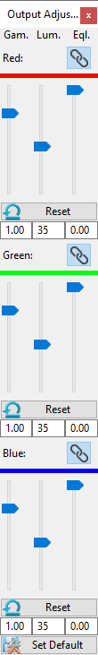

Figure 9‑1. Output adjustment panel.

**Gamma.** It uses a Gamma curve to remap the color intensities. Increasing Gamma brightens the overall result in a nonlinear fashion.

**Luminance.** It is a multiplier that modulates the color intensities. Increasing luminance brightens the result linearly.

**Equalization.** It enhances low color intensities and increases local contrast at the same time. It also equalizes high and low intensity signals.

Settings for red, green, and blue channels can be linked. Use the **link** button  to synchronize settings of any combination of red, green, and blue channels.

Settings of each channel can be reset independently using “**Reset**” .

|  |  |
| --- | --- |
|  | Under certain circumstances, the color channel settings are automatically synchronized to maintain the hue of output color. For example, when a volume channel’s color is set to white, the settings are synchronized. It is still possible to “unlink” the color channels and adjust individually. |

The scope of the application of the settings can vary when different items are selected from the “workspace” panel. When a volume channel is selected in the “Workspace” panel, the output adjustment settings are applied to the group of selection. When a render view is selected in the “Workspace” panel, the output adjustment settings are applied to the selected render view.

|  |  |
| --- | --- |
|  | The equalization settings behave differently based on selections. When a render view is selected, equalization does not enhance local contrast. It suppresses high color intensities only, which can be used to recover details at colocalized regions in the composite channel intermixing mode. |

# Clipping Volumes

When volume property settings become inadequate to reveal occluded structures of thick scans, clipping planes provide an easy solution. For each volume channel, a group of six clipping planes can be adjusted independently. They are +X, -X, +Y, -Y, +Z, and -Z, which are also color-coded as red, magenta, green, yellow, blue, and cyan, for visual distinction.

## Clipping Plane Display Controls

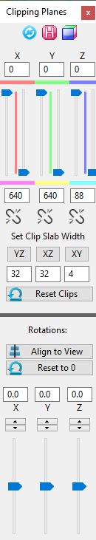

Figure 10‑1. Clipping plane panel.

The top three buttons control how clipping planes are displayed.

 **Synchronize all channels.** Enable clipping plane synchronization so that all channels use the same clipping plane settings.

 **Display hold.** Enable clipping plane display hold so that clipping planes are displayed even the mouse cursor is moved outside of the panel.

 **Display mode.** There are five display modes for clipping planes. Click this button to cycle through all modes.

|  |  |
| --- | --- |
| E:\DESIGNS\FluoRender Arts\list_icons\convert\clip_normal.png | **Normal.** Color-coded planes with high opacity. |
| E:\DESIGNS\FluoRender Arts\list_icons\convert\clip_frame.png | **Wireframe.** Only wireframe of the planes are shown. |
| E:\DESIGNS\FluoRender Arts\list_icons\convert\clip_low.png | **Low opacity.** No colors are assigned to planes, which are shown with low opacity. |
| E:\DESIGNS\FluoRender Arts\list_icons\convert\clip_low_back.png | **Back plane, low opacity.** Only the back planes are shown with low opacity. |
| E:\DESIGNS\FluoRender Arts\list_icons\convert\clip_normal_back.png | **Back plane, normal.** Only the back planes are shown in normal mode. |

## Clipping Plane Translations

When the mouse cursor is moved into the clipping plane panel (Figure 10‑1. Clipping plane panel), the clipping planes of selected volume channel are also visualized in the render view. To adjust one clipping plane, first find its color coding from the render view, and then change its position using the corresponding slider. Data outside of the space between two opposite clipping are excluded.

The movement of two opposite clipping planes can be linked, so that moving one will also move the other. To link the movement, click the link button . When the space between two opposite clipping planes is reduced to one (value difference between two clipping planes becomes one), it becomes a visualization of an image section. The section views in Figure 7‑1 are generated using this method. The space between two opposite clipping planes is also called a clip slab, whose width can be set using the controls under link buttons. To set a clip slab width, first input a number into the numeric box, and then click the button above the numeric box. For example, we want to look at an XY image section. An XY image section moves along the Z axis. So, in Figure 10‑1, we look at the numeric box with value “4” under the “XY” button, which is also under the “Z” axis. We change its value to “1”, and then click the “XY” button. +Z and -Z clipping planes are moved and linked. When we change any of +Z and -Z clipping planes, we are browsing through the XY image sections.

|  |  |
| --- | --- |
|  | Alternatively, you can right-click a slider handle to quickly set clip slab width to one. |
|  | You can use keyboard shortcuts to move clip slabs. See Appendices for more details. |

Use the reset button  to reset all clipping plane translations.

Clipping plane translations of all channels in one render view can be synchronized. To synchronize the settings, enable “Synch Channels”.

## Clipping Plane Rotations

The group of six clipping planes can be rotated independently of the selected volume channel. There are two methods for clipping plane rotations.

To directly adjust clipping plane rotations, change the rotation values using sliders or numeric boxes.

To rotate clipping planes using render view rotation controls, first rotate the view to an angle, so that the user is looking straight at a desired XY plane. Then, click “Align to View” to rotate clipping planes to align with the intended XY plane. This features is useful when a scan is tilted with an angle.

Use the reset button  to reset all clipping plane rotations.

|  |  |
| --- | --- |
|  | You can save a sub volume defined by the clipping planes using the bake feature. See Chapter 5 for more details. |

# Adjusting Mesh Properties

## Basic Mesh Properties

Mesh objects provide clear boundary information. When a mesh object is selected from the “Workspace” panel, its properties are loaded into the property panel (Figure 11‑1). Change these properties



Figure 11‑1. Mesh properties.

### Material properties

**Diffuse color.** The base color of the object.

**Specular color.** The color of the object’s highlight.

**Shininess.** The size of the highlight.

### Other properties

**Transparency.** Lower is more transparent. 1 means opaque.

|  |  |
| --- | --- |
|  | Depth peeling is used for rendering transparent mesh objects, as well as rendering with volumes. For higher transparency quality, increase the number of peeling layers in the settings dialog. See Chapter 22 for more details. |

**Shadow.** When enabled, it adds a shadow effect, whose strength can be adjusted with the slider.

**Lighting.** It enables/disables lighting effect. When both shadow and lighting effects are disabled, mesh objects look flat.

**Scaling.** It is a multiplier to the overall scale of a mesh object. Use it to enlarge or shrink a mesh object.

## Mesh Manipulations

Mesh manipulations are enabled from the “Workspace” panel, though context menu. When enabled, the settings are loaded into the “Property” panel (Figure 11‑2).



Figure 11‑2. Mesh manipulations.

Mesh manipulations allow translate, rotate, scale a mesh object within render view. These settings are changed through numeric input boxes in the user interface.

|  |  |
| --- | --- |
|  | When a mesh object is saved, these manipulation settings are lost. Save a project to save these settings. |

# Movie Playback and Export

This panel enables a user to animate certain aspects of a volume within the rendering view, and is located at the bottom left of the program by default.

The bottom of the panel remains constant for all the tabs. The type of playback depends on which tab is currently visible (Basic vs. Advanced.) If one of the other tabs is in view, the last tab selected determines the playback mode.



Figure 12‑1. Main movie playback controls.

**FPS.** The frames per second text box allows a user to determine how many frames will be exported per second to either a movie file, or a sequence of TIF files. For example, a movie that is 5 seconds long with 30 FPS will have a total of 150 frames in the movie, or 150 TIF files created. A higher FPS increases the quality and “smoothness” of a movie, but also contributes to a larger file.

**Capture.** This drop-down selection box enables a user to choose which rendering frame to playback on and record to export to file. Having multiple rendering frames is not common but sometimes useful for side-by-side comparisons. In most cases, there is only 1 frame to render, and subsequently, only 1 option in this drop-down menu.

 **Help.** This button is a link to open a browser to this reference document.

 **Play.** The “Play” button allows a user to preview what an exported movie will look like.

 **Play with Script.** When a 4D script is enabled in the “Record/Export” panel, the play button changes to indicate the script will be executed along with the movie play back. See Chapter 13 for more details about 4D scripting.

|  |  |
| --- | --- |
|  | 4D script is automatically on after component generation. See Chapter 17 for more details. |

 **Rewind / Reset.** This button returns the playback to the beginning, at time zero, and time frame zero (for a time sequence. If this is pressed during playback or recording, the playback and recording is terminated.

**Time Slider.** This slider indicates where along the movie you are. You can move the slider to any point to visualize a frame at that point in time.

**Time Text.** This text box updates with the slider during playback. You may also edit this to a particular time in the movie (in seconds).

** Save / Export.** This button allows you to export a final movie once you feel the preview playback is adequate.

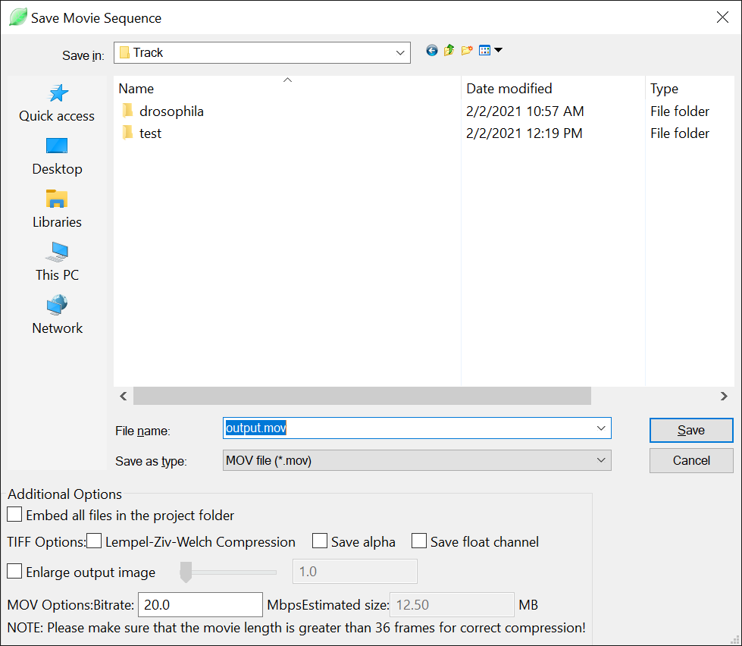

Figure 12‑2. Save or export a movie or time sequence.

Once you click save, you will see several options to export. You can select a location to save the file, as well as a name for the file. If you export TIF files, your filename will be appended with the frame number for each TIF frame. There are two types to save a file as. The default is “MOV”, which is a QuickTime format of movie file. The other option is for a TIF file sequence.

These additional options are available to check before you save the captured image sequence.

**Embed all files in the project folder.** If you choose to save a project along with the movie export, you can check this option to save all original data in the project.

**Lempel-Ziv-Welch Compression.** If you choose to export the movie as an image sequence of TIFF files, check this option to compress with the LZW method. LZW is a lossless compression method, which reduces file size based on useful information in an image.

**Save alpha.** If you choose to export the movie as an image sequence of TIFF files, check this option to save an alpha channel in addition to the RGB channels for each image. You can use the alpha channel to overlay the rendered data on a different background using a compositing software package.

**Save float.** When this option is checked, each channel (RGBA) of the output image will be stored with 32-bit floating point numbers. FluoRender renders everything using floating point frame buffers. Therefore, saving a captured image using the floating-point numbers maximize the precision. You can use an image editing tool, such as Adobe Photoshop to make further adjustments to the captured image without losing the dynamic range. Saving floating-point number images when the HDR (high dynamic range) mode is one way to present the results on non-HDR displays. See Chapter 22 for more information on the HDR mode. Notice that a movie sequence saved in the floating-point format significantly increases its size on disk.

**Enlarge output image.** Check this option and the enlargement factor becomes available. The render view will be rendered at the enlarged size and saved. Both the width and height of the render view are enlarged by the factor.

|  |  |
| --- | --- |
|  | For example, when you set the enlargement factor to 4, it renders the data as if it were connected to a display 4x4=16 times larger. Make sure your graphics card can support an output image this large. If the program stops responding, set a small number and capture again. |

**Bitrate.** You can set the bitrate to adjust the quality of a QuickTime movie file. The estimated size, based on the Mb/s is on the right. As movies get larger and longer, this estimation becomes less accurate. One Mb/s would approximately be 8 Mb (mega bit) in size if the movie is 8 second long. This would be only about 1 MB (megabyte).

|  |  |
| --- | --- |
|  | In order to successfully compress a MOV file, a movie is required to contain at least 36 frames in total. The total number of movie frames is calculated by multiplying FPS to movie length in seconds. For example, at 30 FPS, a 1 second long movie will be too short to be successfully compressed, since it contains only 30 frames. You can either increase the movie length or export individual frames as TIFF files. |

## Basic Movie Operations

Basic operations include axis-aligned rotations (X, Y, and Z), time frame progression (from a set of volumes organized as subsequent times of the same data) and alternating between a set of differing volumes. Based on the first volume loaded into the program, FluoRender automatically chooses the most common basic playback option in this panel for you.

|  |  |
| --- | --- |
|  | If you load a file that meets the naming convention for a time sequence, the “Batch” feature will be disabled. To use the batch feature, make sure the first volume you load does NOT meet the time sequence convention. The default convention is a “\_T”, followed by a number designating the time of that frame. |

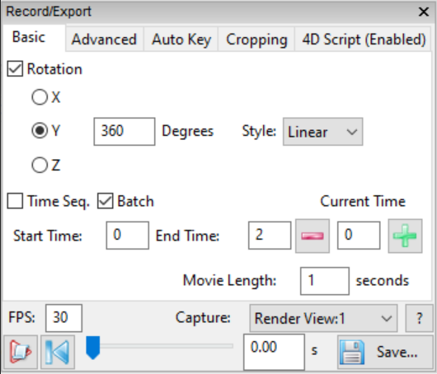

Figure 12‑3. Basic movie playback controls.

**Axis aligned rotations.** Rotations are available axis-aligned in the 3 primary dimensions, X, Y, and Z. The default is Y. When this option is checked, the render view will rotate the volume every frame during playback. The number inside the “Degrees” text box is the number of degrees you wish to rotate for the length of the movie. The number of degrees per frame depends on the length of the movie and the frames per second. For example, if a movie is 5 seconds long, and you are rotating 360 degrees along the Y axis, you will see 72 degrees of rotation in the Y axis when you push the “Play” button. Two options are available for rotation speed control.

* + **Linear.** The rotation speed is constant from the beginning to the end of a movie.
  + **Smooth.** The rotation accelerates and then decelerates through the movie.

**Time sequence.** A time sequence is only available if you loaded one of a set of volumes in a directory that meet the time sequence convention. If you have a directory of 100 files, each labelled “image\_T000.tif” through “image\_T099.tif”, for example, you have a valid time sequence when your first volume to load is any 1 of the 100 files. FluoRender will automatically check “Time Seq.” for you, set the start, end, and current times (based on the # of the file you loaded), and update the movie time slider to where this file is in the sequence.

* + The  button will take one step backwards in time, loading the previous time volume and updating the time slider and the movie time (right of the slider).
  + The  button will take one step forward in time. If the next step is after the total number of frames, the time will wrap around to the beginning. The reverse will occur for the minus button.
  + The start time and end time are set automatically, but you may want to only play back a certain subset of the time frames. For example, out of 100, you may choose to play frames 20-30. FluoRender will correct times that are out of range, including negative numbers.
  + The movie length is unique to the Basic tab of movie making. You can choose how long (in real seconds) you want the exported movie file to be.

|  |  |
| --- | --- |
|  | Although you select both a movie time in this panel, as well as a FPS (Frame Per Second) for your movie, the playback inside of FluoRender may not preview this in real time. Each frame is rendered during playback as fast as your computer and graphics card can handle. Often, to get the quality of movie you desire, the preview will be much slower than the actual exported file (which WILL honor the time constraints you select). |

**Batch sequence.** A batch is a set of several volumes in a directory that may or may not be related. The playback works exactly the same as with a time sequence, but will only have up to the number of frames that matches the number of files in the directory for which your first loaded volume was located. For example, if you have “volumeA.tif”, “volumeB.tif”, and “volumeC.tif”, in a directory, and you load “volumeA.tif”, this playback will alternate between the three files.

For some raw formats, such as Leica LIF, multiple series can be saved in one file. These series are independent images like a batch sequence. Turn on batch sequence and set a series number to load the image. If the image of the series happens to be a time sequence, check the time sequence to enable play back. The time sequence and batch sequence settings are mutually exclusive.

|  |  |
| --- | --- |
|  | The difference between a time sequence and a batch sequence lies in how they are loaded. For a time sequence, the file information is read only from the first file in the sequence. It assumes that all files in the sequence have the same size, channel, and spacing. When a time point is loaded, it simply replaces the existing one. For a batch sequence, everyone in the sequence is considered as an independent file, whose properties can vary. Therefore, memory is released and reallocated for every time point. |

## Advanced Key Frame Movies

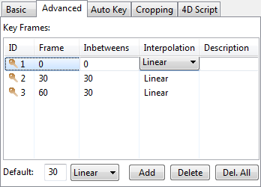

Figure 12‑4. Advanced movie playback controls.

This tab allows for much more advanced types of movies. Unfortunately, however, time and batch sequences are not available in combination with key frames. Instead, a user manipulates the volume manually in the render view, sets a frame, and repeats as many times as desired. FluoRender then linearly or smoothly interpolates between the several key frames to playback. Because this tab explicitly states the number of frames between each key, there is no option to select movie length (in seconds). Only a FPS is necessary. You can determine the movie time by dividing the total number of frames in the table by the current FPS. For example, if you have 90 frames, and your FPS is 30, the movie will be 3 seconds long.

FluoRender will remember and key frame the following aspects of a volume:

* Rotation transformations
* Translation transformations
* Scale transformations (zoom)
* Cropping (from the Crop panel on the right of the program)
* Enabling and disabling visibility via the “on/off” property in the Workspace panel
* Channel intermixing modes (Layered, Depth, and Composite)
* Perspective angle of view
* Timepoint index of a time sequence

|  |  |
| --- | --- |
|  | The time slider has different meanings when the Basic or Advanced animation settings are used. When the Advanced animation settings are used and keyframes are set, use the Basic animation settings to change the time index of a time sequence, as the time slider is used to represent the keyframes. |

The columns for the key frame table are as follows:

**ID.** This is the ID number of the key. If you choose to, you may reorder keys by dragging and dropping them anywhere in the list. The ID is generated starting at 1 and increases during the runtime of FluoRender. The ID is usually the only way to decipher between the various key frames created, unless you add a “Description” (see below).

**Frame.** This indicates at which frame this particular key is active. You may reset the currently viewed key by double clicking on that key.

**Inbetweens.** This column indicates how many frames exist between this key and the previous key. The first key in the list always has this number as zero.

**Interpolation.** This can be either “Linear”, which means between the keys, frames are exactly 1/#inbetweens steps from one key to the next, or “Smooth”, which means the frames slowly ramp up to the transition, and slowly ramp down to the end of the key frame in an “S-curve” fashion. This can be changed by clicking on the “Linear” or “Smooth”.

**Description.** This is initially empty for each frame. You can click and add your own description for each frame to help you determine which key it is.

Below the table is a list of options.

** Default.** This has a text box and a drop down menu. The text box is the number of default frames to add to each key frame when one is created. This can always be changed per key by selecting the current number on the table. The drop down is again, either “Linear” or “Smooth”. You can select the default, but may also choose what each key uses individually by clicking on the table.

** Add.** Add a new key frame to the list, saving the current rendering transformations, croppings, and channel visibilities.

** Delete.** Delete the selected key frame.

 **Delete All.** Delete all of the key frames in the list.

## Automatic Key Generation



Figure 12‑5. Auto key options.

This tab allows a user to select an automatic key generation scheme from a list, and then generate key frame animations. You first choose an auto key type, then click “Generate”. Or, you can double-click an option. This brings you to the “Advanced” panel, which contains automatically generated keys. You can then interact with the automatically generated keys using the same controls provided in the “Advanced” panel.

Currently, we provide three options for automatic key generation. More options will be added into the future versions of FluoRender. These three options are:

**Channel Combination nC1.** It sets a key for each isolated channel within a multi-channel data set. You can browse each channel individually with this setting.

**Channel Combination nC2.** It sets a key for each two-channel pair within a multi-channel data set. You can use this function to visualize colocalization regions between any two-channel combinations.

**Channel Combination nC3.** Similar to nC2, it sets a key for each triple-channel combination. You can use this setting to visualize all colocalization cases of three channels.

## Frame Cropping



Figure 12‑6. Frame cropping controls.

This tab allows a user to crop what is captured in the rendering frame to a smaller area. Often, the important data is not covering the whole render view. Recording the whole frame, including a lot of empty space, can be wasteful and make a movie larger than necessary. When enable cropping is selected, you will see a yellow rectangle in the render frame indicating the pixels that will be read and used in the movie file. The yellow rectangle is automatically based on the area that is covered by data. See Figure 3‑1and Figure 3‑2. The “Center X” and “Y” fields allow you to modify where the center of the movie will take place in pixel coordinates. In addition, you can modify the “Size Width” and “Height”. The yellow box will not be in the output but will remain visible if “Enable Cropping” is selected. The “Reset” button recalculates the cropping region, if you have rotated, zoomed, or panned the view. The cropping square does not resize with the program window as you resize it on your computer, but you can click “Reset” to get the snug cropping region back in the render view.

# Batch Processing with 4D Scripts

## 4D Script Settings

A 4D script can be enabled for batch processing a time sequence. The execution of a 4D script is associated with movie play back functions. You can execute a 4D script by viewing a time sequence, or you can step through time to have a finer control of the batch processing. 4D scripts are managed in the “4D Script” tab of the “Record/Export” panel (Figure 13‑1).

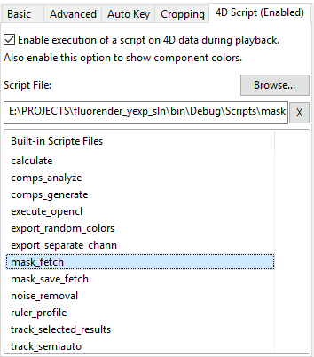

Figure 13‑1. 4D script settings.

The 4D script tab has these controls:

**Enable 4D script.** When you check this option, 4D script execution is enabled. The name of the 4D script tab changes to indicate the enabling of 4D script. The play button in the movie control also changes to indicate that a 4D script will be executed if you play back the movie or step through time. Enabling 4D script execution also enables the visualization of label masks, which uses different colors to represent components. Components are automatically generated with the “Component Analysis” window, or manually assigned with the “Tracking” window.

|  |  |
| --- | --- |
|  | 4D script is automatically on after component generation. See Chapter 17 for more details. |
|  | Remember to turn off the 4D script setting when you only need playing back a time sequence. |

**Browse…** It opens a file dialog for choosing a 4D script file from the hard drive.

**Script File.** It shows the currently selected 4D script file. If no script file is loaded and 4D script is enabled, it is only used to show component colors.

**X.** It clears the script file so that no script will be executed, although 4D script might still need to be on to show the component colors.

**Built-in Script Files.** It lists all built-in script files in the “Scripts” directory where FluoRender is installed. You can click the name of a script file to load it.

## 4D Script Files

A 4D script file is a text file formatted into a hierarchy of a series of commands, each with a certain number of parameters. When the time point of a 4D sequence in FluoRender is changed, the commands are applied sequentially to the current time point. Therefore, you can batch process the entire 4D sequence by simply playing it back.

The structure of a 4D script file is:

|  |
| --- |
| **[tasks]**  **tasknum=***(user defined number)*  **[tasks/task***(task sequence number)***]**  **type=***(task name)*  *(task-specific parameter)***=***(user defined parameter value)*  *(…)*  *(task-specific parameter)***=***(user defined parameter value)*  **[tasks/task***(task sequence number)***]**  **type=***(task name)*  *(task-specific parameter)***=***(user defined parameter value)*  *(…)*  *(task-specific parameter)***=***(user defined parameter value)*  *(…)* |

List 13‑1. The 4D script structure.

A script file starts with **[tasks]**, which is followed by the total number of tasks specified with **tasknum=**. Each task starts with **[tasks/taskn]**, where n is a number starting with 0 and increased by 1 for each subsequent task. You can script as many tasks as you want in one file. They can be different tasks performing different operations on the data, or the same task with different parameters. You can even use the script to run the same task repeatedly for operations such as filtering.

### Common parameters

A task in a script file can be executed before or after loading a new time point. Usually, a task is applied to the current time point data before loading a new time point. However, to make sure all time points in a sequence are processed, the start and end time point may need special handling. Additionally, a task may be applied to a selected channel in a multichannel data set. Or, the task is applied to all channels. The common parameters of a task are used to determine these behaviors.

|  |  |  |  |
| --- | --- | --- | --- |
| Parameter | Purpose | Values | |
| time\_mdoe | Task is applied before or after loading a time point | 0 | Task is applied before loading the new time point |
| 1 | Task is applied after loading the new time point |
| start\_frame | Task is applied to the start time point when time\_mode=1 | 0 | Task is not applied to the start time point |
| 1 | Task is applied to the start time point |
| end\_frame | Task is applied to the end time point when time\_mode=0 | 0 | Task is not applied to the end time point |
| 1 | Task is applied to the end time point |
| chan\_mode | Task is applied to the selected channel or all channels | 0 | Task is applied to the selected channel |
| 1 | Task is applied to all channels |

4D script examples, which could be used as templates, can be found in the /Scripts folder of FluoRender’s installation directory.

## 4D Script Tasks

The number of 4D script tasks has been increasing for more flexibility in batch processing. Currently supported tasks are follows.

### Calculate

Task name (type): **calculate**

Purpose: It loads two channels for calculation and generates a new channel from the calculation result.

Parameters:

**vol\_a** – The first volume channel for the operand A. It is the index value of all shown channels.

**vol\_b** – The second volume channel for the operand B. It is the index value of all shown channels.

**operator** – The operator for the calculation. Supported values include “subtract”, “add”, “divide”, “colocate”, “fill”. They correspond to the operators in the Calculation dialog window.

Example 1, subtract a membrane channel from a nucleus channel for improved separation. The nuclei are in the first channel (index value is 0); the membranes are in the second channel (index value is 1).

|  |
| --- |
| [tasks]  tasknum=1  [tasks/task0]  type=calculate  time\_mode=0  start\_frame=0  end\_frame=1  vol\_a=1  vol\_b=0  operator=subtract |

List 13‑2. Example 1 of a 4D script for membrane subtraction from nucleus channel.

### Component analysis

Task name (type): **comp\_analysis**

Purpose: It analyzes the intensity values of selected structures in each time point. The component analysis result is the same as in the “Component Analysis” window.

Parameters:

**consistent** – When there are multiple bricks, set the consistent parameter to 1 make sure components fall on brick borders are using the same component IDs.

**selected** – Set the selected parameter to 1 to only analyze the selected components using a brush.

**savepath** – The path and file name to save the analysis results.

|  |  |
| --- | --- |
|  | You can use the paint brush tool to generate a selection mask at the first time point and run a script with this task. All subsequent time points will use the save selection mask from the first time point. You can generate different selection masks for each time point and save the masks. You need to add a second task in the script to fetch mask (fetch\_mask) for each time point. Additionally, you can use the tracking functions to generate the selection mask for each time point. In this case, the task is selection tracking (selection\_tracking). |

Example 1, use the paint brush tool to define a region of interest at the first time point, and then use it for all subsequent time points for signal intensity analysis:

|  |
| --- |
| [tasks]  tasknum=1  [tasks/task0]  type=comp\_analysis  time\_mode=0  start\_frame=0  end\_frame=1  chan\_mode=0  consistent=1  selected=0  savepath=./Analysis/FilenamePrefix |

List 13‑3. Example 1 of a 4D script for component analysis.

Example 2, use saved selection masks at each time point for component analysis:

|  |
| --- |
| [tasks]  tasknum=2  [tasks/task0]  type=fetch\_mask  time\_mode=0  start\_frame=0  end\_frame=1  chan\_mode=0  mask=0  label=1  [tasks/task1]  type=comp\_analysis  time\_mode=0  start\_frame=0  end\_frame=1  chan\_mode=0  consistent=1  selected=0  savepath=./Analysis/FilenamePrefix |

List 13‑3. Example 2 of a 4D script for component analysis.

Example 3, use FluoRender’s tracking feature to generate selection mask at each time point and perform component analysis:

|  |
| --- |
| [tasks]  tasknum=4  [tasks/task0]  type=selection\_tracking  time\_mode=0  [tasks/task1]  type=comp\_analysis  time\_mode=0  start\_frame=0  end\_frame=1  chan\_mode=0  consistent=1  selected=1  savepath=./Analysis/FilenamePrefix  [tasks/task2]  type=fetch\_mask  time\_mode=1  chan\_mode=0  mask=0  label=1  [tasks/task3]  type=selection\_tracking  time\_mode=1 |

List 13‑4. Example 2 of a 4D script for component analysis.

### Fetch mask

Task name (type): **fetch\_mask**

Purpose: Use this script to let FluoRender load mask files and label file for each time point without engaging actual tracking functions. You may use the UniIDs tool in the Component and Tracking window to process a tracked time sequence so that IDs are consistent through time (see Chapter 19). Then, use this script to play back the newly generated sequence (List 13‑6).

Parameters:

**mask** – fetch the mask data.

**label** – fetch the label data.

Example:

|  |
| --- |
| [tasks]  tasknum=1  [tasks/task0]  type=fetch\_mask  time\_mode=1  chan\_mode=0  mask=1  label=1 |

List 13‑6. An example 4D script for fetching mask.

Use this task alone to examine the saved selection mask for each time point. This task can also be used together with other tasks, such as component analysis (List 13‑3).

### Generate components

Task name (type): **generate\_comp**

Purpose: This task is the same to the component generation commands in the “Component Analyzer” window. Use this task to generate labeled components for each time point.

Parameters:

**use\_sel** – Only generate components on selected regions with the paint brush. Otherwise, the component generation is applied to the entire volume.

**th\_factor** – A floating point number factor multiplied to the threshold value in the component generation settings. When use\_sel is set, the fact the regions being selected by the paint brush makes component generation easier. Usually, a lower threshold value is desired. Set this parameter to a value less than 1.0 to decrease the threshold value.

|  |  |
| --- | --- |
|  | To save the generated mask at each time point, use the save mask task. |

Example:

|  |
| --- |
| [tasks]  tasknum=2  [tasks/task0]  type=generate\_comp  time\_mode=0  start\_frame=0  end\_frame=1  chan\_mode=0  use\_sel=0  th\_factor=1  [tasks/task1]  type=save\_mask  time\_mode=0  start\_frame=0  end\_frame=1  chan\_mode=0  mask=0  label=1 |

List 13‑7. An example 4D script for noise reduction.

This example script generates components for each time point using the parameters set in the “Component Analyzer” window, and then saves the mask.

### OpenCL filter

Task name (type): **opencl**

Purpose: Use this script to let FluoRender apply a specific OpenCL filter to each time point.

Parameters:

**clpath** – A path to the filter file. Make sure that the file exists.

Example:

|  |
| --- |
| [tasks]  tasknum=2  [tasks/task0]  type=opencl  time\_mode=0  start\_frame=0  end\_frame=1  chan\_mode=0  clpath=./CL\_code/gauss.cl  [tasks/task1]  type=save\_volume  time\_mode=0  start\_frame=0  end\_frame=1  source=executor  format=0  compress=1  delete=1  savepath=./DATA/Calculate/FilenamePrefix |

List 13‑8. An example 4D script for applying an OpenCL filter.

This example performs Gaussian filtering at each time point. See Chapter 21 for details on generating and editing OpenCL kernels for image processing.

### Export components as RGB channels

Task name (type): **random\_colors**

Purpose: If component analysis is applied to each time point of a sequence, you can use this script to export components as RGB channels, each component assigned with a color.

Parameters:

**huemode** – Choose one method to compute the hue value of the exported colors.

Example:

|  |
| --- |
| [tasks]  tasknum=3  [tasks/task0]  type=fetch\_mask  time\_mode=0  start\_frame=0  end\_frame=1  chan\_mode=0  mask=0  label=1  [tasks/task1]  type=random\_colors  time\_mode=0  start\_frame=0  end\_frame=1  chan\_mode=0  huemode=0  [tasks/task2]  type=save\_volume  time\_mode=0  start\_frame=0  end\_frame=1  source=selector  format=0  compress=1  delete=1  savepath=./DATA/Colored/FilenamePrefix |

List 13‑9. An example 4D script for exporting colored components.

### Noise reduction

Task name (type): **noise\_reduction**

Purpose: It applies noise reduction to each time point and save the result as a new file. The settings correspond to those in the noise reduction window.

Parameters:

**threshold** – The threshold for component analysis;

**voxelsize** – The component size to be removed as noise;

Example:

|  |
| --- |
| [tasks]  tasknum=2  [tasks/task0]  type=noise\_reduction  time\_mode=0  start\_frame=0  end\_frame=1  chan\_mode=0  threshold=0.5  voxelsize=20  [tasks/task1]  type=save\_volume  time\_mode=0  start\_frame=0  end\_frame=1  source=calculator  format=0  compress=1  delete=1  savepath=./DATA/Denoise/FilenamePrefix |

List 13‑10. An example 4D script for noise reduction.

This example script applied noise reduction to each time point.

### Save mask

Task name (type): **save\_mask**

Purpose: Use this script to save selection mask for each time point.

Parameters:

**mask** – fetch the mask data.

**label** – fetch the label data.

Example:

|  |
| --- |
| [tasks]  tasknum=2  [tasks/task0]  type=save\_mask  time\_mode=0  start\_frame=0  end\_frame=1  chan\_mode=0  mask=1  label=1  [tasks/task1]  type=fetch\_mask  time\_mode=1  chan\_mode=0  mask=1  label=1 |

List 13‑11. An example 4D script for saving mask.

This example can be used to manually generate/modify selection masks for a time sequence. Use the paint brush tool to generate a mask. When you step to the next time point, it automatically saves the mask and get the mask for the next time point.

### Selection tracking

Task name (type): **selection\_tracking**

Purpose: To view automatically tracked results, to correct and proofread automatically tracked results, or to manually track a time sequence, use this script to let FluoRender know that label files are present and IDs need to be linked.

Parameters: None.

Example 1, viewing tracking results:

|  |
| --- |
| [tasks]  tasknum=3  [tasks/task0]  type=selection\_tracking  time\_mode=0  [tasks/task1]  type=fetch\_mask  time\_mode=1  chan\_mode=0  mask=0  label=1  [tasks/task2]  type=selection\_tracking  time\_mode=1 |

List 13‑12. An example 4D script for viewing tracking results.

You need to perform a manual or automatic tracking using the tools provided in FluoRender before you could use this script. For details on tracking, see Chapter 19.

Example 2, semi-automatic tracking:

|  |
| --- |
| [tasks]  tasknum=8  [tasks/task0]  type=selection\_tracking  time\_mode=0  [tasks/task1]  type=unlink\_cells  time\_mode=0  start\_frame=0  end\_frame=0  chan\_mode=0  [tasks/task2]  type=generate\_comp  time\_mode=0  start\_frame=0  end\_frame=0  chan\_mode=0  use\_sel=1  th\_factor=0.2  [tasks/task3]  type=save\_mask  time\_mode=0  start\_frame=0  end\_frame=0  chan\_mode=0  mask=1  label=1  [tasks/task4]  type=selection\_tracking  time\_mode=0  [tasks/task5]  type=add\_cells  time\_mode=0  start\_frame=0  end\_frame=0  chan\_mode=0  [tasks/task6]  type=link\_cells  time\_mode=0  start\_frame=0  end\_frame=0  chan\_mode=0  [tasks/task7]  type=fetch\_mask  time\_mode=1  chan\_mode=0  mask=1  label=1 |

List 13‑12. An example 4D script for semi-automatic tracking.

### Save volume data

Task name (type): **save\_volume**

Purpose: Save a volume channel from a designated source.

Parameters:

**source** – The source of the volume channel to be saved.

|  |  |
| --- | --- |
| Values | Meanings |
| channels | Channels already loaded |
| calculator | Calculated results |
| selector | Selected results |
| executor | OpenCL filter results |

**bake** – Whether volume properties are applied when saving (It can be used to apply volume properties to non-RGB volumes as well);

**format** – The file format to be saved;

**compress** – Whether the file is to be compressed;

**savepath** – A path to saved files. Make sure that the path exists before executing the script.

Example: It separates multiple channels and saves them as individual files.

|  |
| --- |
| [tasks]  tasknum=1  [tasks/task0]  type=save\_volume  time\_mode=0  start\_frame=0  end\_frame=1  source=channels  format=0  compress=1  delete=0  savepath=./DATA/Channels/FilenamePrefix |

List 13‑13. An example 4D script for RGB channel separation.

### Export ruler profiles

Task name (type): **ruler\_profile**

Purpose: Create rulers for a time sequence data and use this script to export the ruler profile for each time point. If you use non-transient rulers, it samples the same locations through time. You may also use transient rulers, so that each time point can have a unique set of sample locations for the profile. See Chapter 16 for more details about rulers.

Parameters: None.

Example:

|  |
| --- |
| [tasks]  tasknum=1  [tasks/task0]  type=ruler\_profile  time\_mode=0  start\_frame=0  end\_frame=1 |

List 13‑15. An example 4D script for exporting ruler profiles.

# Managing Projects

Work in FluoRender can be saved as projects. To save a project, click “Save Project”  in the main toolbar. In the file browser dialog, choose a directory to save a project file (Figure 14‑1).



Figure 14‑1. Save project dialog.

Two options are available when saving a project.

**Embed all files in the project folder.** When checked, FluoRender copies currently opened files and saves them in a folder with the project file. If you choose this option, make sure you copy the folder with the project file.

|  |  |
| --- | --- |
|  | FluoRender does not save data files (volumes, mesh objects, etc.) within a project file. It saves paths instead. If you moved data files or project files, there might be missing links in a project file. When missing links are detected during project loading, FluoRender first searches within the directories containing the project file and looks for files that match the saved names. If missing links cannot be found, the project may not be loaded correctly. You can manually edit a project file using a text editor if this happens. |
|  | Volumes will be saved in TIFF format, disregarding their original formats. |

**Lempel-Ziv-Welch compression.** When enabled, FluoRender uses LZW compression for saving TIFF formats.

Projects can be automatically saved when capturing a render view or exporting a movie. This setting can be enabled in the setting dialog. See Chapter 22 for more details.

To open a saved project, click “Open Project”  in the main toolbar and choose the project file from the file browser dialog.

# Paint Selection

FluoRender allows selecting a portion of a volume channel based on underlying structures. Users can directly paint on visualizations in render view and select desired structures. Selected structures become the basis of many subsequent analysis and processing operations. The paint selection settings are in the “Paint Brush” dialog. To open the “Paint Brush” dialog, click “Paint Brush”  on the main toolbar. If the button is not currently showing, use the drop-down list on Windows, or the main menu, under Tools, on OS X.

The Paint Brush dialog controls the behavior of paint brushes through a series of settings (Figure 15‑1).

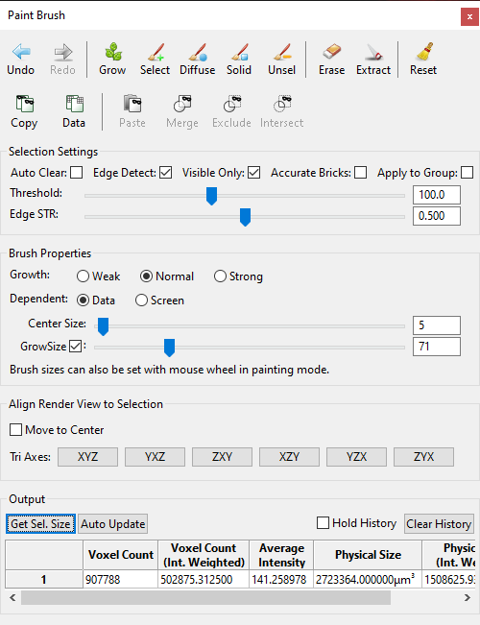

Figure 15‑1. The Paint Brush dialog.

## Brush Types

There are three brush types. They are accessed by clicking the toolbar buttons in the “Analyze” dialog. When any of the following brush types is selected, user can start painting in render view using a mouse or similar pointing device.

 **Grow.** When enabled, click on a structure to select it. The selection mask grows from a point where the mouse clicks. Hold down the mouse button to continuously grow the selection mask. It can be useful to find all connected structures to a point. When the growth of a structure such as nerves is dominant in one direction, drag the mouse to that direction to constraint the grow selection.

|  |  |
| --- | --- |
|  | Divide a large data set into multiple bricks to accelerate the selection speed. Avoid growing to all bricks in one click. Multiple clicks limit the computation to a small region of the entire data set. Interactive speed can then be achieved. |

** Select.** When enabled, user can paint on visualizations in render view to initialize selection of desired structures. The brush is typically equipped with two strokes, whose stamps are indicated by two concentric circles. The inner circle, called center stroke stamp, defines seeds for selection. Seeds are selected based on the “Threshold” value in the “Selection Settings”. The outer circle, called diffuse stroke stamp, defines a diffusion region for seeds. Seeds can diffuse or grow within the diffusion region based on a diffusion equation.

** Diffuse.** When enabled, user can paint on visualizations in render view to diffuse or grow existing selected structures. The diffusion brush is exactly a selection brush without the center stamp for seeding. It is used for selecting structures that are three-dimensionally connected to existing selections. It is useful to select complex 3D structures, such as nerves, neuron axons, and dendrites.

 **Solid.** When enabled, user can create masks of fully selected regions disregarding the underlying structures. You can use this brush to create masks even on completely empty regions of the data. It is useful when partial or entire data need to be selected and analyzed without missing any information (including empty space). The solid brush is enabled when the “Shift” key is held down in “Probe”  measurement tool. See Chapter 16 for more details.

** Unselect.** When enabled, user can paint on visualizations in render view and remove selected structures. It behaves like an eraser for masks.

In addition, “Reset All”  can be used to clear all selections.

|  |  |
| --- | --- |
|  | The same set of buttons are found in the “Workspace” toolbar. Alternatively, these keyboard shortcuts can be used: holding “Shift” – Select; holding “z” – Diffuse; holding “x” – unselect. |
|  | Selected structures are indicated by a mask with a different color than original volume channel. The mask color is calculated from the original color and should provide sufficient contrast to be distinguished from the original. For information on assigning IDs and changing mask colors, see the chapter on components and tracking. |

|  |  |
| --- | --- |
|  | Many settings that changes the visualization of a volume channel can influence the paint selected result. Volume properties take part in the calculation of selected results. For example, voxels out of the threshold value range in the volume proper settings are not selected by the paint brush. One important feature is to use clipping planes to restrict paint selection. For example, when you set the opposite clipping planes in an axis with slab with of one, it essentially allows you to perform paint selection on image sections. |
|  | Enable large data streaming and set a proper brick size for paint selecting on a large data set. Only bricks covered by a paint brush stroke are included in the computation to reduce processing time. |

## Brush History

You can let FluoRender keep a history of the most recent brush strokes, and undo/redo the operations. By default, the history setting is turned off. You need to first choose the number of strokes to be kept in history in the FluoRender Settings (Chapter 22). Once the brush history is turned on, you can use the **Undo**  and **Redo**  buttons to step through the brush stroke history.

|  |  |
| --- | --- |
|  | It consumes more memory and slows down the operations when the brush history is enabled. Disable this feature if you are not working with brushes. |

## Selection Settings

The behavior of bushes can be further refined using the selection settings.

**Auto clear.** When enabled, it automatically estimates a threshold value for the selection brush. The threshold estimation is calculated based local histogram under a brush stroke. When a stroke is finished, the estimated threshold values is updated. It clears previously selected region.

**Edge detect.** When enabled, it incorporates local contrast information into the diffusion process. When high local contrast (usually structure boundaries, or edges) is detected, the diffusion stops. You can further adjust the strength of edge detection by the **Edge STR** settings when edge detection is enabled.

**Visible only.** When enabled, in the seeding process, seeds occluded in 3D are not selected. It is useful to select densely packed structures, such as cells.

**Accurate bricks.** When there are multiple bricks, the diffusion may not go across brick borders. Check this option to allow diffusion to go across brick boarders. It may slow down the brush operations significantly.

**Apply to group.** When enabled, brush strokes are applied to structures from different volume channels within the same group of current selection. It can be used to study colocalized structures within a region defined by brush strokes.

**Threshold.** It is the threshold value for seeding with in the center stroke stamp region. It is also used to determine the strength of the diffusion process. Threshold value can be estimated by enabling the auto threshold function. To find a proper threshold value, adjust the setting after painting with a brush tool. The selection result is updated automatically with the change of the threshold as long as the viewing direction is unchanged.

|  |  |
| --- | --- |
|  | If auto threshold estimation cannot generate a satisfactory result, user can still change the threshold value manually with the auto threshold option enabled. However, only diffusion brush becomes available for selecting structures. |

**Edge STR.** The edge strength value adjustment is enabled when edge detection is checked. It sets the strength for edge detection. A high value of edge strength prevents the diffusion to select neighboring structures. When the edge strength value is 0, it is equivalent to turning off edge detection.

## Brush Properties

Brush diffusion strength and stamp sizes are controlled using the following settings.

**Growth.** It provides three strength levels for the diffusion process. It essentially determines how many iterations are used for evaluating the diffusion equation. Stronger means more iterations. When more iterations are used, diffusion tends to grow further, but it may take more time to calculate. Use a strong growth strength for coarse selection of large structures. Use weak growth strength for selecting finely detailed structures.

**Dependent.** It determines the unit of the brush size. Two options are available. Choose the data-dependent size to match brush size with a certain structure in the data.

* Data. Brush size uses voxel as unit. Brush changes its size to match zooming.
* Screen. Brush size uses screen pixel as unit. Brush keeps its size when zooming.

**Center size.** It is the center stroke stamp size in screen pixels. It determines the region that seed can be chosen by the selection brush.

**Grow size.** It is the outer stroke stamp size in screen pixels. It determines the region that seed can grow. The grow size can also be disabled. When disabled, the selection brush uses the center stroke stamp only. So, the selection brush is for seeding only. The selection will strictly follow the threshold setting. In addition, both the diffusion brush and un-selection brush use the center size for their stamps.

|  |  |
| --- | --- |
|  | When the brush types are enabled, user can use the mouse wheel to adjust the stamp sizes. For the selection brush, the mouse wheel adjusts the grow size only. Hold the Ctrl key to adjust the center size. |

## Wacom Tablet and Display Tablet Support

Use a pressure-sensitive stylus for intuitive paint operations. The pressure of the stylus controls these settings:

**Threshold.** Increase the stylus pressure to lower the threshold setting, so that low intensity structures are selected.

**Edge STR.** Increase the stylus pressure to lower the edge strength setting, so that dimly connected structures are selected.

**Brush size.** Pressure on the stylus changes brush size slightly. This is a visual indicator for pressure value. The change of brush size is insignificant to selection results.

When a Wacom-branded tablet or display tablet is connected, a Wacom Airbrush may be used. The Airbrush is equipped with a wheel on the stylus body, which can be used to adjust the brush size.

## Creating New Channels from Selection

FluoRender allows creating new channels based on selection. When a structure is selected within a volume channel, two operations are available to create new channels. They are located in the toolbars of the Analyze window and Workspace panel.

**Erase.** It creates a new channel from original volume without the selected structures.

**Extract.** It creates a new channel from original volume with only the selected structures included.



The newly created channels inherit settings from the original channel, including the bit-depths.

|  |  |
| --- | --- |
|  | You can keep creating new channels using the extract operations. However, the erase operation behaves differently. It creates a new channel and append “\_DELETED” to the end of channel name. If you select some structures from the newly created channel and use the erase operation again, it will operate directly on that channel, without creating a new one. “\_DELETED” is used to identify a channel so that it will not create a new channel for repetitive erase operations. If you do not want this behavior, make sure you change the channel name to one without “\_DELETED”. Additionally, make sure a file name does not include “\_DELETED”, if you do not want to erase directly on the volume channel. |

## Mask Copy and Paste

Copy an existing mask from one channel to another, so that they share the exact same mask. Two masks can be calculated to generate a new mask. The original intensities can also be used as a mask.

Copy. Select a channel from the Workspace panel. It copies the mask of the selected channel to be pasted into another channel.

Data-Mask. It copies the original data of the selected channel, which is used as a mask to be pasted into another channel as the mask.

Paste. Select a channel from the Workspace panel. It pastes the copied mask into the selected channel.

Merge. It merges a copied mask into the selected channel with its existing mask. The result is the union of two masks.

Exclude. It pastes a copied mask into the selected channel and subtract it from the existing mask.

Intersect. It pastes a copied mask into the selected channel and computes the intersection between the two masks.

## Output

You can get the size information on the select regions from the output. If you are using a fast computer system, you may get real-time information, as it updates with each brush selection operation.

**Get Sel. Size.** Use the brush tool to select a region first. Click this button to get the size information on the selected region.

**Auto Update.** It is an option that can be enabled or disabled. When this button is pushed down, the size information is updated automatically after each brush operation.

**Hold History.** Check this option to keep a list of size information entries. Each time a new size information entry is generated by either clicking the get selection size button or by brush painting when auto update is on, the information entry is inserted to the top of the list. You can use this feature to make several size measurements on a single structure, such as a cell, and compute an averaged value. Or, you can select multiple structures individually and get a list representing their size distribution.

**Clear History.** The data entries in the list are cleared.

There are four data entries displayed every time the size information is computed.

**Voxel Count.** The total number of voxels within the selected region. A voxel is counted as long as its mask value is greater than 0.

**Voxel Count (Int. Weighted).** The sum of the intensity values of all counted voxels. The intensity value for each voxel is a normalized value within the range [0, 1], where 1 represents the value 255 for 8-bit data and the max intensity for 16-bit data. The intensity-weighted voxel count can be significantly smaller than the voxel count for low intensity structures.

**Average Intensity.** The average intensity is computed as (Intensity weighted voxel count) / (voxel count).

**Physical Size.** The physical size of the selected region is computed by multiplying the voxel count with the voxel size. The voxel size is retrieved from metadata or set by user in the volume property panel.

**Physical Size (Int. Weighted).** Similar to the voxel count, it is weighted by intensity values.

## Align Render View to Selection Mask

Rotate the render view so that the screen space XYZ axes are aligned to the selection mask.

**Move to center.** When this option is enabled, it also pans the render view when an axis option is selected, so that the center of the selection mask is aligned with the render view center.

**Tri axes.** Three axes are computed from the voxels of the selection mask using the principle component analysis method. Then, the render view is rotated so that the three computed axes are aligned with the screen space XYZ axes.

|  |  |
| --- | --- |
|  | Set the rotation angles after alignment as the zeros in render view, so that they can be recovered easily. See Chapter 7 for more details. |

# Measurement

Measurement functions allow users to create locators and rulers to get position information and measure length. To use the measurement functions, click “Measurement”  on the main toolbar. If the button is not currently showing, use the drop-down list on Windows, or the main menu, under Tools, on OS X.



Figure 16‑1. Launch Measurement window from main toolbar.

The Measurement window is shown in Figure 16‑2.

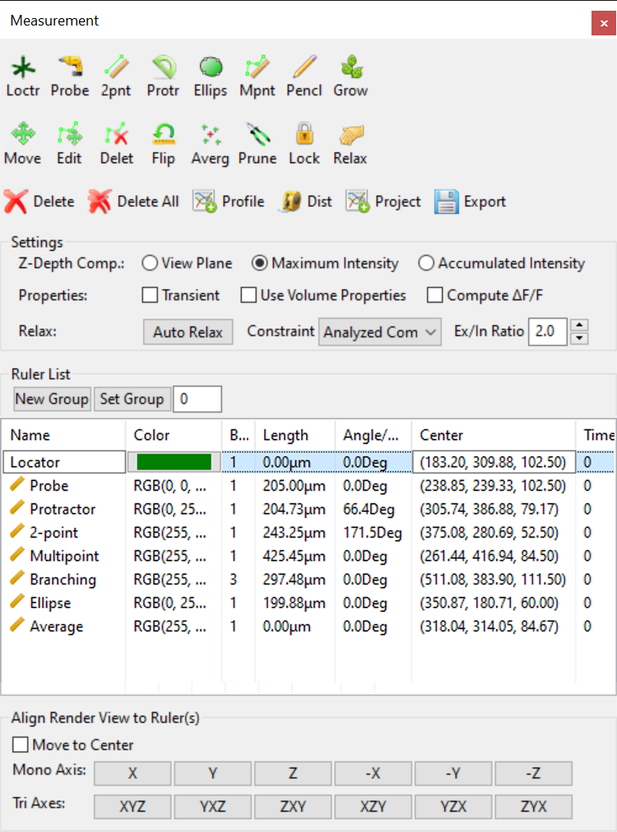

Figure 16‑2. Measurement window.

## Measurement Tool Types

There are five types of measurement tools that you can create.

** Locator.** First click the icon of locator. Then, click in render view to create a locator. A locator is a single point in 3D space, which measures its position in X, Y, and Z coordinates. The newly created locator is added to the list in the measurement window along with its information. The coordinates of the locator is listed under “Start/End Points (X, Y, Z)”. You can keep clicking in render view to create more locators, as long as the toolbar icon is checked.

 **Probe.** Probe tool allows you to create a two-point ruler that goes through the data from the current viewing direction. First find a viewing direction y rotating the view. Then, click once in the render view with the probe tool selected. The newly created probe is added to the list in the measurement window along with its information. The probe tool is mainly used with the paint brush tool and profile tool to generate an averaged intensity profile along the viewing direction. See the profile tool for more details.

** Two-point ruler.** First click the icon of two-point ruler. Then, click in render view twice to create the ruler with two end points. The newly created ruler is added to the list in the measurement window along with its information. The length, angle and start/end points can be found in the list as well. You can keep clicking in render view to create more two-point rulers, as long as the toolbar icon is checked.

**Protractor.** Protractor allows you to measure the angle between two lines. Click three times in the render view to create an angle measurement. The angle value in degrees is shown in the list of the measurement dialog window.



**Ellipse.** First click the icon of two-plus-point ruler. Then, click in render view to create the ruler with multiple points. You can end the ruler by right-clicking. Or, you can uncheck the toolbar icon to end the ruler. The length and start/end points can be found in the list of measurement window. After ending a ruler by right-clicking, you can keep creating more rulers, as long as the toolbar icon is checked.



**Multipoint ruler.** First click the icon of multipoint ruler. Then, click in render view to create the ruler with multiple points. You can end the ruler by right-clicking. Or, you can uncheck the toolbar icon to end the ruler. The length and start/end points can be found in the list of measurement window. After ending a ruler by right-clicking, you can keep creating more rulers, as long as the toolbar icon is checked. The multipoint ruler also supports branches. To create a branch, click on an existing ruler point, which becomes the root of the branch. Then, click subsequent points for the branch. There is no limit on the number of branches or how the branches are created. When a ruler with multiple branches are created, its branch count is listed.

**Pencil.** Click and drag the mouse to create a ruler using the pencil tool. Ruler points are added when the mouse cursor is moved away from a previous ruler point. Since the ruler point distance is determined in screen space, zoom in to create a ruler with dense points, and zoom out for coarse ruler points. Branches can be created by starting drawing from an existing ruler point.



**Grow.** The grow ruler is used the same as the grow selection tool in the Paint Brush tools. Click on the starting point of a structure and hold the left mouse button. A selection mask is created and started to diffuse from the starting point. For each growth step, the newly grown structures are analyzed. Separate ruler points are created for branching structures. When the grow ruler tool is enabled, successive operations add ruler points to the latest ruler.

|  |  |
| --- | --- |
|  | Paint selection brush can be activated when a ruler tool is enabled. It can be used to measure the volume of paint selected structures. To activate paint brush during ruler measurement, you have to use the keyboard shortcut. Hold down the “Shift” key and then paint. A new ruler point is created or appended. The volume of the selection is listed under “Volumes” of the measurement list. The coordinates of a locator or ruler point is the centroid of the selected volume structure. |
|  | Measurement tools disable normal render view interactions. To interact with render view with measurement tools enabled, hold down the “Alt” key and use normal render view interactions, including rotation, zooming, and panning. |

## Averaging

 The average tool computes the average of the centers of a number of ruler tools and creates a locator at the averaged center. At least one ruler needs to be created already for the averaging to work. When multiple ruler tools are created, you can select several among them for the averaging calculation. When no ruler is selected, all rulers will be used for calculating the average.

## Profiling

 The profile tool generates an intensity profile within a volume along a selected ruler. First select a ruler from the list in the measurement window, and then click the profile tool. When you export the rulers, the intensity profiles are saved as sequences of numbers in text format. You can read the numbers using an external tool, such as Microsoft Excel. The range of intensity values is 0 to 1, with 1 representing the maximum intensity value of the entire data volume. For most of the ruler types, a number in the intensity profile is sampled from one voxel of the volume data. If the probe tool is used along with a paint brush, which creates a cylindrical mask of the data, the profile tool samples within the masked volume and calculates averaged intensities along a sequence of disk-shape regions along the probe ruler. You can adjust the size of the brush to calculate the averaging in a larger or smaller region.

## Distance

 The distance tool computes the distances between a selected ruler tool and analyzed components. You need to first generate and analyze the components and then select a ruler tool to apply this function. The resulting distances are output in a text file that is Excel-compatible.

## Project

 The project tool projects analyzed components to a selected ruler. Perform a component analysis first in the Component window (see Chapter 17). Then, select a ruler from the list and compute the projected components. The results are saved in a text file, which can be read by Microsoft Excel. The results contains the ID of each component and the distance of its centroid to the selected ruler.

## Making Changes to Measurement Tools

You can change the position of locators or ruler points after they have been created. In addition, you can change the settings to more easily set the position of locators and ruler points in 3D. These settings and tools are available to make changed to measurement tools.

 **Flip ruler.** When a ruler has more than 1 point, the order of ruler points can be flipped by clicking this button. In the ruler list, the start and end points are swapped after flipping.

**Name.** Click a measurement tool in the list. A text edit box shows to allow you change the name of the selected tool. When you type in the text edit box, the name of the selected tool is updated in the render view port at the same time.

**Color.** Click a measurement tool in the list. A color swatch button shows to allow you change the color of the selected tool. Click the color swatch button. It shows a color selector dialog window. Choose the desired color and close the dialog window. A new color is updated to the selected tool in the render view port at the same time.

|  |  |
| --- | --- |
|  | When no color is set for a measurement tool, it uses an automatically calculated color so that it is visible against current background. |

**Group.** Rulers can be organized under a group number. The initial group number start with 0. Click “New Group” to increase the group number by one. Subsequently created rulers are grouped under the new number. To change the group to a specific number, type in the number in the group number input box and click “Set Group”.

 **Move.** Click on a ruler point and move its position. All ruler points of the ruler are moving together.

 **Edit.** When enabled, you can click on a locator or ruler point, and change its position by dragging it in render view. Notice that, normal render view interactions are allowed. A locator or ruler point is selected only when you first click within the region indicated by the square box representing the locator or ruler point. Otherwise, you may accidentally rotate the view.

**Delete ruler point.** When enabled, click a ruler point to delete it.

 **Prune.** Delete very short branches from a selected ruler.

The XYZ coordinates of a locator can be edited on the list. Click a locator tool and its center coordinates becomes editable. Input the XYZ coordinates and the locator will change its location. You can also copy can d paste the center coordinates from other ruler tools to a locator. Use the keyboard shortcut Ctrl+C or Cmd+C to copy the coordinates of a ruler center. The copied coordinate format is also Excel-compatible.

** Delete.** Delete the currently selected ruler(s) in the measurement list.

** Delete all.** Delete all locators and rulers in the measurement list.

**Export.** Export the measurement list to a file. The file is in text format and can be loaded into a spreadsheet editor such as Microsoft Excel. When a ruler tool has more than two ruler points, the coordinates of each point are exported along with other information of the ruler.



You can double-click on a ruler tool on the list to hide or show it. A hidden ruler tool has a gray background color when it is not highlighted.

### Ruler relaxation

Ruler points on a ruler can be automatically reshaped using a spring mass system. Each pair of adjacent ruler points is connected by a spring, whose rest length is determined when the ruler is created. A multipoint ruler also attempts to straighten itself. A smoother ruler can be generated. Use constraint to further shape the ruler to follow structures in 3D.

 **Relax.** Click to perform relaxation on a selected ruler. A ruler can be relaxed as many times as needed to settle down.

**Lock.** When enabled, click on ruler points to lock them and thus exclude them from relaxation calculations. Click a locked ruler point once more to unlock it.



Relaxation settings:

**Auto Relax.** Click to enable automatic relaxation. When the drawing of a ruler is finished (right-click for multipoint ruler, and release of mouse button for pencil ruler), the relaxation is computed automatically to smooth the ruler shape or constraint it to structures in 3D.

**Constraint.** Use volume, selection mask, or analyzed components to constraint the shape of a ruler, so that t ruler points stay at structural centers.

|  |  |
| --- | --- |
| Constraint type | Effects |
| Free | No constraint is applied. The ruler is smoothed using its internal forces. |
| Volume | Use the selected volume channel to reshape ruler. Ruler points are attracted by voxels. High intensity voxels have stronger attraction force. |
| Selection | Use the selection mask to reshape ruler. Ruler points are attracted by voxels of the selection mask. |
| Analyzed components | Use analyzed components to reshape ruler. Ruler points are attracted by component centers. |

**Ex/In Ratio.** When analyzed components are present, this value determines the ratio of force strengths between the attractors (volume, selection mask, or analyzed components) and internal springs. Increasing the ratio makes stronger attraction forces from the components.

### Choosing a depth calculation method

There are three methods you can choose to determine how the 3D position of a locator or ruler point is calculated from screen position. Choose the method based on the underlying volume channel’s structures.

**View plane.** It places a locator or ruler point on the view plane that is perpendicular to the viewing direction, disregarding the under lying volume channel. The depth is fixed when this method is used. Use this method, for example, if you are measuring lengths on an image section.

**Maximum intensity.** It places a locator or ruler point at a depth of a voxel having the maximum intensity along the ray from the viewer. If multiple maximum intensity voxels exist, the closest one is chosen. Use this method, if you want to trace a nerve. However, if the nerve happens to be occluded by other structures at certain locations. The depth may not be calculated as desired. Use the edit tool to correct those points from a different angle of view if necessary.

**Accumulated intensity.** It places a locator or ruler point at a depth of a voxel that all preceding voxels along the ray have an accumulated intensity adequate to occlude it. It usually finds a point on a well-defined structural surface. Use this methods if you want to measure length on a surface. If no such point can be found, it automatically switches to the view plane method.

### Other settings

**Transient.** When enabled, a locator or ruler can only be created and viewed at a specific time point, when a time sequence data set is loaded. The time point that a locator or ruler belong to can be obtained from the measurement list, under “Time”. The setting is ignored when non time sequence data are loaded.

|  |  |
| --- | --- |
|  | This feature can be used to manually track the movement of a certain structure. You can disable transient, choose two-plus-point ruler tool, go to a certain time point of the data, selecting a structure with the paint brush activated, and then proceed to the next time point. Since the transient feature is disabled, you can create a multi-point ruler tool across a series of time point, which represents the trajectory of movement of the selected structure. More sophisticated tracking features are discussed in Chapter 19. |

**Compute ΔF/F for probe tool.**  When enabled, it calculates ΔF/F when multiple probe tools are created. Values from the first probe tool are used as background signals. ΔF, the difference between subsequent probe tools and the background signal is then compared to the background signal F as a ratio ΔF/F.

**Use volume properties.** When enabled, the calculation of the depth value is based on the mapped values after volume properties are applied, include Gamma, threshold, saturation, etc. It allows more precise depth calculation but may take more time to calculate.

## Align Render View to Rulers

Rotate the render view so that the screen space XYZ axes are aligned to rulers.

**Move to center.** When this option is enabled, it also pans the render view when an axis option is selected, so that the center of the ruler points is aligned with the render view center.

**Mono axis.** Create a 2-point ruler first as the reference for an axis to align with. Then, choose one of the axis options to rotate the render view. For example, click the X axis so that a 2-point ruler is leveled in the render view. Use the negative axis options to flip the render view.

**Tri axes.** Three axes are computed from ruler points using the principle component analysis method. Then, the render view is rotated so that the three computed axes are aligned with the screen space XYZ axes. At least 3 points not on a straight line are needed to compute the axes correctly.

|  |  |
| --- | --- |
|  | You can select a single ruler or multiple rulers to perform the alignment. Only the ruler points are used for alignment calculations. |
|  | Set the rotation angles after alignment as the zeros in render view, so that they can be recovered easily. See Chapter 7 for more details. |

# Component Analysis

A volume channel may contain distinct structures that visually separate from each other, such as individual cells or neuronal fibers. These structures are called components. Use the Component Analyzer to first separate them and then examine each component. To use the Component Analyzer, click “Components”  on the main toolbar. If the button is not currently showing, use the drop-down list on Windows, or the main menu, under Tools, on OS X. The Component Analyzer dialog is shown in Figure 17‑1. It contains three pages for different settings and functions. The Generate page is for generating components from a volume channel; the cluster page is for separating connected components using common clustering methods; and the analysis page is for analyzing the components generated from previous pages.

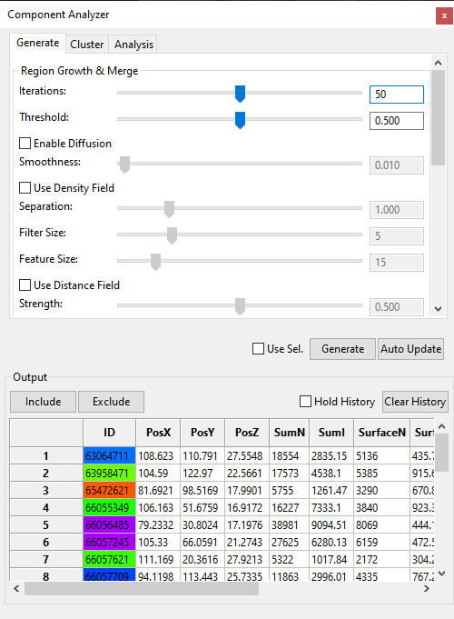

Figure 17‑1. The basic settings in the component analyzer dialog.

|  |  |
| --- | --- |
|  | You may enable large data streaming and then perform component analysis on a loaded data set. The analysis will apply to each brick of the data set and the resulting bricks are stitched. You may see seams between bricks. However, components belonging to one connected structure will be computed as one stitched entity. |

## Settings for Component Generation

To generate components from a selected volume channel, you may enable and configure a series of settings (Figure 17‑1). The calculations are based on the “Synthetic Brainbows” algorithm (Wan et al., Synthetic Brainbows. *Computer Graphics Forum*, Vol. 32, No. 3, 2013), which is an agglomerative algorithm that starts with a state of all separated voxels and merges them iteratively according to signal strength and structural shapes.

|  |  |
| --- | --- |
|  | Enable “Auto Update” at the bottom of the setting page to allow any changes to the settings to be applied immediately. Turn on auto update to find out proper settings more intuitively. However, you need a fast GPU to use this feature. |
|  | Enable “Use selection” to only generate components within a selection mask. When large data streaming is enabled, only bricks having a selection mask are included in the component calculations. Therefore, processing time can be significantly reduced when only local features are analyzed in a large data set. |

Basic Settings:

**Iterations.** The number of passes the Synthetic Brainbow algorithm is run. Use a sufficient number of iterations so that voxels from one component are fully merged. You can observe the merging process by using the “Refine” button, which applies iterations on top of existing result.

**Threshold.** It sets a threshold on intensity values. Voxels with lower than threshold intensities are excluded from the component generation.

**Enable Diffusion.** When enabled, a falloff setting is available. Diffusion controls component generation speed based on intensity values. Voxels with high intensity values tend to merge more quickly than low ones.

**Falloff.** It is the parameter in a Gaussian distribution that controls how fast intensity values lower than the threshold fall out of the component merging process. When diffusion is enabled, different intensity values lower than the threshold are assigned with different merging speed for component generation. A high falloff value means more low intensity values are included in the merging process; a low falloff value means that merging becomes stricter for only those intensity values greater than the threshold.

Advanced Settings:

**Use Density Field.** For data with uneven brightness, the density field is generated for equalization. The original data’s intensity field is first filtered to smooth the result. Then, it is divided into a series of cubic regions, where local density distributions are computed. The local density distributions are interpolated for each voxel. The separation of structures is determined by a voxel’s intensity relative to its local density distribution, making low intensity structures to be more easily separated from the high intensity ones. Once the density field is enabled, these settings become available:

**Separation.** It works like a local threshold setting. A higher value allows low intensity voxels relative to its neighbors to be separated.

**Filter Size.** The smoothing filter’s window size for preprocessing the original data. Increase this value for noisy data; decrease this value when structures of small size need to be distinguished.

**Feature Size.** The size of the cubic region for local distribution calculation. Set it to be about the same size as the structures need to be distinguished.

**Distance Field.** For data with strongly connected components (For example, when a couple of cell nuclei are very close together, there are almost no lower intensity voxels to separate them), only using their intensity information will not be sufficient to separate them. The distance field is a derived intensity field where a voxel’s intensity value is determined by its distance to a global perimeter. The global perimeter is generated by thresholding the original intensity value. Once the distance field is enabled, these settings become available:

**Strength.** The derived distance field is intermixed with the original data. The strength of the distance field is the factor for intermixing. A 0 value means no distance field is used; and a 1 value means all calculations are based on the distance field.

**Perimeter Value.** The threshold value to generate the perimeter, which is then used to calculate the distances.

**Filter Size.** The smoothing filter’s window size for preprocessing the original data. Increase this value for noisy data; decrease this value when structures of small size need to be distinguished.

**Feature Size.** It determines how far the distance is calculated from the perimeter. Set it to be about the same size as the structures need to be distinguished.

**Fixate Grown Regions.** Enable this option so that already separated regions of certain size will not merge into each other. A data set may contain different structures; a group of settings may only be able to handle a portion of the data set. Use this feature to apply settings to different regions.

**Stop Size.** Already merged structures of larger size will be fixated. They cannot merge with each other as long as the Fixate function is enabled.

**Refix.** Reapply the Fixate function after settings have changed.

**Clean Up.** Use density threshold only can generate a large number of single-voxel components around large components. Enable this feature to let large components “absorb” small components. However, large components cannot merge with each other.

**Iterations.** The number of passes the cleanup is executed.

**Size.** Components smaller than the size setting can be merged by neighboring large components.

**Clean More.** Apply the clean up one more time.

Because components may be generated in a multistep fashion with complex settings, the macro recorder can record the steps to generate a result. A recorded command can be applied to similar data sets.

**Record.** Click once to start recording. Click again to stop recording.

**Play.** Execute a recorded command.

**Reset.** Clear a recorded command.

**Load.** Open a file browser and load a previously saved command.

**Save.** Save the recorded command to a file.

Set the settings and then click “Generate” to generate components. A progress bar indicates the calculation progress. To visualize the components, enable 4D script in the “Record/Export” panel (Chapter 13). Check “Use Sel.” to apply the settings to only brush selected regions. Turn on “Auto Update” to apply the changes to settings immediately.

For a time sequence, you can apply settings at different time points and observe the results. When you are satisfied with the results, run a 4D script called “generate\_comp” to apply the settings to all time points. See Chapter 12 for more details on running a 4D script to execute external executables.

## Clustering

To segment locally selected features with clustering algorithms, click the second tab to show the clustering settings.



Figure 17‑2. Clustering tools.

You need to select structures from the view first (Chapter 15). The selection can be two cells/nuclei fused together. Then, choose one of the clustering methods to separate them.

**K-means.** It uses the k-means algorithm to cluster structures. You need to provide the number of clusters to separate the selection.

**EM.** It uses the expectation-maximization algorithm on a Gaussian mixture model. You need to provide the number of clusters to separate the selection.

**DBSCAN.** It uses the DBSCAN algorithm to cluster structures based on density. You need to set a minimum size and a neighborhood range for this algorithm.

Depending on the selected algorithm, different settings may be available.

**Cluster Number.** The number of expected clusters.

**Max Iterations.** The number of iterations an algorithm can run at most.

**Tolerance.** It controls the quality of the clustering results. A higher tolerance number means stricter condition.

**Min. Size.** The minimum size for the DBSCAN algorithm.

**Neighborhood.** The range for searching neighbors for the DBSCAN algorithm.

Click the button “Cluster” to run clustering. If you enabled 4D script and the clustering is successful, the separated structures will be rendered with different colors. Use the “Analysis” tab to get detailed information on the clusters.

|  |  |
| --- | --- |
|  | The EM algorithm is using a Gaussian mixture model to detect ellipsoid shaped objects. When more than 2 clusters need to be separated, use the K-means method first to get an approximate result. Then, you can apply the EM method, which can continue from the K-means result and refine shapes. |

## Component Analysis

To analyze generated components, click the fourth tab to show the panel for analysis.

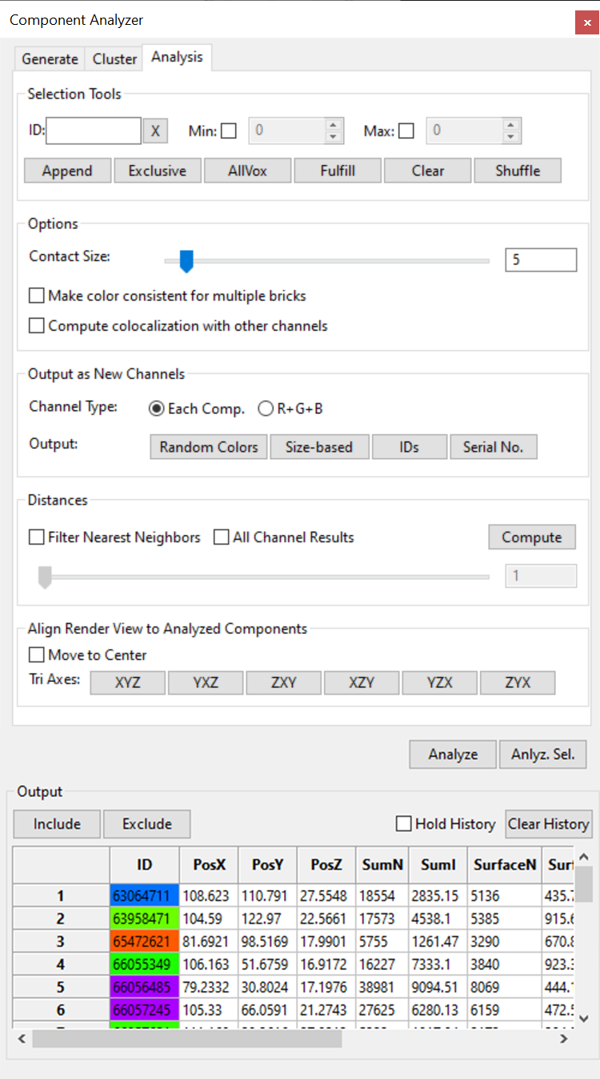

Figure 17‑3. Component analysis tools.

You can analyze an entire data set, or just the selected part.

**Analyze.** Analyze all components of an entire data set. The analysis results are printed in the Output panel. If the results contain a large number of entries, it prompts you to save them in a text file. Choose a text file and click the Save button. The results are Tab-separated, which can be opened using a spreadsheet editor software, such as Microsoft Excel.

**Anlyz. Sel.** Only analyze the selected part of a data set. The analysis results are printed in the Output panel. If the results contain a large number of entries, it prompts you to save them in a text file. Choose a text file and click the Save button. The results are Tab-separated, which can be opened using a spreadsheet editor software, such as Microsoft Excel.

### Selection Tools

You can use the paint brush tool to select components of interest. It also provides a series of tools to fine tune the selection.

**ID input box.** You can type in the ID of a component and then select it. It also shows the color of the ID as you type.

|  |  |
| --- | --- |
|  | When a large data set is divided into bricks for either streaming or because a max texture limit is set, a component is uniquely identified by its brick ID and ID, instead of just ID when only one brick is present. This is because the same ID can be reused across multiple bricks. If you only input the ID of a component, all components assigned with the same ID will be selected from all bricks. To select a component within a brick, type its brick ID before the component ID, with a non-digit character to separate them, for example, 1:123456. |

**X.** The X button clears the content of the ID input box.

**Min Size.** Check this option to enable a limiter on minimum voxel size. The input value determines the minimum voxel number of a component to be selected. Use this setting to exclude small size components to be counted, for example, noise data. Uncheck this option if the minimum size limiter is not needed.

**Max Size.** Check this option to enable a limiter on maximum voxel size. The input value determines the maximum voxel number of a component to be included in the analysis. Use this setting to exclude large size components to be counted. Uncheck this option if the maximum size limiter is not needed.

**Append.** Add a component with the exact ID in the ID input box to the selection while keeping the currently selected components.

**All.** Select all components.

**FullCompt (full component).** A selection made with the paint brush usually does not match exactly with labeled voxels. Click this button after you have made a selection with the paint brush tool and would like to find out the entire component. Make sure to leave the ID input box empty if selecting the entire component is the desired operation. Otherwise it is equivalent to the Append button. Pressing the enter key when the ID input box is in focus has the similar results.

|  |  |
| --- | --- |
|  | When a large data set is divided into bricks for either streaming or because a max texture limit is set, perform component analysis once to stitch components that span multiple bricks. Component selection after analysis will take the stitching information into consideration and include parts of such components in neighboring bricks, even if all the parts are assigned with different IDs. |

**Replace.** Replace currently selected components with a component with the exact ID in the ID input box.

**Clear.** Clear the selection of all components.

**Shuffle.** Since component colors are assigned according to their IDs, neighboring components may have the same or similar colors. To better distinguish adjacent components, shuffle the colors by clicking this button.

### Options

You can set these options before analysis.

**Contact size.** When large data streaming is enabled, a single component spanning multiple bricks is combined. The contact size is the number of overlapping voxels at brick borders. Only components having a contact size larger than this setting are combined into a unified component. Use this setting to exclude noise signals and structures slightly connected.

**Make color consistent for multiple bricks.** When a large data set is divided into bricks for either streaming or because a max texture limit is set, some components may span multiple bricks. Different parts of such components within neighboring bricks may not be assigned with the same ID and color. Check this option and FluoRender will replace IDs within neighboring bricks to make the colors of such components consistent.

**Compute colocalization with other channels.** Check this option and FluoRender will compute the colocalization information for each component of the selected channel with other visible channels in the project. The colocation information is output along with other fields of components.

### Output as New Channels

You can output components as new channels. There are two options to create multiple channels from components.

**Each Comp.** Each component is output as one channel. Use the selection tools to limit the number of components that can be processed.

|  |  |
| --- | --- |
|  | Make sure that you have enough memory if the number of components is high. It may also take a long time to generate a large number of channels. |

**R+G+B.** All components are output as a combination of the three color channels. Only three channels will be generated, no matter how many components are processed.

Click these two buttons to generate new channels. You can also set the colors of new channels.

**Random Colors.** Each component is assigned a color according to its ID.

**Size-based.** The colors of components are mapped according to their sizes.

Additionally, you can generate an annotation channel to show each component’s ID.

**Annotations.** More detailed analysis results are stored with annotations. Click this button to add annotated results.

**Serial No.** Instead of showing the component ID, it shows the row number in the output table.

|  |  |
| --- | --- |
|  | Save an annotation from the “Dataset” panel. Detailed information includes ID, centroid coordinates, size in voxel, size in physical unit, and averaged intensity. |

### Distances

Calculate the distances between pairs of components. The full result is an adjacency matrix of distances. The matrix is saved in a text file that is Excel compatible. When there are more than one channel analyzed, the components from all channels are computed and the results are presented in a unified adjacency matrix.

For each component, you can only include the nearest neighbors.

**Neighbors.** Check this option to filter the result and only include nearest neighbors. Then, you can set a number for neighbors.

|  |  |
| --- | --- |
|  | In the adjacency matrix, the distance from a component to itself is included, which is always zero. When the nearest neighbor filter is enabled, the self-distance is excluded. Therefore, the number of neighbors does not include the component itself. |

### Align render view to components

Rotate the render view so that the screen space XYZ axes are aligned to the analyzed components.

**Move to center.** When this option is enabled, it also pans the render view when an axis option is selected, so that the center of the components is aligned with the render view center.

**Tri axes.** Three axes are computed from the components using the principle component analysis method. Then, the render view is rotated so that the three computed axes are aligned with the screen space XYZ axes.

|  |  |
| --- | --- |
|  | Set the rotation angles after alignment as the zeros in render view, so that they can be recovered easily. See Chapter 7 for more details. |

### Output

The component analysis results are output to the table control. Each component has the following property values:

**ID.** The integer value used to identify a component. The color of a component is computed from its ID. The color is shown as the cell background color.

**PosX.** The x coordinate value of the center of the component.

**PosY.** The y coordinate value of the center of the component.

**PosZ.** The z coordinate value of the center of the component.

**SumN.** The total number of voxels within the component.

**SumI.** The total number of voxels within the component weighted by their intensity values.

**PhysN.** The physical size of the component. PhysN = SumN x Voxel size. The voxel size is retrieved from the metadata.

**PhysI.** PhysI = SumI x Voxel size.

**SurfN.** The number of voxels that are on the surface of a component.

**SurfI.** The number of voxels that are on the surface of a component weighted by their intensity values.

**Mean.** The mean intensity value of all voxels within a component.

**Sigma.** The standard deviation of the voxel intensity values within a component.

**Min.** The minimal intensity value within a component.

**Max.** The maximal intensity value within a component.

**Dist.** The distance of the component to a ruler tool. See “Distance” in Chapter 16 for more details.

**PcaL.** The length of a component computed as the length of the principal component.

Check the Hold History option to keep the component information in the list. Click Clear History to clear the list. Select one or multiple cells, rows, columns from the table and copy them into Microsoft excel using the shortcuts Ctrl+C and Ctrl+V.

### Select and filter components



Figure 17‑4. Select components from the output table or in the render view.

Select a component from the output table by clicking its row number. A box is drawn around the component in the render view to indicate its whereabouts (Figure 17‑4). Multiple components can be selected by dragging a box to select multiple rows in the table. Or, hold the Ctrl key to select nonconsecutive rows. Components can also be selected directly from the render view by clicking on them. Their corresponding rows in the output table will be highlighted too. To select multiple components from the render view, hold the Ctrl key and click on components. The Ctrl key is also used to unselect a selected component in the render view.

The selected components can be included or excluded from the selection mask (such as that generated by the paint brush). To only include the selected components in the selection mask, click the Include button. The keyboard shortcut is Enter/Return. To exclude the selected components from the selection mask, click the Exclude button. The keyboard shortcut is /.

# Processing and Analyzing Volumes

The Component Analyzer (Chapter 17) provides a general solution to several specific processing operations. For example, you may set a maximum voxel size limit and then select all components with a relatively small size. Then, you can erase those small components, which are generally noise signals. There are a series of modules in FluoRender that are built on top of the general component analysis module and perform specific processing and analyzing functions. These modules can be found on the drop-down menu of the main tool bar (Figure 18‑1).



Figure 18‑1. Access the additional processing and analyzing functions from the drop-down menu of the main tool bar

## Volume Size



Use the “Volume Size” dialog to calculate sizes of components (Figure 18‑2). To open the “Volume Size” dialog, click the downward arrow head on the right side of the analysis tool button, and choose “Volume Size” (Figure 18‑1).



Figure 18‑2. Volume size dialog.

These settings are available in the “Volume Size” dialog.

**Selected only.** Only paint selected structures within a volume channel is analyzed. Otherwise, the entire volume is analyzed. If this option is checked, make sure that you have something selected.

**Min voxel.** The minimum voxel number of a component to be included in the analysis. Use this setting to exclude small size components to be counted, for example, noise data.

**Max voxel.** The maximum voxel number of a component to be included in the analysis. Use this setting to exclude large size components to be counted.

**Ignore Max.** When checked, it ignores the setting of “Max voxel”, so that arbitrarily large components are counted.

Two value results are displayed under the component analysis settings, after the analysis is finished.

**Components.** It shows the number of components. For example, if you use it to count the number of cells, it is the number of cells.

**Total volume.** It shows the total number of voxels from all components.

|  |  |
| --- | --- |
|  | Some previous functions in the volume size dialog have been replaced by those in the component analyzer dialog. |

## Noise Reduction



Computing of noise reduction is based on the component analysis. Components of small size are considered noise and can be removed. Noise reduction can be performed in the “Noise Reduction” dialog (Figure 18‑3). To open the “Noise Reduction” dialog, click the downward arrow head on the right side of the analysis tool button, and choose “Noise Reduction” (Figure 18‑1).



Figure 18‑3. Noise reduction dialog.

These settings are available in the noise reduction dialog.

**Threshold.** It sets a threshold value to select components. It is the same value in the “Component Analyzer”.

**Voxel size.** It sets the minimum size to select components. It is the same value as “Min voxel” in the “Component Analyzer”.

**Select. Only.** It applies noise reduction only to the selected region.

**Enhance selection.** It highlights the selected noise signals in a different color than the selected volume channel.

Click **“Preview”** to visualize selected noise. Click **“Erase”** to create a new channel of volume with selected noise removed.

|  |  |
| --- | --- |
|  | “Preview” functions the same as “Analyze” button in the component analyzer, and “Erase” functions the same as erase for paint selection. |

## Volume Channel Calculations



Volume channel calculations can be performed in the “Calculations” dialog (Figure 18‑4). To open the “Calculations” dialog, click the downward arrow head on the right side of the analysis tool button, and choose “Calculations” (Figure 18‑1). Since up to two channels can be selected and calculated, the volume channels to be calculated have to be loaded into the two slots before calculations.



Figure 18‑4. Calculation functions in the Analyze window.

**Operand A.** To load volume A, select a volume channel from the “Workspace” panel, and then click the “Load” button on right side of “Operand A”. The name of the loaded volume is shown in the slot next to the button. You can also load a group as operand A when you use the “Combine Group” operation.

**Operand B.** To load volume B, select a volume channel from the “Workspace” panel, and then click the “Load” button on right side of “Volume B”. The name of the loaded volume is shown in the slot next to the button.

### Single-valued operations

Single valued operations only requires volume A to be loaded. Only one operation is available.

**Consolidate voxels.** It sets all voxels of the interior of volume A to the maximum intensity (255 for 8-bit data).

|  |  |
| --- | --- |
|  | Consolidating voxels before size calculation may be desired to “fill” holes of original data. |

**Combine Group.** It combines all channels in a group and generates a new group of red, green, and blue channels. Colors selected for the original channels are summed up in the RGB channels respectively.

### Two-valued operations

Four calculations require both operands A and B.

**Subtract.** It subtracts volume B from A, and creates a new volume channel as the result.

**Add.** It adds volume A and B, and creates a new volume channel as the result.

**Divide.** It divides volume A with B, and creates a new volume channel as the result.

**Colocalize.** It creates a new volume channel as the common structures of volume A and B.

## Colocalization Analysis



Colocalization analysis is based on both component analysis and calculations. Colocalization analysis can be performed in the “Colocalization” dialog (Figure 18‑5). To open the “Colocalization” dialog, click the downward arrow head on the right side of the analysis tool button, and choose “Colocalization” (Figure 18‑1).



Figure 18‑5. Colocalization analysis dialog.

Colocalization analysis computes the overlapping between two volume channels. The result is an adjacency matrix generated for all pair-wise results. For example, the element (1, 2) of the matrix is the overlapping between channel 1 and 2; the element (1, 1) is the size of channel 1 itself. The colocalization analysis is perform for a volume group. To perform the colocalization analysis, select the group or any channel within a group from the Workspace panel. Then, click “Colocalize” to perform the analysis.

There are different methods for computing the overlapping between two channels. This is because the definition of “overlapping” becomes obscure for intensity values with a certain range, instead of being binary.

**Threshold + Logical AND.** The intensity values of a channel are first thresholded and converted to binary data. Then, the overlapping of two binary channels is where both are above the threshold value, i.e. AND(ch1, ch2). The threshold values are set using the volume property panel.

**Min Value.** The overlapping channel of two channels is the minimum intensity for each corresponding voxel, i.e. Min(ch1, ch2).

**Product.** The overlapping channel of two channels is the product of normalized intensities at each voxel, i.e. Norm(ch1) X Norm(ch2). Notice that the normalization maps the intensity values to the range [0, 1]. Therefore, the product is always equal or smaller than the original intensity values.

The output adjacency matrix can have several formats. When none of the formatting options is checked, the output contains numbers of voxel count for the overlapping.

**Ratio (%).** The ratio in percentage of an overlapping (non-diagonals) versus the original channel (diagonals). For example, the element (row=1, column=2) of the matrix represents the ratio between the overlapping of channel 1 and 2 versus channel 1, while the element (row=2, column=1) of the matrix represents the ratio between the overlapping of channel 1 and 2 versus channel 2.

**Int. Weighted.** The voxel count is weighted by the normalized intensity values.

**Physical Size.** The voxel count or intensity weighted voxel count is scaled by the voxel size from metadata.

Additionally, a color map can be applied to the elements of the matrix. When color map is enabled, it is using the same color map currently set for the selected volume channel.

Click Colocalize to compute the result and show it in the output area. To only compute the colocalization on the freehand-selected region, check “Use Selection”. Check “Auto Update” to instantly show the result when a parameter or selection changes.

Check the Hold History option to keep the component information in the list. Click Clear History to clear the list. Select one or multiple cells, rows, columns from the table and copy them into Microsoft excel using the shortcuts Ctrl+C and Ctrl+V.

|  |  |
| --- | --- |
|  | Notice that the time for computing a large number of channels increases quadratically with the number of channels. For example, to generate a 100x100 adjacency matrix of 100 channels, a total of 100C2 = 4950 comparisons are needed. |

# Tracking

In Chapter 17, when a volume channel is analyzed, each component is assigned with a unique ID. A time sequence can be labeled similarly for each time point. You can also use the 4D script functions to apply component generation to each time point of a time sequence and generate label/mask files. Once the label files are generated, you can use automatic, manual, or the combination of the two to track the movements of individual structures. The tools are in the Tracking window. The tracking results can then be visualized as trajectories of each linked IDs.

Tracking functions are in the “Tracking” window. To open this window, click the downward arrow head on the right side of the “Analyze” button. The top part of the “Tracking” window organizes several sets of tools into five tabs, which generally represent a workflow from automatic tracking, to visualization, fixing problems manually, and finally to performing analysis. Despite a typical workflow, you don’t have to follow the tabs step by step. You can perform a fully manual tracking using the “Linkage” and “Modify” tabs. Or, you can manually assign IDs and then perform an automatic tracking.

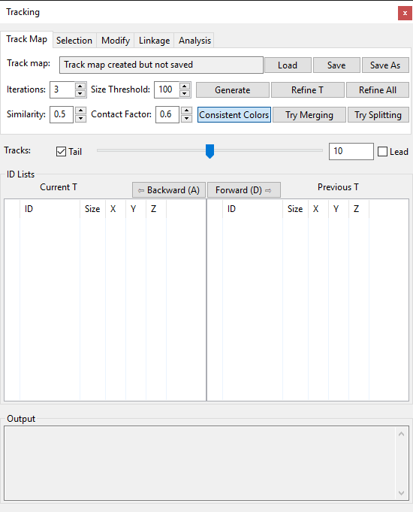

Figure 19‑1. Components and Tracking window.

|  |  |
| --- | --- |
|  | An ID is a 32-bit unsigned integer to identify a component. In automatic tracking, the same tracked component in different time points may be assigned with different IDs. A tracked structure may be separated into several components in one time point. |

## Track Map Generation and Management

Figure 19‑1 shows the first tab of the “Component and Tracking” window. It is for automatic track map generation and management. A track map describes the linking relationships among components over time. You can generate a track map and then refine it progressively. You can also load a previously generated track map or save the current one to disk.

**Track map file name.** A text box showing the file name of a currently loaded track map or one that has been saved. If a newly generated track map is not saved, it notifies the user that there exists a track map but has not been saved.

**Load.** Click the load button and browse to a track map file (\*.track) to load it into FluoRender. An unsaved track map generated previously will be replaced.

**Save.** Click the save button to save an existing track map.

**Save As.** Click the save as button to save a modified track map with a different name or directory.

**Generate.** Click the generate button to compute a new track map. It uses the number in the iteration times for the computing. You need a time sequence and the time sequence has to be labeled already. Use the included external executable cl\_synthetic\_brainbows.exe (Windows only) with a 4D script to perform the labeling operations.

|  |  |
| --- | --- |
|  | An unsaved track map will be saved when you save the project. It is loaded when you load the project. |
|  | Since version 2.17, a new format (\*.track) for the tracking results is adopted. The old format (link map, \*.fll) becomes deprecated and unsupported in the new versions. The two formats are also incompatible with each other. Use tracking result files only with the version of FluoRender that generated them. |

**Refine T.** Click the “Refine T” button to refine an existing track map at the current time point. It improves the tracking results for all components of the current time point. It uses the number in the iteration times for the computing.

**Refine All.** Click the “Refine All” button to refine an existing track map for all time points. It uses the number in the iteration times for the computing.

You can adjust these parameters to fine tune the behavior of the tracking.

**Iteration times.** The number of iterations for the track map generation and refinement. Use more iteration times to refine the track map so the tracking becomes more accurate. However, more iteration times also take more time to compute.

**Size Threshold.** The default value for filtering component by size. Components having voxels less than the threshold value will not be used in the tracking calculations.

**Similarity.** When comparing the sizes of two components to decide which one has a better likelihood to match to another structure, this value is used to determine how similar the two size values are. If two size values are similar, both are considered with equal likelihood, and more conditions are needed to determine their matching.

**Contact Factor.** A threshold for the overlap between two components so that large overlap enables the two components to be grouped together in the tracking calculations.

**Consistent Colors.** Tracked components will change their IDs so that one component has a consistent color over time.

**Try Merging.** Check this option to let the tracking algorithm determine if several components can be merged to better match them. The DBSCAN algorithm is used to cluster the components.

**Try Splitting.** Check this option to let the tracking algorithm determine if one component can be split into several components to better match it. The expectation-maximization algorithm is used to cluster the component.

## Semi-Automatic Tracking

The semi-automatic tracking allows you to only select structures from each time point and advance in time. FluoRender will segment your selections from the time points and link them automatically. The semi-automatic tracking is achieved via a 4D script. See Chapter 13 for more details about 4D scripts and the specific tasks for semi-automatic tracking. To enable semi-automatic tracking, enable 4D script and select the script track\_semi\_auto. Then, make sure the paint brush settings are proper for selecting the desired structures.

## Component Selection Settings



Figure 19‑2. The Selection tab of the Component and Tracking window.

After loading or generating a track map, components can be selected to show the tracking results. The paint brush tools are usually used to select components. You can also fine tune the selection or make precise ID-based selections using these tools. All ID-based selection tools are in the second tab of the Component and Tracking window (Figure 19‑2).

**ID input box.** You can type in an ID and then use one of the following buttons to select it. You can also type “all” in the input box to select all components that have IDs. You can also type and press the enter key on a keyboard to select desired components. Notice that when the enter key is pressed, it is equivalent to clicking the FullCompt button.

**X.** The X button clears the content of the ID input box.

**FullCompt (full component).** A selection made with the paint brush usually does not match exactly with labeled voxels. Click this button after you have made a selection with the paint brush tool and would like to find out the entire component. Make sure to leave the ID input box empty if selecting the entire component is the desired operation. Otherwise it is equivalent to the Append button. Pressing the enter key when the ID input box is in focus has the similar results.

**Replace.** Replace currently selected components with a component with the exact ID in the ID input box.

**Append.** Add a component with the exact ID in the ID input box to the selection while keeping the currently selected components.

**Clear.** Clear the selection of all components.

**Shuffle.** Since component colors are assigned according to their IDs, neighboring components may have the same or similar colors. To better distinguish adjacent components, shuffle the colors by clicking this button.

**Component size.** A filter for component selection so that only components of sizes greater than the value are selected.

**Uncertainty filter.** Filter components with a tracking uncertainty range. Components with tracking uncertainty values within the range are selected. When nothing is selected, the uncertainty filter applies to the entire data set. To get a distribution of the tracking uncertainty, use the uncertainty analysis function in the analysis panel.

## Visualizing Tracking Results

You can select any number of components using a combination of the paint brush and the ID-based selection tools. Once components have been selected, they are added to the ID list of current time in the Component and Tracking window. You can then go through time step by step and watch the tracking results.

|  |  |
| --- | --- |
|  | Internally, a 4D script is executed to find out and highlight tracking results. You need to enable 4D script and choose the correct script file in order to use the tracking features. See Chapter 12 and Chapter 22 for more details. |

There are several controls under the tabs in the Component and Tracking window. You can use them to control the display of the tracking results and perform time stepping.

**Tracks.** Tracks are line segments before and after a tracked component to indicate its movement. Tracks indicating the movement ahead of time are called **leads**; Tracks indicating the past movement are called **tails**. You can control the visibility of leads and tails individually by checking their names before and after the track number slider. The track length slider is controlling the length of tracks, or line segments can be displayed. Although the range of the slider is [0, 20], you can type in an arbitrarily larger number in the numeric input box.

|  |  |
| --- | --- |
|  | You need to select a component and add it to the ID list below to view its tracks. |



**Tail**

**Lead**

Figure 19‑3. Tracks of a tracked cell.

**ID Lists.** There are two lists for current and previous time points. Time point values are shown on top of both lists. When the time point is set forward by one, the current time point value is that of the previous plus one; when the time point is set backward by one, the current time point value is that of the previous minus one. When time point changes, IDs on the current time point list are copied to the previous time point list, and current time point list is updated. You can use the Backward and Forward buttons to step through time and watch the tracking results. Additionally, you can select one or multiple components from the ID lists and then perform linking operations.

|  |  |
| --- | --- |
|  | You can copy a selected ID using shortcuts provided by your operating system. |
|  | You can use keyboard shortcuts A and D to go backward and forward in time. |

An entry in the ID list is a component, whose ID value, size in terms of voxels, and center coordinates are shown. It uses colors, which correspond to the visualization in the render view, to visually identify a component. It also uses the following symbols to indicate more detailed tracking information.

|  |  |
| --- | --- |
| ◯ | Just selected component. No tracking information. |
| ─ | Tracked component that is also standalone. |
| ┌ | Tracked component that belongs to a group. It indicates the beginning of a group. |
| │ | Tracked component that belongs to a group. It indicates the middle of a group. |
| └ | Tracked component that belongs to a group. It indicates the end of a group. |

**Output.** Information is shown in the output box.

## Assign/Modify IDs

Automatically generated IDs may not match desired components well. You need the manual ID modification tools in the fourth tab of the Component and Tracking window (Figure 19‑5).



Figure 19‑5. The Modify tab of the Component and Tracking Window.

Similar to the Linkage tab, it provides several ID-based selection tools as a convenience. However, the ID input box has an additional layer of behavior, depending on the subsequent button to push.

**ID input box.** For the purpose of selecting a component from its ID, it works the same as in the Selection and Linkage tabs. It also doubles as an input for the desired ID to be assigned. To notify users about the importance of this ID input box, it uses the same color as an ID should be mapped as a highlight. The following operations will take the value in the ID input box into consideration:

|  |  |  |
| --- | --- | --- |
| **Assign ID** | **Add ID** | **Replace ID** |

|  |  |
| --- | --- |
|  | The value 0 is not used for an ID. If a component is assigned with 0, it means that it is not used for tracking. When 0 is entered in the ID input box, it uses a teal color to remind users. The same color is also used to render a selected component without any ID assigned. |

**Assign ID.** It assigns a non-conflicting ID to currently selected components. If a valid ID value is entered in the ID input box, the value will be used. If 0 is entered in the ID input box, it erases IDs that have already been assigned. If the ID input box is empty, it automatically generates a new ID. It will check whether the ID is conflicting with values that have already been assigned to ensure the uniqueness. If a conflict is detected, the value is increased and checked against existing IDs until a valid number is found. If you manually enter an ID in the ID input box, the resulting ID may be different but keep the same color.

**Add ID.** If there are components already selected and have IDs assigned, you can make more selections, assign IDs, and append the most recently selected components to the ID list, without modifying the existing IDs of the previously selected components. Use this feature to segment a group of components so that components selected first can be highlighted and used as a reference.

|  |  |
| --- | --- |
|  | Add ID only works on data without ID already assigned. |

**Replace ID.** It replaces the ID of currently selected components with the value entered in the ID input box. You may use this feature to change the color of a selected component.

**Combine.** It combines the components in the current ID list into a single component.

**Separate.** If two or several components are grouped (indicated by the ┌, │, and └ symbols in the ID lists), use divide to separate them into independently trackable entities.

**Segment.** Set the number of components you want and segment a selected structure using the K-means clustering method.

## Manually Linking Components

Manual component linking is useful when automatic track map generation fails to compute the correct results. For a simple tracking task, you can also perform manual component linking for the most accurate result. Tools for component linking are in the third tab “Linkage” of the Component and Tracking window (Figure 19‑4).



Figure 19‑4. The Linkage tab of the Component and Tracking window.

**ID input box.** You can type in an ID and then use one of the following buttons to select it. You can also type “all” in the input box to select all components that have IDs. You can also type and press the enter key on a keyboard to select desired components. Notice that when the enter key is pressed, it is equivalent to clicking the Append button. The content of the ID input box here is linked to that of the Selection tab, so that you don’t need to switch between these two tabs when you are selecting and linking components at the same time.

**X.** The X button clears the content of the ID input box. Since the contents of the ID input boxes of the Selection and Linkage tabs are linked, clearing one will clear both.

**Append.** Add a component with the exact ID in the ID input box to the selection while keeping the currently selected components.

**Clear.** Clear the selection of all components.

|  |  |
| --- | --- |
|  | Notice that the duplication of the selection tools in the Linkage tab, which provides a convenience. Also notice the slightly different associated operations for the enter key in the ID input boxes, i.e., Full Component vs. Append. |

**Excl. Link (Exclusive Link).** Components from the current and previous ID lists are linked while breaking any links with components that don’t belong to the lists. This is useful to fix mistakenly tracked components. The operation is equivalent to isolating the components from both the current and previous ID lists and then linking them (see below). The operation is performed on the selected components within the ID lists if anything is selected. Otherwise, it is performed on all components in the lists.

**Link IDs.** Links are added between components in the current and previous ID lists. Notice that existing linking will be kept. This is useful to add a missing link to a mitosis event. The operation is performed on the selected components within the ID lists if anything is selected. Otherwise, it is performed on all components in the lists.

**Link New IDs.** Newly assigned IDs from manual modification or segmentation can be linked.

**Isolate.** It breaks all existing links from components in the current ID lists. Therefore, components become isolated without any links. The operation is performed on the selected components within the current ID list if anything is selected. Otherwise, it is performed on all components in the current ID list.

**Unlink IDs.** It breaks existing links only between components in the current and previous ID lists. It is useful to remove mistakenly tracked results. The operation is performed on the selected components within the ID lists if anything is selected. Otherwise, it is performed on all components in the lists.

## Making Analysis

The last tab page of the Component and Tracking window provides several analysis functions (Figure 19‑6).



Figure 19‑6. The Analysis tab of the Component and Tracking window.

**Rulers.** It converts the trajectories of tracked and currently selected components into rulers. You can view the information of the rulers and export them into a text file in the Measurement window (Chapter 16).

**UniIDs.** Make component color consistent over time.

**Compnts.** It computes the information of currently selected components, including ID, total voxel number, surface voxel number, average intensity value, standard deviation of intensity value, minimum intensity value, and maximum intensity value. The information is printed in the output area at the bottom.

**Links.** It computes the information of the currently loaded track map, including time value, orphan numbers, and multi-link numbers. An orphan is a component that is tracked to no other components in the adjacent time point; a multi-link is a component that is tracked to more than one component in the adjacent time point.

**Uncertainty.** If any components are selected, it prints out the tracking uncertainty value for each selected components. If nothing is selected, it prints out a distribution of the tracking uncertainty values of the entire data set. High values mean the tracking results are unreliable. Filter components based on uncertainty values may help identify and correct tracking issues.

**Save As.** It saves the content in the output area as a text file on disk. Information computed from selected components and track map can be read by a spreadsheet editor, such as Microsoft Excel.

# Volume-Mesh Conversion

You can extract iso-surfaces from a volume channel or its selected part, and create a new mesh object. The settings of volume-mesh conversion are in the “Convert” dialog. To open convert dialog, click the downward arrow head on the right side of the analysis tools of the main tool bar, and then in the dropdown menu select “convert”.



Figure 20‑1. Convert dialog.

You can select a volume channel and click “Convert” to generate a new object. Additionally, you can first select part of a volume channel using the paint brush, and then convert only the selected part. Before you click the convert button, several settings are available to adjust the conversion.

**Threshold.** The iso-value for mesh calculation.

|  |  |
| --- | --- |
|  | The marching-cubes algorithm is used to calculate the iso-surface. |

**Down sample XY.** It increases the grid size on the XY plane to the setting value. The generated mesh object becomes coarse as the value increases.

**Down sample Z.** It increases the grid size in on the Z axis. The generated mesh object becomes coarse as the value increases.

**Use transfer function.** When enabled, the iso-surface calculation takes volume properties into consideration. For example, no mesh is generated for voxels with intensity below the threshold setting in the volume properties.

**Selected only.** Only the paint selected part of a volume channel is used to generate the mesh object. Make sure you have something selected if this option is enabled.

**Weld vertices.** It merges overlapping vertices so that a smooth shading can be applied.

**Output.** When a volume or its selected parts are converted to a mesh object, its surface area is printed out in the output area. You may use this feature to find out the surface area of an object.

# Data Processing with OpenCL Filters

To open the OpenCL kernel editor, click the downward arrow head on the right side of the analysis tool on the main tool bar, and in the drop down menu select “OpenCL Kernel Editor” (Figure 21‑1). You can load an OpenCL kernel file and apply it to currently selected volume channel. Or, you can write your own kernel code with the built-in editor.

|  |  |
| --- | --- |
|  | OpenCL 1.2 is currently supported. If FluoRender fails to run because of the lack of OpenCL, download and install the latest driver for your graphics card. |

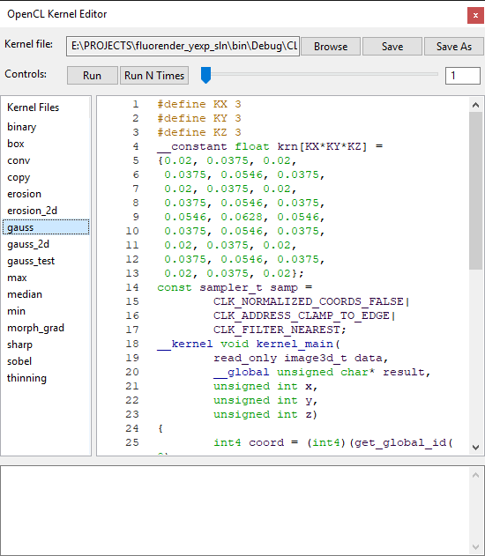

Figure 21‑1. OpenCL kernel editor.

### Open and save kernel files

To open a kernel file, click “Browse”, and in the file browser dialog, choose a kernel file. To save an already opened kernel file, click “save”, and the content of the original file will be overwritten. To save a modified kernel file with a different name or path, click “save as”, and in the file browser dialog, choose a directory and file name to save it.

### Built-in kernel files

Built-in kernel files can be found in the CL\_code folder. Any file in this folder is listed on the left side of the OpenCL kernel editor window. To load a built-in kernel file, click the kernel file name. Then, the kernel code is loaded to the code panel in the editor.

### Code panel

Write your own code or modify built-in code for more data processing functions. Coding should strictly follow the OpenCL 1.2 standard ([www.khronos.org/opencl/](http://www.khronos.org/opencl/)). In addition, pay attention to the following requirements.

1. Kernel entry point should be named with kernel\_main.
2. Currently selected volume channel is read by the kernel as an OpenGL 3D texture. The first parameter of type image\_3d is used.
3. Resulting volume channel has type unsigned char\*, its resolution is specified by the subsequent parameters, which are of unsigned int type.

|  |  |
| --- | --- |
|  | The current design of OpenCL interface allows one input volume and one output volume of exactly the same resolution. A kernel can have access to all sample point of both volumes. Please contact us for suggestions on more interface types. |

### Run a kernel

Click “Run” to execute a kernel on currently selected volume channel. A new channel of calculation result is created if the kernel is successfully compiled. The new channel is named after the original channel with “\_CL” appended to the end. If you apply a kernel to a channel with “\_CL” tag in its name, no new channel is created, and the kernel’s processing is directly applied to it. This allows you to repeatedly apply a kernel to a channel.

You can also run a kernel successively for a certain number of iterations. Use the slider to set the number iterations, and then click “Run N Times”.

### Output panel

Kernel compiling information is listed in the output panel. If a kernel fails to compile, error messages can be found in the output panel. Correct your kernel code based on the error messages if this happens.

# Settings

FluoRender’s settings are found in the “Settings” dialog. To open setting dialog, click “Settings”  in the main toolbar. The setting dialog groups settings into four panels for project, rendering, performance, and file formats.

|  |  |
| --- | --- |
|  | FluoRender’s settings are saved in text format with fluorender.set. You can use a text editor to modify settings directly. |

## Project Settings

Project settings are in the project panel. (Figure 22‑1)

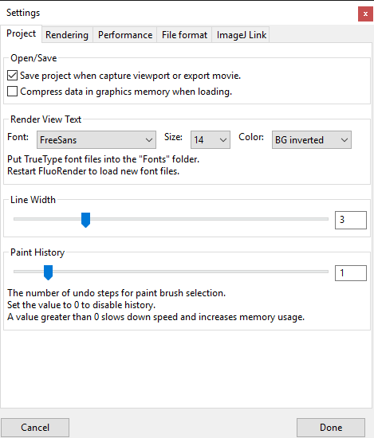

Figure 22‑1. Settings, project panel.

### Open/Save

**Save project when capture viewport or export movie.** When enabled, it automatically saves a project file when you click the “capture” button in render view, or export a movie.

**Compress data in graphics memory when loading.** When enabled, it uses OpenGL texture compression to save graphics memory.

|  |  |
| --- | --- |
|  | Depending on your graphics hardware, textures may not be correctly compressed. Disable this option if this happens. |

### Render View Text

**Font.** FluoRender searches and lists all True-type font files in the /Fonts folder within its installation directory. Choose the desired font so that it is used for render view text.

|  |  |
| --- | --- |
|  | If you want to display Unicode characters in the render view port, you have to copy a True-type font file that supports the character sets into the /Fonts folder. Then, restart FluoRender so that the font list can be regenerated. |

**Size.** Change the font size for render view text.

**Color.** You can choose a scheme for the color of render view text. The default setting chooses a color that is opposite to the background color of the render view. However, if the render view text is on top of a data set, instead of the background, you may choose a different color than the default. The schemes for render view text color are:

**BG inverted.** It calculates a color opposite to the background color.

**Background.** It uses the same color as the background.

**Vol sec color.** It uses the secondary color of currently selected volume channel. When nothing is selected, it uses the default color. See Chapter 8 on details of setting the secondary color of a volume channel.

### Line Width

The width of lines for rulers, tracks, etc.

### Paint History

Paint history is the number of paint brush operations that can be remembered by FluoRender. Set a number greater than 0 to use the **Undo** and **Redo** features in the Analyze window. The paint history is kept for each volume independently. Make sure that you choose a reasonable number so that memory consumption remains low.

## Rendering Settings

Rendering settings are in the rendering panel (Figure 22‑2).

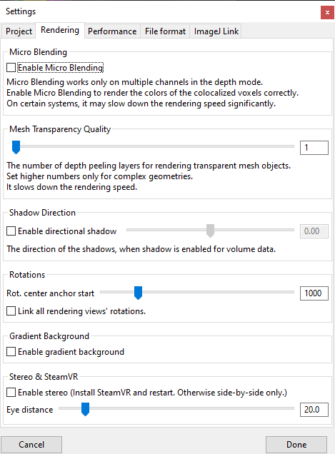

Figure 22‑2. Settings, rendering panel.

### Micro Blending

**Enable micro blending.** When enabled, channel intermixing in depth mode has more accurate results.

### Mesh transparency quality

It sets the number of depth peeling layers for rendering semi-transparent mesh objects, and for mixing mesh objects with volumes. Higher number is for better quality when mesh objects have complex shapes.

### Shadow direction

**Enable directional shadow.** When enabled, shadows are casted at an angle to the viewing direction.

**Shadow direction.** Use the slider to set shadow direction when directional shadow is enabled.

### Rotations

**Rotation center anchor start.** The zoom ratio above which the rotation center anchoring is turned on automatically. The rotation center anchoring is turned off when the zoom ratio is below this setting. However, users can manually override the anchoring mode. If a user changes the setting manually, the rotation center anchoring will not be enabled/disabled automatically.

**Link all render view rotations.** When enabled, rotations of multiple render views are synchronized. You can view all render views from the same angle.

### Gradient background

**Enable gradient background.** Use a gradient background with a faded horizon, instead of a solid color set in render view.

### Stereo & SteamVR

**Enable stereo.** Check this option to render two frames each time for the left and right eyes. The stereo can work in two modes. The first mode is the plain stereo mode. It uses the same projection settings as the normal rendering mode, which can be changed in the render view settings. Use the plain stereo mode for two situations. 1) Render and capture a video with side-by-side stereo, which can be viewed later using a VR headset, or cellphone-based VR. 2) Connect a cellphone to the computer and use it as a secondary display for the computer. Put the cellphone in a proper cellphone-based VR enclosure, and then view the renderings in stereo. The second mode is the SteamVR mode. It is turned on automatically when a SteamVR headset is properly connected to the computer after a restart of FluoRender. In SteamVR mode, the projection is set by the headset and cannot be changed by render view settings. Use the VR headset to view the renderings. You can still operate FluoRender normally using the user interface on the computer display. To switch back to the plain stereo mode, disconnect the VR headset and restart FluoRender.

**Eye distance.** It is the distance between the two rendered frames for the left and right eyes. It doesn’t have to be set to the actual eye distance of the user. Change the value so that the stereo view feels natural.

## Performance Settings

Performance settings are in the performance panel (Figure 22‑3).

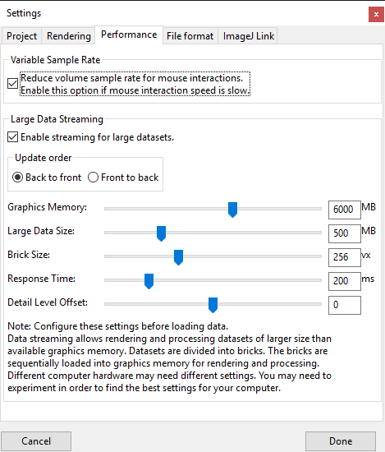

Figure 22‑3. Settings, performance panel.

### Variable sample rate

**Reduce volume sample rate for mouse interactions.** When enabled, a lower sample rate is used during mouse interactions. It allows better interaction speed, but rendering may flicker.

### Large data streaming

**Enable streaming for large data sets.** Enable this option if data sets to be visualized are too large to load into graphics hardware or too slow to render.

**Update order.** You can choose the update order when multiple bricks cannot be rendered within one render loop.

**Graphics memory.** Set this setting to the size of your graphics memory. Check hardware information on graphics cards. Data larger than this size are streamed from system memory to graphics memory.

**Large data size.** It is a limit that larger data sets are broken into bricks.

**Brick size.** When a data set is larger than the limit set by **large data size**, it is broken into bricks with a size of this setting for each of X, Y, and Z axes.

**Response time.** It is a time limit between two updates during data streaming. Shorter time makes rendering more responsive to user interactions, but less content of a data set may be processed and rendered.

**Detail level offset.** When a multiresolution data set is loaded, use this setting to control the resolution level displayed at a certain zoom ratio. Decrease this setting to show lower resolution levels, which can be useful for low-end or old computers.

|  |  |
| --- | --- |
|  | Large data streaming is on by default since version 2.22. A volume channel smaller than the large data size setting will not be divided into bricks. |
|  | When you load a data set, the progress dialog shows current streaming settings. |
|  | Since version 2.26.2, large data streaming applies to brush painting and component analysis. Painting locally on a large data set when only a few data bricks are covered by the paint stroke reduces processing time significantly. Checking “use selection” for component generation and analysis also constrains the computations only within selected bricks to reduce processing time. |
|  | Consider setting different bricks sizes for visualization and analysis. Component analysis requires more computational power and thus smaller brick size. |

## File Format Settings

File format settings are in the file format panel (Figure 22‑4).

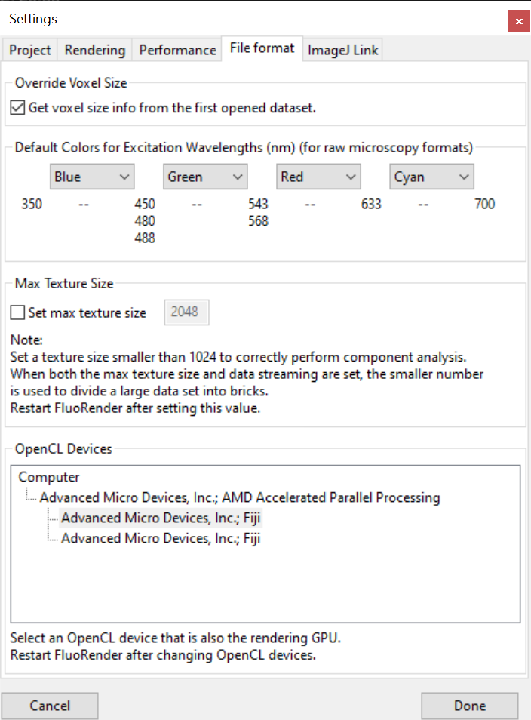

Figure 22‑4. Settings, file format panel.

### Override voxel size

**Get voxel size info from the first opened data set.** When multiple data sets are opened and they have different voxel sizes, you can enable this option so that all use the voxel size from the first opened file. If this option is not enabled, you can still set all data sets to use the same voxel size by typing voxel spacing values in one data set’s volume property panel (see Chapter 8 for more details).

### Default colors for excitation wavelengths

You can set different default colors for four excitation wavelength intervals. If metadata are read from a microscopy format and its excitation wavelength falls into one of the intervals, a predefined color is used. You can still change the color of a volume channel once it is loaded.

|  |  |
| --- | --- |
|  | For Olympus formats, if a channel is lit by transmitted light, the default color is always set to white. |

### Max texture size

You can force dividing a data set into bricks without using the streaming settings. When this option is unchecked, the value in the input box is the max texture size by the graphics hardware. You can override this size by checking the option and type in a smaller number. A data set loaded subsequently will be divided into bricks no larger than the setting. It is useful to configure this setting for applying OpenCL kernels on large data that do not require streamed rendering.

### OpenCL devices

A computer may be equipped with more than one GPU. It is common for laptops with both integrated and discrete GPUs, or a Thunderbolt system with externally connected GPUs. In FluoRender, resources including volume textures are shared between OpenGL for rendering and OpenCL for computing. Most drivers require the rendering GPU and computing GPU to be the same when resources are shared. When the default OpenCL GPU is different than the OpenGL GPU, a calculation, such as component generation or filtering, may fail. Use the list as a guide to select the correct GPU. FluoRender needs to be restarted after the OpenCL GPU is changed.

## ImageJ Link Settings

To link FluoRender with ImageJ functions, configure settings on the ImageJ Link panel (Figure 22‑5).

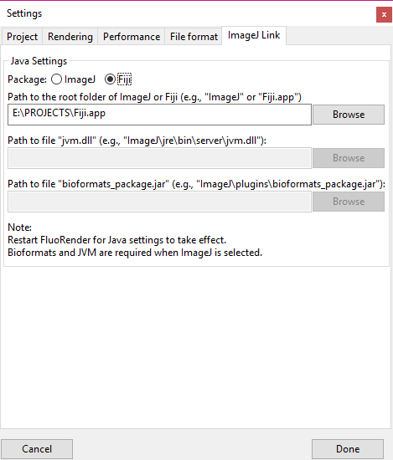

Figure 22‑5. Settings, ImageJ Link panel.

### Java settings

First choose which ImageJ package you’d like to use.

**ImageJ**. The barebone ImageJ package includes all the basic functions. Additional plugins, such as Bioformats, need to be downloaded and installed.

**Fiji**. It added plugins and more versatile functions into the original ImageJ package. Bioformats plugin is included.

FluoRender needs to know where to find Java and ImageJ functions. Type in the full path to the required files. Or use the browse button to find the files.

**Path to the root folder of ImageJ or Fiji** is the main folder. This is needed for both ImageJ and Fiji.

**Path to “jvm.dll”** is for the dynamically linked library file of Java Virtual Machine. Use the file that comes with your ImageJ package. This is needed only when ImageJ is selected.

**Path to “bioformats\_package.jar”** is for the BioFormats plugin. It is located inside the plugin folder of the ImageJ package. If it does not exist, download it from the BioFormats website. This is needed only when ImageJ is selected.

## Settings through the “fluorender.set” File

Some advanced and experimental settings of FluoRender are not exposed in the user interface. You have to modify these settings in the “fluorender.set” file. The “fluorender.set” is a text file that can be edited by any text file editor, such as WordPad or TextEdit. Settings are grouped under entries, whose names are in brackets. An entry can have multiple values. You need to locate a value under an entry, and then change the value behind the equal sign. Depending on the operating system, you may need the administrator privilege to make modifications to the file.

### Pixel format

Change the values under [pixel format] to modify the bit depth of the RGBA channels output to the display devices.

To enable 10-bit output, use these settings:

|  |
| --- |
| [pixel\ format]  red\_bit=10  green\_bit=10  blue\_bit=10  alpha\_bit=2  depth\_bit=24 |

List 22‑1. Pixel format settings for 10-bit output.

|  |  |
| --- | --- |
|  | You will need the latest professional graphics card (AMD FirePro or Nvidia Quadro) and a 10-bit capable LCD display to use this feature. This feature is also Windows only. Ten-bit signals are not supported by Thunderbolt or HDMI connections. You have to use DisplayPort to enable this feature. |

To enable HDR output, use these settings:

|  |
| --- |
| [pixel\ format]  red\_bit=16  green\_bit=16  blue\_bit=16  alpha\_bit=16  depth\_bit=24 |

List 22‑1. Pixel format settings for 10-bit output.

|  |  |
| --- | --- |
|  | You will need the latest nVidia graphics card and an HDR10 capable display or TV to use this feature. HDR is also Windows 10 only. Enable HDR from Windows display settings before launching FluoRender in HDR mode. To enable HDR, right click on the empty area of the Windows desktop. From the context menu, choose “Display settings”. If your display hardware supports HDR10, an option to turn on HDR will be available under the “Window HD Color”. Otherwise, considering update Windows 10 or upgrading your hardware components. |

If HDR is set to enable in FluoRender but your system does not support it, launching FluoRender will cause if to close automatically. Then, the pixel format settings will revert back to the defaults.

The default settings are:

|  |
| --- |
| [pixel\ format]  red\_bit=8  green\_bit=8  blue\_bit=8  alpha\_bit=8  depth\_bit=24 |

List 22‑2. Pixel format settings for standard output.

### Antialiasing

Change the value of “samples” under [pixel format] for antialiasing settings. The setting of 0 disables antialiasing. Setting of a higher number can smooth jagged edges and lines of the rendering.

|  |
| --- |
| [pixel\ format]  samples=4 |

List 22‑3. Pixel format settings for antialiasing.

|  |  |
| --- | --- |
|  | The actually supported sample number varies depending on your graphics hardware. Set it to 0 if antialiasing is not supported by your graphics card, or rendering becomes too slow. |

### Selection of OpenCL GPUs

Change the value of “device\_id” under [cl device] to select a different GPU for OpenCL calculations. The installed and activated GPUs are numbered starting from 0. Make sure that the selected GPU ID is within the valid range.

|  |
| --- |
| [cl\ device]  device\_id=0 |

List 22‑4. OpenCL device ID setting.

### Selection of OpenGL core profile version and GLSL version

Change the values “gl\_major\_ver” and “gl\_minor\_ver” under [context attrib] to set the OpenGL core profile version and GLSL version. Make sure that a valid version for your system is selected. The default OpenGL version is 4.4. If you experience any problem of using the core profile or creating context on your graphics card, you can set a third parameter “gl\_profile\_mask” to switch to the compatibility profile. For the parameter “gl\_profile\_mask”, setting it to 1 means the core profile, and setting it to 2 means compatibility profile. The default value for the profile mask is 1.

Since the operating system that FluoRender is running on may not honor the OpenGL version settings and select its own, the actually used OpenGL version numbers are saved back to the setting file after FluoRender has been successfully launched and shutdown once. Then, check the setting file to see the exact version that has been used.

|  |
| --- |
| [context\ attrib]  gl\_major\_ver=4  gl\_minor\_ver=5  gl\_profile\_mask=1 |

List 22‑5. OpenGL version setting.

|  |  |
| --- | --- |
|  | For some graphics cards, anti-aliasing becomes unavailable under certain OpenGL versions. Straight lines become jagged without anti-aliasing. Change the OpenGL version to see if anti-aliasing is enabled. |
|  | Generally speaking, you need to set it to the core profile if you are running FluoRender on Mac OS X, or if you are using an Intel CPU-integrated GPU. For the Windows operating systems, if you are using a discrete graphics card with nVidia or AMD GPUs, you can set the profile mask to the core profile or the compatibility profile. However, we found that on certain AMD GPUs, especially the FirePro series, you might need to set it to the compatibility profile in order for certain functions (such as streaming) to work properly. |

### Soft threshold

Change this value so that threshold settings of a volume use a value range to transit from low to high values. This can give the edges a soft look. This feature is turned off by setting the value to 0.

|  |
| --- |
| [soft\ threshold]  value=0.1 |

List 22‑6. Soft threshold setting.

### Test mode

Change the values under test mode to enable or disable certain test features. Set a value to 1 to enable; set a value to 0 to disable.

|  |
| --- |
| [test\ mode]  speed=0  param=0  wiref=0 |

List 22‑7. Test mode settings.

The test modes are:

**Speed.** Continuously refreshing the render view even without user interactions. The FPS reading tells you the speed of your computer hardware.

**Param.** Displaying more parameter information.

**Wiref.** Showing volume bounding boxes and slices in wireframe mode.

# Contributing to FluoRender

You can contribute to FluoRender by adding new functions to its source code.

## Developing and Contributing with Source Code via GitHub

FluoRender is “Open Source” and hosted on GitHub publicly. Anyone can clone or download the repository to access the source code and build it for their own machine. You are expected to learn and understand “git” if you wish to contribute to FluoRender. FluoRender is accessible with the terms of the MIT license agreement.

You may view the GitHub page for FluoRender for full and detailed clone and build instructions:

<https://github.com/SCIInstitute/fluorender>

The build instructions can change frequently, so duplicating them in this document is not feasible.

A simple SSH clone of the repository is done in the command line (assuming you have GIT installed) with the following line:

|  |
| --- |
| git clone git@github.com:SCIInstitute/fluorender.git |

You can then fork your own branch to make changes and improvements.

If you wish to merge your improvements into the master branch, or another branch, please request a “Merge Request” via GitHub, or on the command line.

You may also report bugs and suggest feature requests on GitHub.

# Appendices

## A. Functions of FluoRender

### List of functions of FluoRender on Windows and Mac OS X/macOS

| Functions | Windows | Mac OS X/macOS |
| --- | --- | --- |
| **Basic visualization** | **●** | **○** |
| View rotation | **●** | **●** |
| Geared rotation of 45º | **●** | **●** |
| Two styles of rotation slider control | **●** | **●** |
| Zero rotation | **●** | **●** |
| View panning | **●** | **●** |
| Rotation center anchor | **●** | **●** |
| Center data/panning reset | **●** | **●** |
| View zooming | **●** | **●** |
| 1:1 zoom ratio setting | **●** | **●** |
| Data-dependent zoom ratio display | **●** | **●** |
| Pixel-dependent zoom ratio display | **●** | **●** |
| View-dependent zoom ratio display | **●** | **●** |
| Depth attenuation | **●** | **●** |
| Screen capture | **●** | **●** |
| Save alpha channel in screen capture | **●** | **●** |
| Save floating-point numbers in screen capture | **●** | **●** |
| Enlarge image when capturing render view | **●** | **●** |
| View center axis | **●** | **●** |
| View information display | **●** | **●** |
| Legend display | **●** | **●** |
| Color map legend | **●** | **●** |
| Scale bar display | **●** | **●** |
| Perspective angle adjustment | **●** | **●** |
| Free fly | **●** | **●** |
| Background color setting | **●** | **●** |
| Background color inversion | **●** | **●** |
| Gradient background | **●** | **●** |
| Render view font | **●** | **●** |
| Render view text color settings | **●** | **●** |
| Create new render view | **●** | **●** |
| Link render view rotations | **●** | **●** |
| Render view setting save | **●** | **●** |
| Full screen mode | **●** | **○** |
| Standard orthographic views | **●** | **○** |
| Line thickness setting | **●** | **●** |
| **Touch gesture support** | **●** |  |
| One finger to rotate | **●** |  |
| Two fingers to pan | **●** |  |
| Pinch to zoom | **●** |  |
| **Multi-channel support** | **●** | **●** |
| Layered channel intermixing mode | **●** | **●** |
| Depth channel intermixing mode | **●** | **●** |
| Micro blending in depth mode | **●** | **●** |
| Composite channel intermixing mode | **●** | **●** |
| Channel grouping | **●** | **●** |
| Synchronize group settings | **●** | **●** |
| Depth mode for group | **●** | **●** |
| Channel streaming | **●** | **●** |
| **Large data streaming** | **●** | **●** |
| Graphics memory setting | **●** | **●** |
| Large data size setting | **●** | **●** |
| Brick size setting | **●** | **●** |
| Response time setting | **●** | **●** |
| **Multiresolution data support** | **●** | **●** |
| VVD | **●** | **●** |
| **Format support** | **●** | **●** |
| TIFF, including Z stack and time sequence | **●** | **●** |
| ImageJ hyperstack (> 4GB) | **●** | **●** |
| Tiled TIFF | **●** | **●** |
| Big TIFF | **●** | **●** |
| OIB, Olympus image binary | **●** | **●** |
| OIF, Olympus original imaging | **●** | **●** |
| LSM, Zeiss laser scanning microscope | **●** | **●** |
| XML, Prairie view | **●** | **●** |
| Metadata interpretation for microscopy | **●** | **●** |
| Nrrd, Near raw raster data | **●** | **●** |
| OBJ, Wavefront object | **●** | **●** |
| VRP, FluoRender project | **●** | **●** |
| DFT, FluoRender defaults | **●** | **●** |
| SET, FluoRender settings | **●** | **●** |
| MSK, FluoRender mask, auto-resample | **●** | **●** |
| LBL, FluoRender label, auto-resample | **●** | **●** |
| CL, OpenCL kernel | **●** | **●** |
| S3 texture compression | **●** | **●** |
| TRACK, FluoRender track map | **●** | **●** |
| Zeiss CZI | **●** | **●** |
| Nikon ND2 | **●** |  |
| Leica LIF | **●** | **●** |
| Leica LOF | **●** | **●** |
| **ImageJ functions** | **●** | **●** |
| File format import using Bioformats | **●** | **●** |
| Fiji support | **●** | **●** |
| **Volume operations and settings** | **●** | **●** |
| Click selection | **●** | **●** |
| DVR, direct volume rendering | **●** | **●** |
| MIP, maximum intensity projection | **●** | **●** |
| High transparency mode | **●** | **●** |
| Trilinear Interpolation | **●** | **●** |
| Smoothing | **●** | **●** |
| Add to legend | **●** | **●** |
| Voxel spacing | **●** | **●** |
| Primary color | **●** | **●** |
| Secondary color | **●** | **●** |
| Gamma | **●** | **●** |
| Extract boundary | **●** | **●** |
| Saturation | **●** | **●** |
| Low and high thresholds | **●** | **●** |
| Luminance | **●** | **●** |
| Light | **●** | **●** |
| Shadow, can be disabled | **●** | **●** |
| Directional shadow | **●** | **●** |
| Alpha, can be disabled | **●** | **●** |
| Sample rate | **●** | **●** |
| Shading, can be disabled | **●** | **●** |
| Color map, can be disabled | **●** | **●** |
| Color map type | **●** | **●** |
| Color map inversion | **●** | **●** |
| Color map mapping mode | **●** | **●** |
| Default setting save/restore | **●** | **●** |
| Synchronizing all settings | **●** | **●** |
| Synchronizing individual settings | **●** | **●** |
| **Volume clipping planes** | **●** | **●** |
| Axis-aligned clipping | **●** | **●** |
| Synchronize positive and negative planes | **●** | **●** |
| Clipping plane display hold | **●** | **●** |
| Clipping plane display modes: 5 | **●** | **●** |
| Clip slab width | **●** | **●** |
| Clipping plane rotation | **●** | **●** |
| View-aligned rotation | **●** | **●** |
| Resetting | **●** | **●** |
| Synchronize channels | **●** | **●** |
| Visualizing clipping planes | **●** | **●** |
| **Output adjustment** | **●** | **●** |
| RGB independent adjustment | **●** | **●** |
| Automatic RGB channel synchronization | **●** | **●** |
| Gamma | **●** | **●** |
| Luminance | **●** | **●** |
| Equalization | **●** | **●** |
| Default setting save/restore | **●** | **●** |
| Independent settings for render view | **●** | **●** |
| **Mesh operations and settings** | **●** | **●** |
| Click selection | **●** | **●** |
| Wireframe | **●** | **●** |
| Diffuse color | **●** | **●** |
| Specular color | **●** | **●** |
| Shininess | **●** | **●** |
| Transparency | **●** | **●** |
| Shadow, can be disabled | **●** | **●** |
| Lighting, can be disabled | **●** | **●** |
| Line size limit (for lines only) | **●** | **●** |
| Translation | **●** | **●** |
| Rotation | **●** | **●** |
| Scaling | **●** | **●** |
| Transparency quality (depth peeling) | **●** | **●** |
| **Data set view operations** | **●** | **●** |
| Add selection to view (data duplication) | **●** | **●** |
| Rename selection | **●** | **●** |
| Save selection | **●** | **●** |
| Resample | **●** | **●** |
| Bake (save selection with settings applied) | **●** | **●** |
| Delete selection | **●** | **●** |
| Delete all | **●** | **●** |
| **Workspace operations** | **●** | **●** |
| Visibility toggle | **●** | **●** |
| Create group for volume data | **●** | **●** |
| Create group for mesh data | **●** | **●** |
| Ordering through drag-n-drop | **●** | **●** |
| Delete selection | **●** | **●** |
| Isolation | **●** | **●** |
| Show all | **●** | **●** |
| Randomize color | **●** | **●** |
| **Record/Export operations** | **●** | **●** |
| Axis-aligned rotations | **●** | **●** |
| Smooth interpolation for axis-aligned rotations | **●** | **●** |
| Time sequence playback | **●** | **●** |
| File batch playback | **●** | **●** |
| Time control | **●** | **●** |
| View selection | **●** | **●** |
| Key frame animation | **●** | **●** |
| Key frame interpolation (linear/smooth) | **●** | **●** |
| Automatic key generation | **●** | **●** |
| View cropping | **●** | **●** |
| 4D script | **●** | **●** |
| Enlargement | **●** | **●** |
| **Movie export formats** | **●** | **●** |
| TIFF, LZW compression selectable | **●** | **●** |
| MOV, bit rate selectable | **●** | **●** |
| **Paint selection** | **●** | **●** |
| Grow | **●** | **●** |
| Selection brush | **●** | **●** |
| Diffusion brush | **●** | **●** |
| Solid brush | **●** | **●** |
| Unselecting brush | **●** | **●** |
| Reset selection | **●** | **●** |
| Erase | **●** | **●** |
| Extract | **●** | **●** |
| Threshold setting | **●** | **●** |
| Threshold adjustment after painting | **●** | **●** |
| Auto threshold estimation | **●** | **●** |
| Edge detection | **●** | **●** |
| Edge detection strength setting | **●** | **●** |
| Visible-only selection | **●** | **●** |
| Accurate for bricks | **●** | **●** |
| Select multi-channel volumes in group | **●** | **●** |
| Growth strength | **●** | **●** |
| Brush size adjustment | **●** | **●** |
| Brush size dependency | **●** | **●** |
| Paint history | **●** | **●** |
| Paint in streaming mode | **●** | **●** |
| Wacom tablet support | **●** | **●** |
| Getting selection size | **●** | **●** |
| Copy mask | **●** | **●** |
| Copy data as mask | **●** | **●** |
| Paste mask | **●** | **●** |
| Merge mask | **●** | **●** |
| Exclude mask | **●** | **●** |
| Intersect mask | **●** | **●** |
| Align render view axes to selection mask | **●** | **●** |
| **Measurement** | **●** | **●** |
| Locator | **●** | **●** |
| Probe | **●** | **●** |
| Protractor | **●** | **●** |
| 2 point ruler | **●** | **●** |
| Multipoint ruler | **●** | **●** |
| Branching ruler | **●** | **●** |
| Ellipse | **●** | **●** |
| Grow ruler | **●** | **●** |
| Pencil ruler | **●** | **●** |
| Flip ruler | **●** | **●** |
| Move ruler | **●** | **●** |
| Ruler point editing | **●** | **●** |
| Ruler point deletion | **●** | **●** |
| Ruler prune | **●** | **●** |
| Average | **●** | **●** |
| Profile | **●** | **●** |
| Distances to components | **●** | **●** |
| Project components to ruler | **●** | **●** |
| Lock ruler point | **●** | **●** |
| Ruler relaxation | **●** | **●** |
| Auto relax | **●** | **●** |
| Ruler relaxation constraint | **●** | **●** |
| Ex/In ratio | **●** | **●** |
| Delete selection | **●** | **●** |
| Delete all | **●** | **●** |
| Export ruler information | **●** | **●** |
| Setting ruler point on view plane | **●** | **●** |
| Setting ruler point at maximum intensity | **●** | **●** |
| Setting ruler point at accumulated intensity | **●** | **●** |
| Time-dependent ruler (transient) | **●** | **●** |
| Use volume properties for calculation | **●** | **●** |
| ΔF/F | **●** | **●** |
| Paint brush selection in ruler mode | **●** | **●** |
| Measure location | **●** | **●** |
| Measure length | **●** | **●** |
| Measure angle (2 point ruler only) | **●** | **●** |
| Measure volume (when paint selected) | **●** | **●** |
| Configurable text | **●** | **●** |
| Configurable color | **●** | **●** |
| Align render view axis to ruler (mono) | **●** | **●** |
| Align render view axes to ruler (PCA) | **●** | **●** |
| Ruler group | **●** | **●** |
| **Component Analyzer** | **●** | **●** |
| Component generation | **●** | **●** |
| Auto update | **●** | **●** |
| Synthetic Brainbows | **●** | **●** |
| Diffusion | **●** | **●** |
| Density field | **●** | **●** |
| Distance field | **●** | **●** |
| Fixate grown regions | **●** | **●** |
| Clean up | **●** | **●** |
| Command record and play | **●** | **●** |
| Load command file | **●** | **●** |
| Save command file | **●** | **●** |
| Streaming support | **●** | **●** |
| EM clustering | **●** | **●** |
| DBSCAN clustering | **●** | **●** |
| K-means clustering | **●** | **●** |
| Cluster number setting | **●** | **●** |
| Cluster size setting | **●** | **●** |
| Cluster neighborhood range setting | **●** | **●** |
| Component selection by ID | **●** | **●** |
| Component selection by size | **●** | **●** |
| Component color shuffling | **●** | **●** |
| Make color consistent in streaming mode | **●** | **●** |
| Multichannel colocalization | **●** | **●** |
| Output each component as a channel | **●** | **●** |
| Output all components as RGB | **●** | **●** |
| Random color coding for components | **●** | **●** |
| Size-based color coding for components | **●** | **●** |
| Component annotations | **●** | **●** |
| Component distances | **●** | **●** |
| Component length | **●** | **●** |
| Component output | **●** | **●** |
| Component selection in table | **●** | **●** |
| Component selection in render view | **●** | **●** |
| Include components in mask selection | **●** | **●** |
| Exclude components in mask selection | **●** | **●** |
| Align render view to components | **●** | **●** |
| **Processing and analysis** | **●** | **●** |
| Component counting | **●** | **●** |
| Component size | **●** | **●** |
| Component export | **●** | **●** |
| Component annotation | **●** | **●** |
| Noise removal | **●** | **●** |
| Voxel consolidation | **●** | **●** |
| Combining channels to RGB | **●** | **●** |
| Volume subtraction | **●** | **●** |
| Volume summation | **●** | **●** |
| Volume division | **●** | **●** |
| Volume colocalization | **●** | **●** |
| Volume-mesh conversion | **●** | **●** |
| Mesh surface area computing | **●** | **●** |
| **Colocalization analysis** | **●** | **●** |
| Threshold + AND method | **●** | **●** |
| Min value method | **●** | **●** |
| Product method | **●** | **●** |
| Voxel count output | **●** | **●** |
| Ratio output | **●** | **●** |
| Intensity weighted output | **●** | **●** |
| Physical size output | **●** | **●** |
| Color map | **●** | **●** |
| Freehand selection | **●** | **●** |
| Instant update | **●** | **●** |
| Adjacency matrix output | **●** | **●** |
| **Component tracking** | **●** | **●** |
| Track map generation (automatic tracking) | **●** | **●** |
| Track map refinement | **●** | **●** |
| Track map refinement at one time point | **●** | **●** |
| Track map computing iteration | **●** | **●** |
| Tracking component size limiter | **●** | **●** |
| Tracking component contact factor | **●** | **●** |
| Tracking component similarity setting | **●** | **●** |
| Merge components during tracking | **●** | **●** |
| Split components during tracking | **●** | **●** |
| Track map loading | **●** | **●** |
| Track map saving | **●** | **●** |
| Track map visualization | **●** | **●** |
| Track length control | **●** | **●** |
| Component listing | **●** | **●** |
| Component selection by ID | **●** | **●** |
| Component filter by uncertainty | **●** | **●** |
| Manual component linking | **●** | **●** |
| Automatic component linking | **●** | **●** |
| Exclusive component linking | **●** | **●** |
| Component isolation | **●** | **●** |
| Component unlinking | **●** | **●** |
| Manual ID assignment | **●** | **●** |
| ID appending | **●** | **●** |
| ID replacement | **●** | **●** |
| Component combining | **●** | **●** |
| Component separation | **●** | **●** |
| Clustering-based segmentation | **●** | **●** |
| Converting trajectory to rulers | **●** | **●** |
| Generating consistent colors over time | **●** | **●** |
| Uncertainty filtering | **●** | **●** |
| Computing component information | **●** | **●** |
| Computing track map information | **●** | **●** |
| Saving tracking information | **●** | **●** |
| **OpenCL filtering** | **●** | **●** |
| Successive execution | **●** | **●** |
| Box filter | **●** | **●** |
| Gaussian filter | **●** | **●** |
| Convolution | **●** | **●** |
| Median filter | **●** | **●** |
| Morphological erosion | **●** | **●** |
| Morphological dilation | **●** | **●** |
| Feature sharpening | **●** | **●** |
| Sobel edge detection | **●** | **●** |
| Morphological gradient | **●** | **●** |
| Binary | **●** | **●** |
| Thinning | **●** | **●** |
| **Batch processing (4D script)** | **●** | **●** |
| Enable 4D script | **●** | **●** |
| Load 4D script | **●** | **●** |
| Built-in 4D script list | **●** | **●** |
| Calculate | **●** | **●** |
| Component analysis | **●** | **●** |
| Fetch mask | **●** | **●** |
| Generate components | **●** | **●** |
| Executing OpenCL filter | **●** | **●** |
| Export components as RGB channels | **●** | **●** |
| Noise reduction | **●** | **●** |
| Save mask | **●** | **●** |
| Selection tracking | **●** | **●** |
| Save volume | **●** | **●** |
| Export ruler profiles | **●** | **●** |
| **Project** | **●** | **●** |
| Loading project | **●** | **●** |
| Saving project | **●** | **●** |
| Automatic project saving when capture | **●** | **●** |
| **Miscellaneous** | **●** | **○** |
| 10-bit output (requires GPU support) | **●** |  |
| HDR10 support (requires GPU support) | **●** |  |
| Texture size limiter | **●** | **●** |
| Antialiasing (requires GPU support) | **●** | **●** |
| Selection of OpenCL GPU (requires multiple GPUs) | **●** | **●** |
| Selection of OpenGL core profile version | **●** | **●** |
| Feedback of OpenGL core profile version | **●** | **●** |
| Stereo rendering | **●** | **●** |
| SteamVR | **●** |  |
| Xbox controller support | **●** |  |

 = New or improvements since FluoRender 2.26

## B. File Formats

FluoRender supports a series of file formats to load and save data. This is a list of all supported formats.

### Tagged Image File Format (TIFF)

The implementation of TIFF format is based on TIFF specification revision 6.0 of June, 1992. Features of TIFF format that are supported in FluoRender include:

System-dependent bit order;

Grayscale and RGB data;

Image stacks;

BYTE and SHORT data;

LZW compression;

Data strips;

Tiles.

In addition, Big-TIFF specification is also supported.

### ImageJ Hyperstack Format (TIFF)

ImageJ can save multichannel time sequence data with the hyperstack format. FluoRender automatically detects this format and reads channels and time points correctly. ImageJ hyperstack files large than 4 GB are also supported.

### Near Raw Raster Data (NRRD)

Nrrd reading and writing is based on Teem tools. FluoRender supports reading and writing single channel byte and short nrrd formats.

### Olympus Microscopy (OIB and OIF)

Our implementation is based on OIB/OIF format specification version 1.0.0.0.

### Zeiss Laser Scanning Microscopy (LSM)

Our implementation is based on LSM 5/7 release 6.0 of January 2011. Larger-than-4GB data are supported.

### Prairie View (XML)

Prairie View version 5.1 and older are supported. Our implementation of the Prairie View format is supported by developers from Bruker Corporation.

### VVD (VVD)

A VVD file is a multiresolution format designed by Takashi Kawase. Extremely large data can be downsampled into a series of resolution levels and then converted to the VVD format. When a VVD format is loaded into FluoRender, the resolution loaded and visualized depends on the zoom level. In addition, use the level offset setting in the FluoRender setting dialog to increase or decrease the resolution levels.

### Zeiss ZISRAW (CZI)

Our implementation is based on the ZISRAW file format design specification V 1.2.2, published in July 2016.

### Nikon ND2 (ND2)

Our implementation is based on the ND2 SDK version 1.1.0.0. The SDK only provides support on Windows and Linux. Therefore, the ND2 file support is not available on macOS.

### Leica Image Format (LIF and LOF)

Our implementation is based on the Leica Image File Formats Version 3.2, published in September 2016. A LIF file may contain multiple images from different experiments. Use the new series selection function to select one image at loading. A LOF file can only contain one image. See Chapter 4 for more details.

## C. Keyboard Shortcuts

|  |  |
| --- | --- |
|  | Make sure the mouse cursor is in the render view region when render view related shortcuts are used. |

### For render view

**F5.** Refresh render view.

**Ctrl + Left.** Pan left for one entire view.

**Ctrl + Right.** Pan right for one entire view.

**Ctrl + Up.** Pan up for one entire view.

**Ctrl + Down.** Pan down for one entire view.

**Esc.** Exit full screen mode (Microsoft Windows Only).

### For color input in volume property settings

**B.** Blue (0, 0, 255)

**C.** Cyan (0, 255, 255)

**G.** Green (0, 255, 0)

**K.** Black (0, 0, 0)

**M.** Magenta (255, 0, 255)

**R.** Red (255, 0, 0)

**W**. White (255, 255, 255)

**Y.** Yellow (255, 255, 0)

### For paint brush tool

**Shift (Hold).** Enable selection brush.

**Z (Hold).** Enable diffusion brush.

**X (Hold).** Enable eraser.

**V (Hold).** Disable highlighting.

**C.** Clear selection.

### For selecting components

**Ctrl (Hold).** Select multiple components; select/unselect components.

**Enter/Return.** Include components.

**/ (Slash).** Exclude components.

### For moving clipping plane slab

**W.** Move up one slab.

**S.** Move down one slab.

### For stepping through a time sequence

**A.** Step backward one time point.

**D.** Step forward one time point.

**Space (Hold).** Continuously play back a time sequence.

### For tracking

**F.** Select full component.

**L.** Link IDs.

**N.** Assign ID.

**M.** Save masks.

## D. Command Line Options

FluoRender supports a series of command line options when launched from the Windows command line tool or macOS Terminal. Browse to the FluoRender executable and open the command line tool or Terminal from the directory. Notice that macOS needs the directory inside of the application contents. You may also add the directory to system path, so that FluoRender can be launched anywhere with the command line tool.

|  |  |  |  |  |
| --- | --- | --- | --- | --- |
| Command Type | Long Command | Short Command | Purpose | Example |
| Switch | --alpha | -a | Turn on the alpha channel for the exported movie, which needs to be in the TIFF format | FluoRender.exe **-a** -m “D:\Example\test\_movie.tif” “D:\Example\test\_data.tif” |
| Switch | --benchmark | -b | Start FluoRender in the benchmark mode. The benchmark mode keeps refreshing the render view even without any interactions. Turn on the render view information to see the frame rate. | FluoRender.exe **-b** “D:\Example\test\_data.tif” |
| Option | --bitrate | -br | Set the bit rate for movie export, which needs to be in the QuickTime format | FluoRender.exe -m “D:\Example\test\_movie.mov” **-br 20** “D:\Example\test\_data.tif” |
| Switch | --fullscreen | -f | Start FluoRender in the full-screen mode. | FluoRender.exe **-f** “D:\Example\test\_data.tif” |
| Option | --height | -h | Set the window height. It only takes effect when the windowed switch is set. | FluoRender.exe -win -w 1920 **-h 1080** |
| Switch | --hidepanels | -hp | Hide all panels in the user interface | FluoRender.exe **-hp** |
| Switch | --imagej | -j | Use ImageJ to load data. ImageJ and Bioformats need to be configured correctly before use. | FluoRender.exe **-j** “D:\Example\test\_data.nd2” |
| Switch | --lzw | -lzw | Use LZW compression for movie export, which needs to be in the TIFF format. | FluoRender.exe -m “D:\Example\test\_movie.tif” **-lzw** “D:\Example\test\_data.tif” |
| Switch | --usage | -u | Print out the command line usage information | FluoRender.exe **-u** |
| Option | --width | -w | Set the window width. It only takes effect when the windowed switch is set. | FluoRender.exe -win **-w 1920** -h 1080 |
| Switch | --windowed | -win | Start FluoRender in windowed mode. | FluoRender.exe **-win** -w 1920 -h 1080 |
| Parameter | NA | NA | Specify data files or a project file to load on startup. Multiple data files are supported. | FluoRender.exe **“D:\Example\Data1.tif” “D:\Example\Data2.tif” “D:\Example\Data3.tif”**  Or:  FluoRender.exe **“D:\Example\test\_project.vrp”** |

## E. Frequently Asked Questions

### 1. What computer hardware is good for running FluoRender?

First of all, FluoRender is built to run on a personal computer with good graphics processing capabilities. Although most of newly purchased personal computers can run FluoRender, including Windows desktops, laptops, Apple MacBooks, iMacs, and MacPros, it is best to purchase one with a gaming level or professional graphics card. Wikipedia provides detailed comparisons of graphics card from both Nvidia and AMD. Generally speaking, a graphics card with higher “Processing Power GFLOPs” is also better for FluoRender. We would recommend a top-of-the-line gaming graphics card over a professional graphics card. FluoRender can take advantage of some features of a professional graphics card, such as 10-bit output and better anti-aliasing. However, the difference is subtle in most situations. Second, strong CPU processing power is generally desired. We would recommend a latest CPU with higher clock frequency over more cores. Third, if you have large data sets to process, equip as much system memory as possible. For the year 2019, the consumer level computers can be equipped with as much as 128 GB of system memory, while a professional desktop can have 1 TB or more. Last, if you want to load data quickly or play back large time sequence smoothly, you need high speed access to hard drives. We would recommend PCI Express based RAID configurations including onboard or a discrete controller with abundant cache. Speed of hard drives is also important for handling large data sets. We would recommend SSDs that support the NVMe standard for onboard RAID controllers or 4-8x SATA/SAS SSDs for discrete RAID controllers.

### 2. Can I use an external graphics card on a laptop computer?

It depends on the specific hardware and OS combination. If an external graphics card can be successfully recognized by your system, FluoRender can take advantage of the extra processing power. We have tested an external graphics card on Microsoft Windows 10 based laptops equipped with the Thunderbolt 3 technology. A significant improvement on user interaction speed can be achieved. Varying success has also been achieved on Apple computers. However, current macOS only supports a selection of AMD graphics cards (mid 2018).

### 3. Does FluoRender support multi-GPU rendering?

We have tested FluoRender on a limited number of multi-GPU systems. When CrossFire is enabled for AMD GPUs, you need to manually add FluoRender to application profile settings and set its CrossFire mode to “AFR Friendly”. Rendering speed may scale only in full screen mode. You are encouraged to try FluoRender on a multi-GPU system. However, speed scaling is not guaranteed.

### 4. Why can’t I start FluoRender?

There are several possibilities for FluoRender to fail. First, check if the graphics driver is installed and updated to the latest version. Some old graphics card may not support OpenCL, which is required since version 2.15. If that is the case, you can download and try an earlier version of FluoRender. Since version 2.16, we require the graphics card to support at least OpenGL 3.3. If you have an old graphics card and want to use FluoRender on it, please replace your graphics card or download an old version of FluoRender. Second, make sure that your operating system supports 64-bit applications. Since version 2.15, we have dropped the support of 32-bit applications, which means FluoRender is 64-bit only. For Windows, you have to purchase the x64 version of the operating system; for Mac OSX, you have to update to the recent versions. Finally, FluoRender may not be properly installed, or some required modules have been accidentally uninstalled. Reinstalling FluoRender may solve the issue.

### 5. Why can’t I load a file into FluoRender?

FluoRender can only load supported file formats, which include TIFF and some microscopy manufacturer specific formats. We write our own readers for these formats to achieve the best performance, especially for large data and time sequence data. So, we can only support “Open” and standard formats. If you have files of unsupported formats, you have to convert the format using a third-party tool. ImageJ can be a good choice in most situations.

### 6. Why can’t I use some of the functions in FluoRender?

If you can use FluoRender for the basic visualizations of volume data, but not some advanced functions, such as paint brushes, it means your system does not support all OpenGL features. This can be that you are using a virtual machine, a remote client, or a system with an integrated graphics card with limited capabilities. You may want to upgrade your system to a standalone desktop computer with the latest graphics hardware to use all features in FluoRender.

### 7. Does FluoRender have a Linux version?

The official FluoRender releases only include a Windows version and a Mac OSX version, both 64-bit. If you want to run FluoRender on systems other than these, you can download the source code of FluoRender and build it on a different operating system. Additionally, you can send us emails and let us know your requirements.

### 8. How can I fix FluoRender crashes when rendering and computing take long time?

You may add a registry value, called “TdrLevel”, on Windows. More information can be found here: <http://nvidia.custhelp.com/app/answers/detail/a_id/3007/~/opengl-message-%E2%80%9Clost-connection%E2%80%9D>

# Index

A

Alpha 38, 40

B

Bake 27, 75

C

Channels 21, 36, 49, 75, 83, 106

Clipping plane 51, 52

Colocalization 31

Colocalized 36, 61, 81

Component analysis 93

Composite mode 36

Cropping 60, 62

D

Depth attenuation 37

Depth mode 36, 43

E

Edge detect 81

Equalization 49

F

FPS 55, 60

Full screen 39

G

Gamma 40, 49

I

Install 11

Interpolation 43, 60

L

Layered mode 36, 43

Leads 113

Legend 37, 43

Lempel-Ziv-Welch Compression 38

M

Measurement 31, 86

MIP 42

N

Noise 27, 43, 71, 99, 105

Noise reduction 31, 71, 105

O

OpenCL 121

OpenGL 122, 124, 132

P

Paint selection 79

Perspective 35

Probe 87

Profile 88

Project 77

S

Sample rate 42

Select 36, 79, 80, 81, 98, 104

Sequence 22, 23, 55, 63, 91, 110

Settings 32, 37, 43, 50, 79, 81, 91, 123

Shading 42

Shadow 42, 53, 125

Streaming 24, 127

Surface area 120

Synchronize 43, 44, 49, 51, 125

T

Tails 113

Threshold 41, 71, 81, 82, 94, 105

Tracking 31, 110

Tracks 113